Highway Trip to Peru

When I made the Jeep trip to Peru there were no highway maps available. This highway information was given to me by a person who had recently been over the same route from the other direction. This form of highway information regarding the difficulties of making highway trips during these early years. I Think I Made this Trip in 1947 or 1948. This Jeep was the second one I bought due to having sold the other Jeep in Nicaragua. I did not attempt to take a house trailer on this trip.
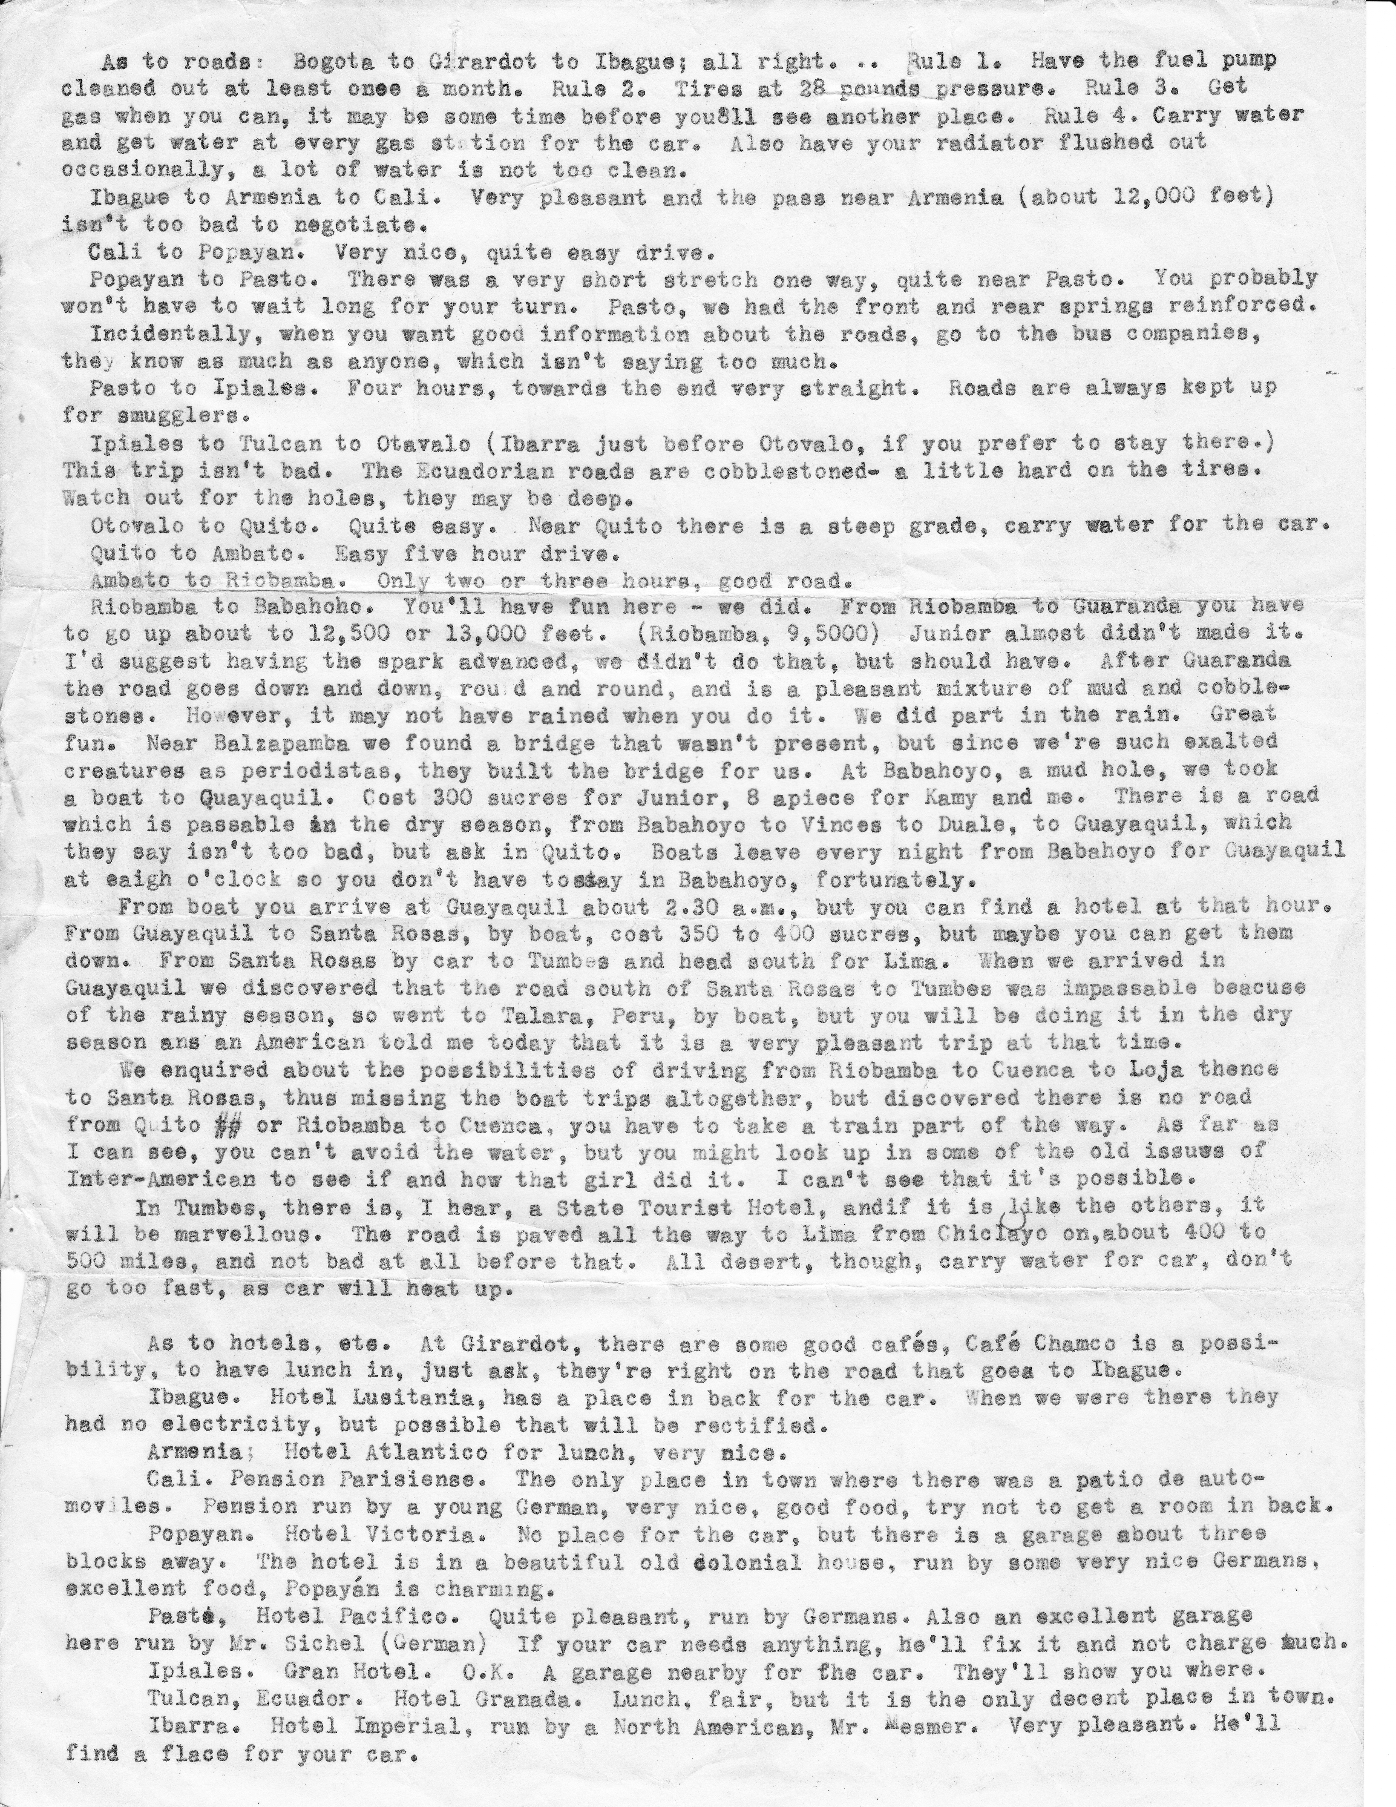
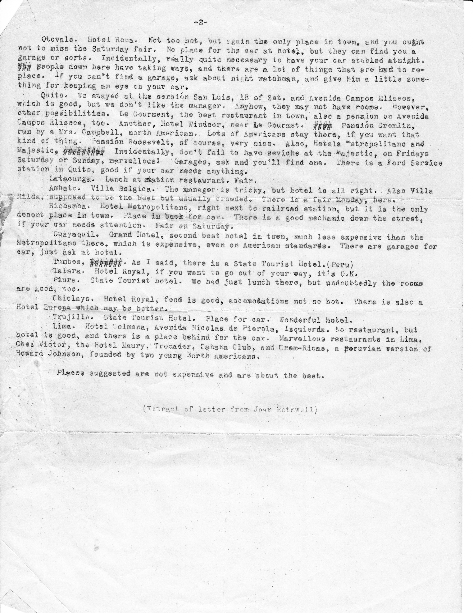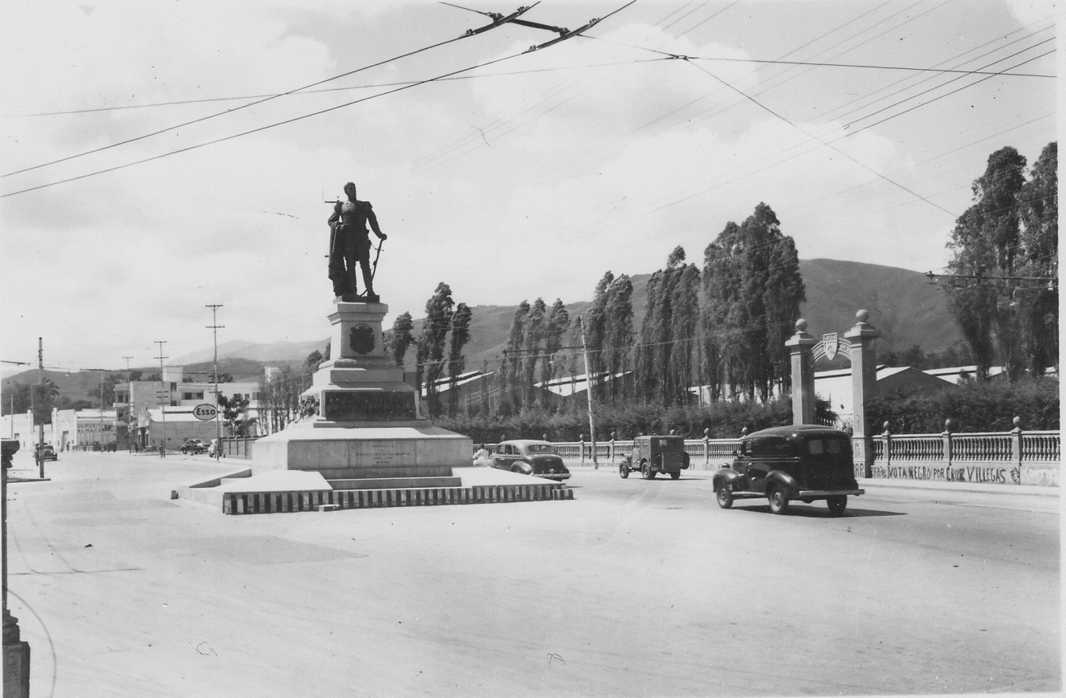
Passing the statue of San Martin on the way out of Caracas, Venezuela.

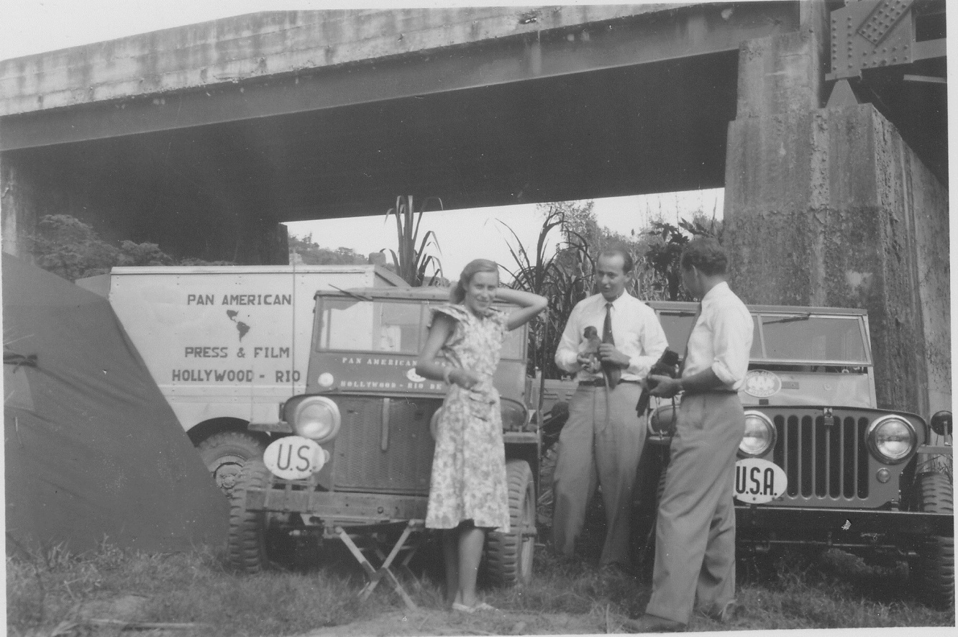
Another expedition I met near Caracas, Venezuela. They weren’t driving through but mainly taking pictures.

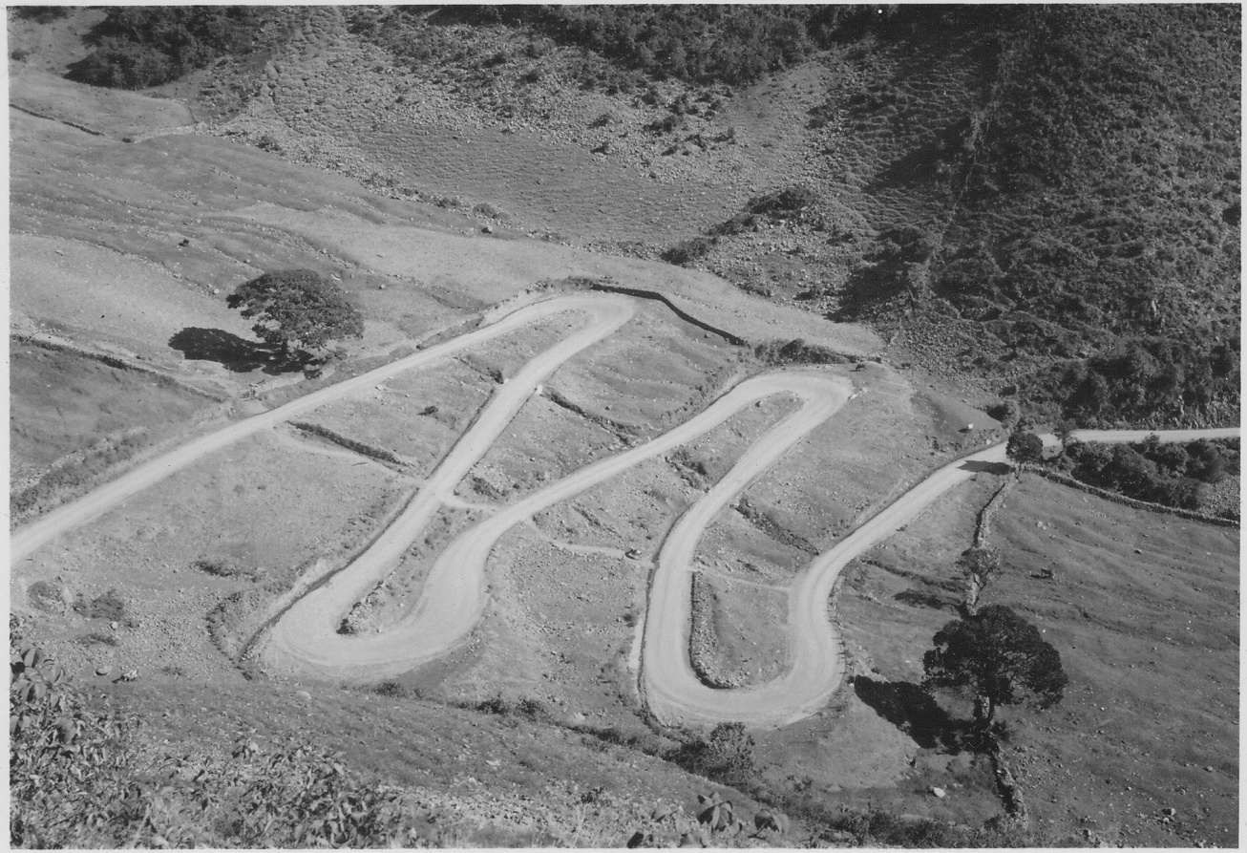
A section of the highway in Venezuela.

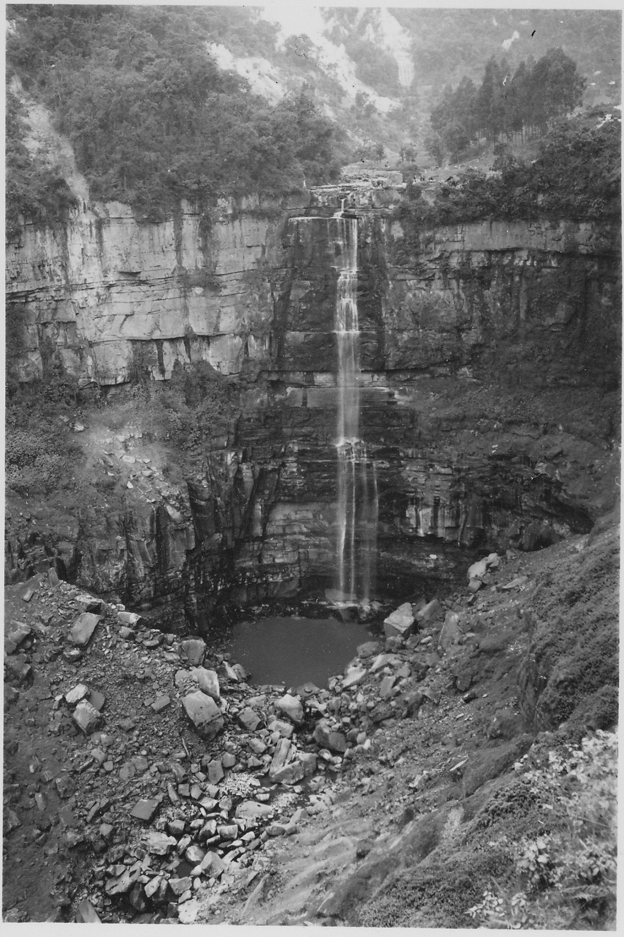
The Tequendama Falls (440 feet) along the Pan American Highway just a few miles south of Bogota, Columbia. During the rainy season the falls are said to be spectacular.

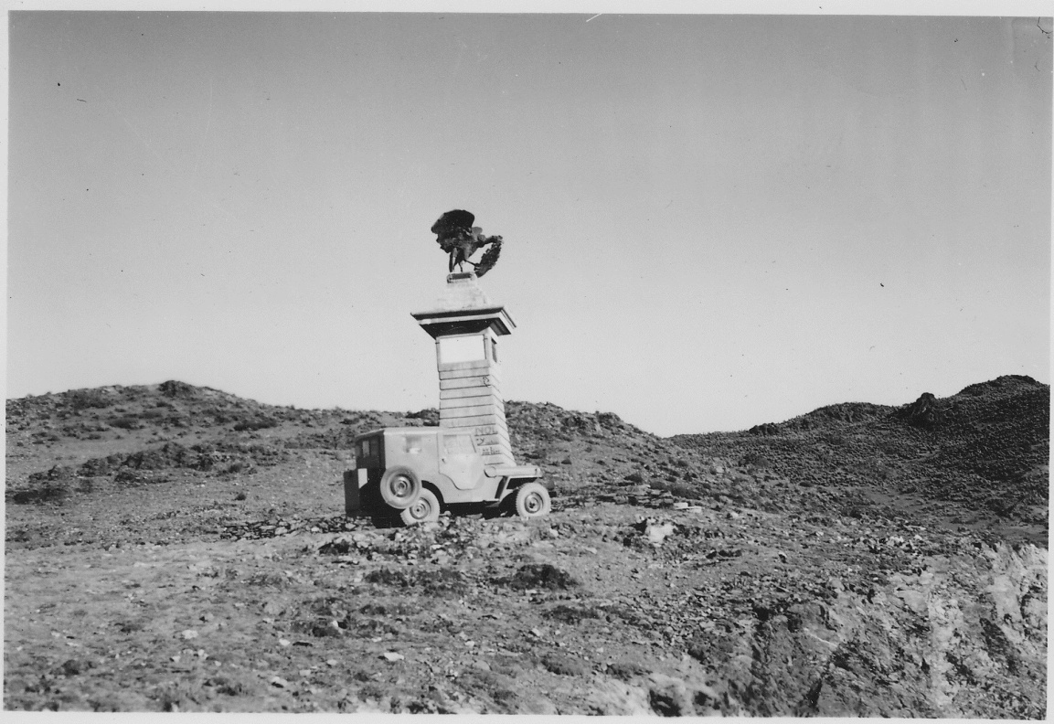

The monument (bronze condor) marking the place where Bolivar crossed the Andes with his troops in the successful war of independence with Spain. High on the Pan American Highway so far at 13,500’.

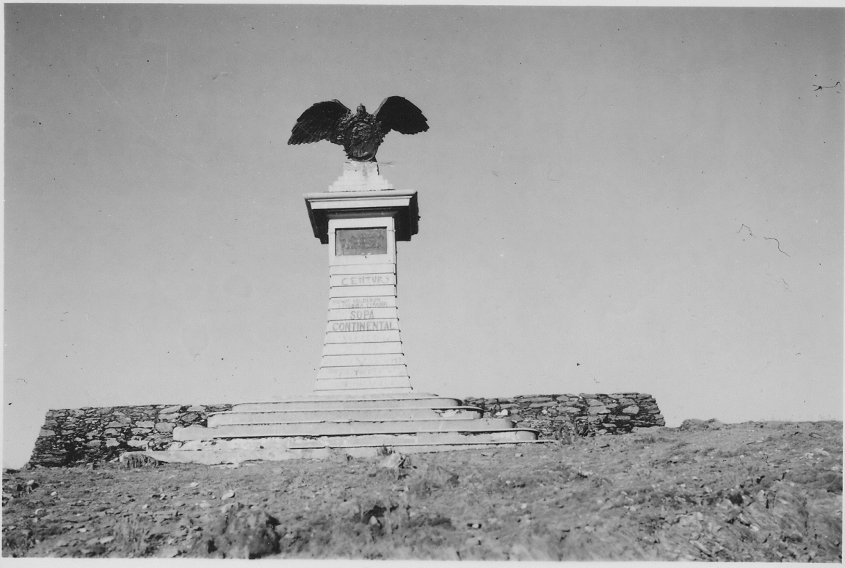
Monument to Bolivar (along the highway) marking the point wherer he crossed the Andes at 12,500’ with his troops.

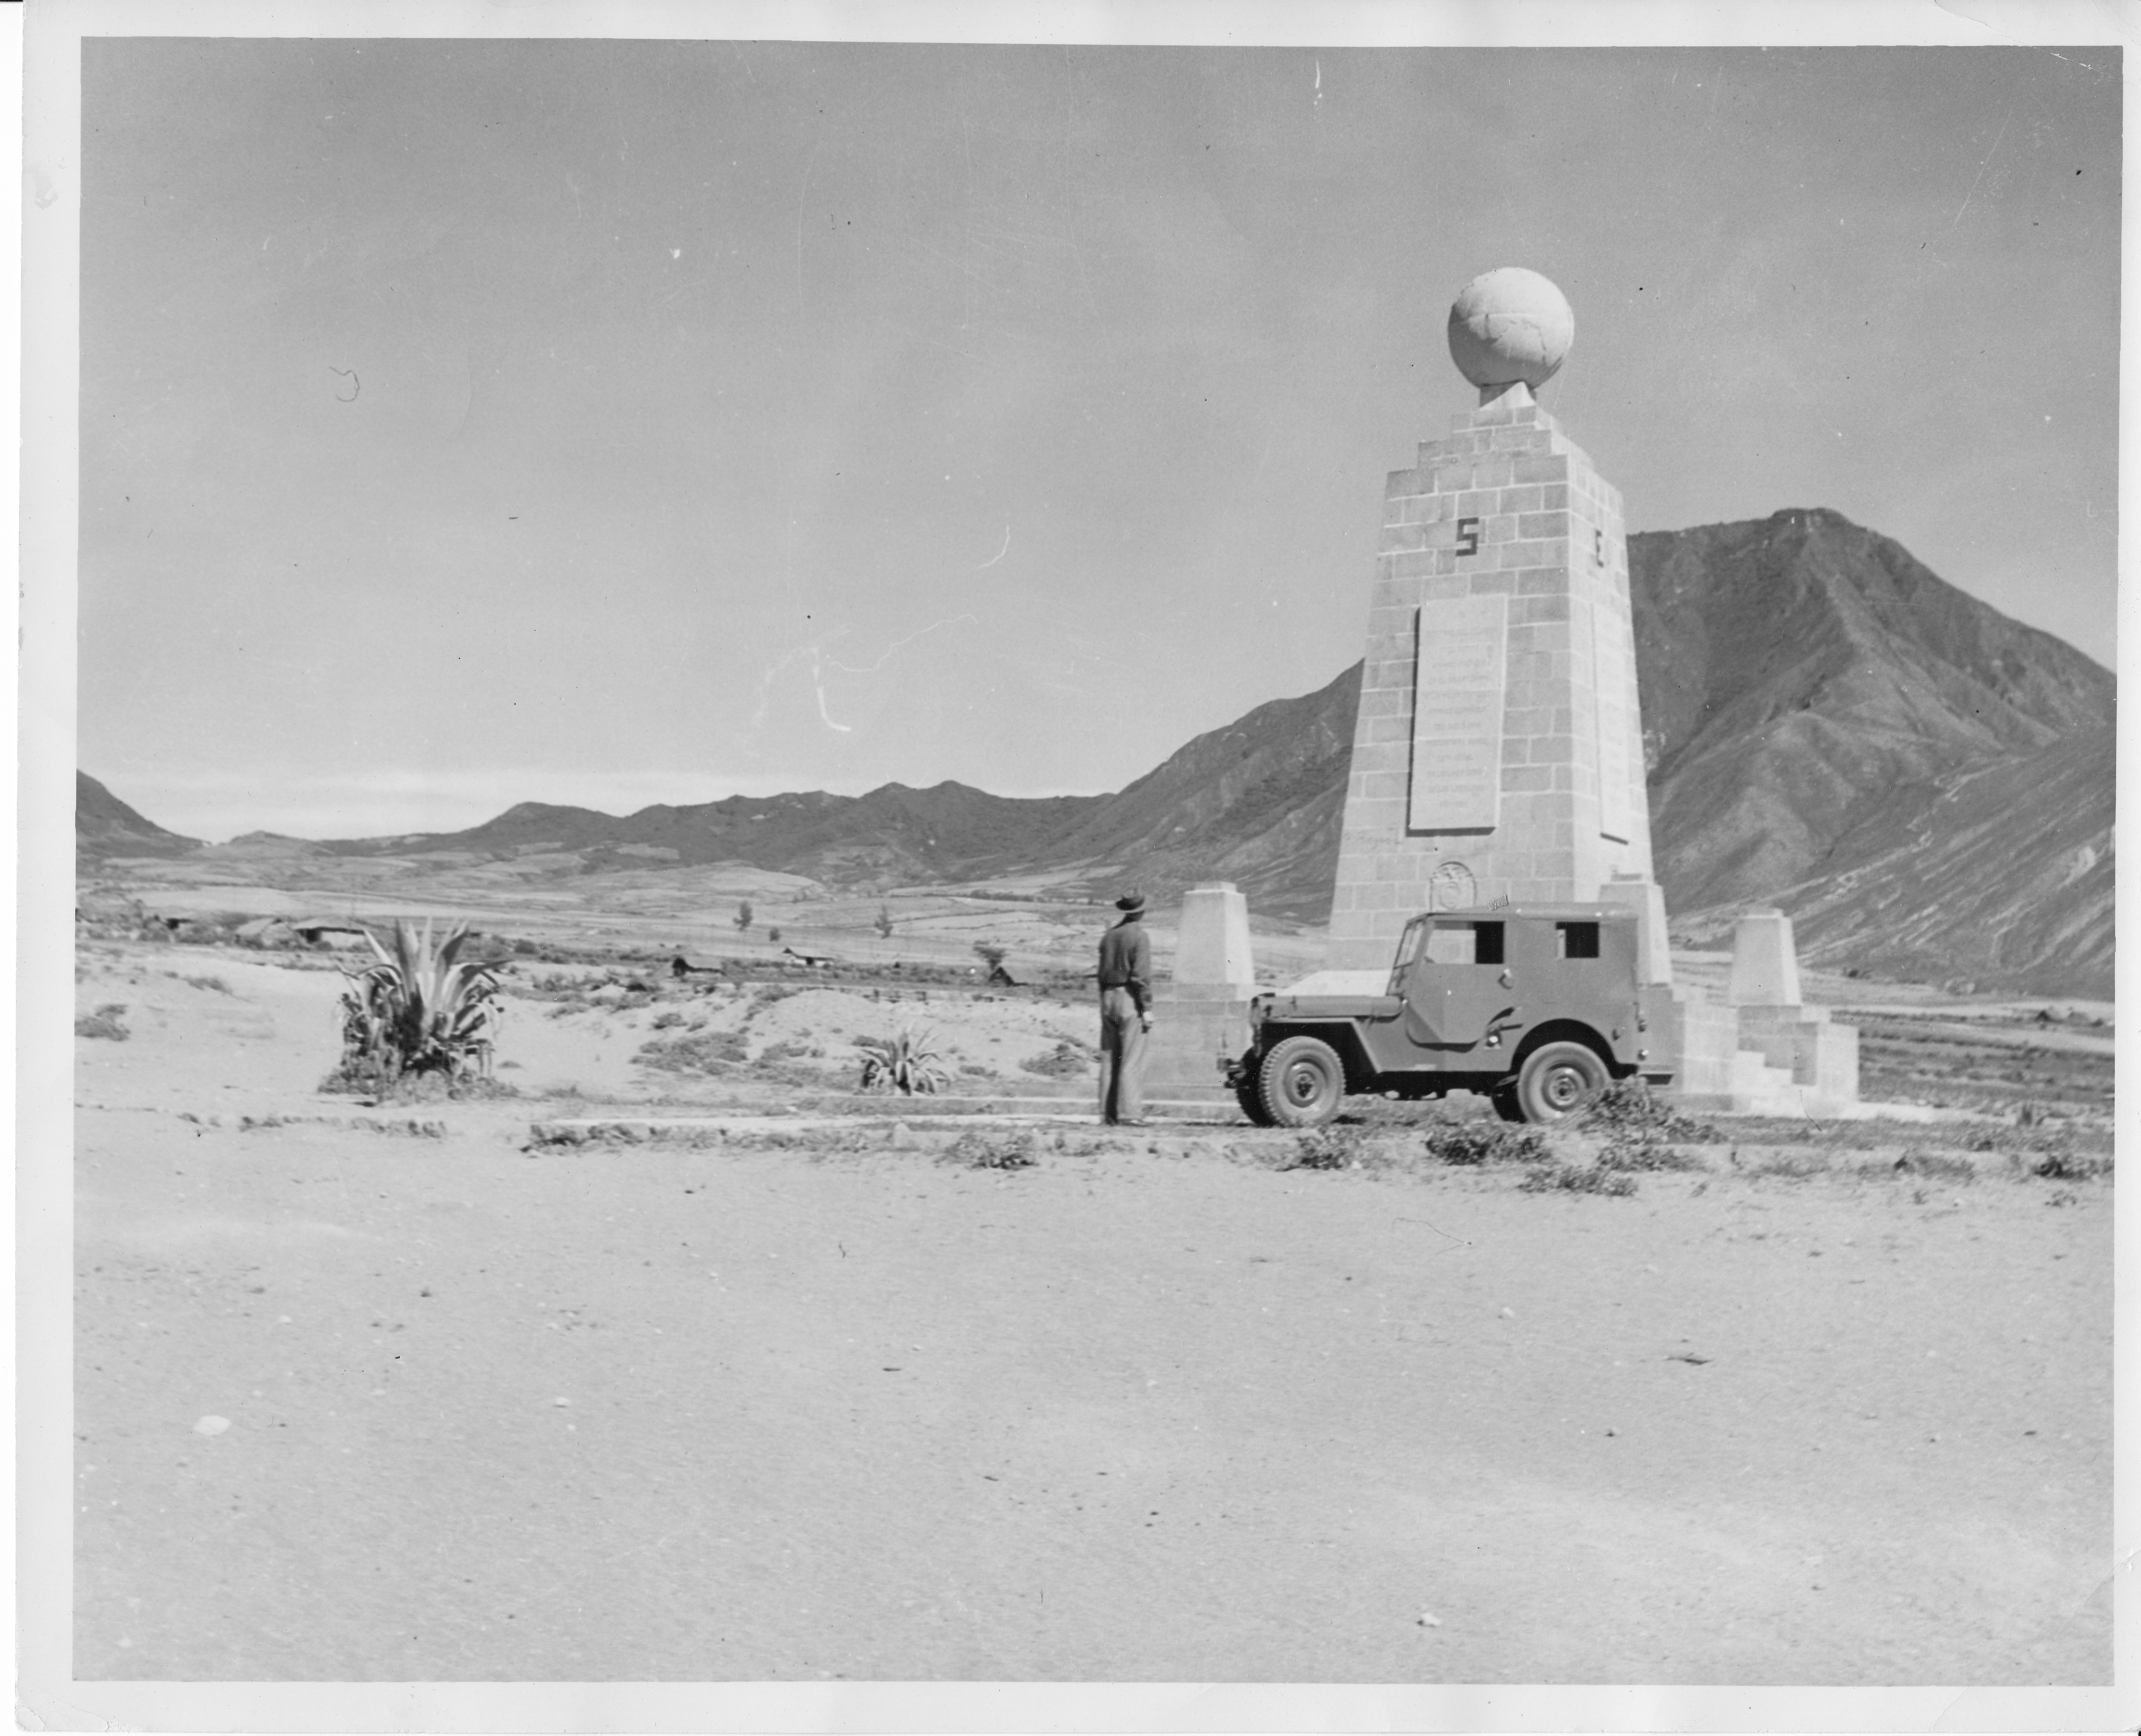
Taken at the monument standing at the Equator, along the highway near Quito.

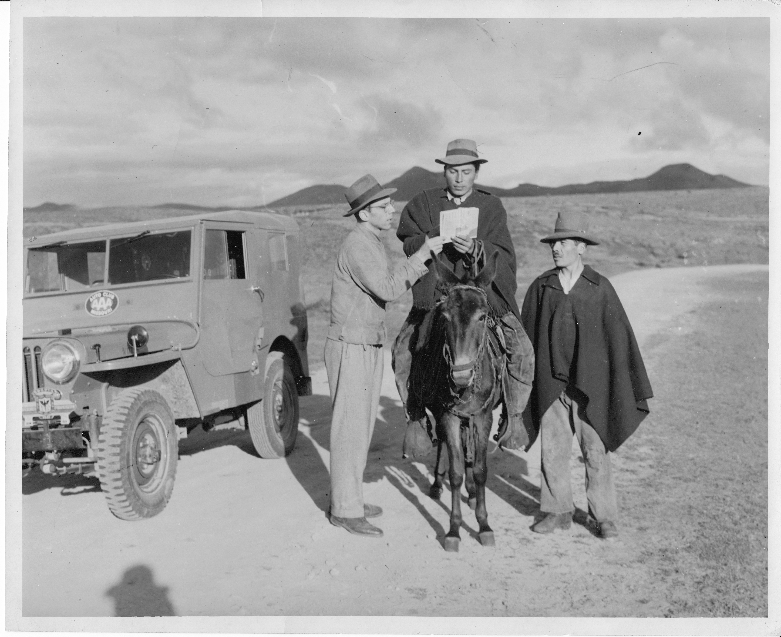
Getting help
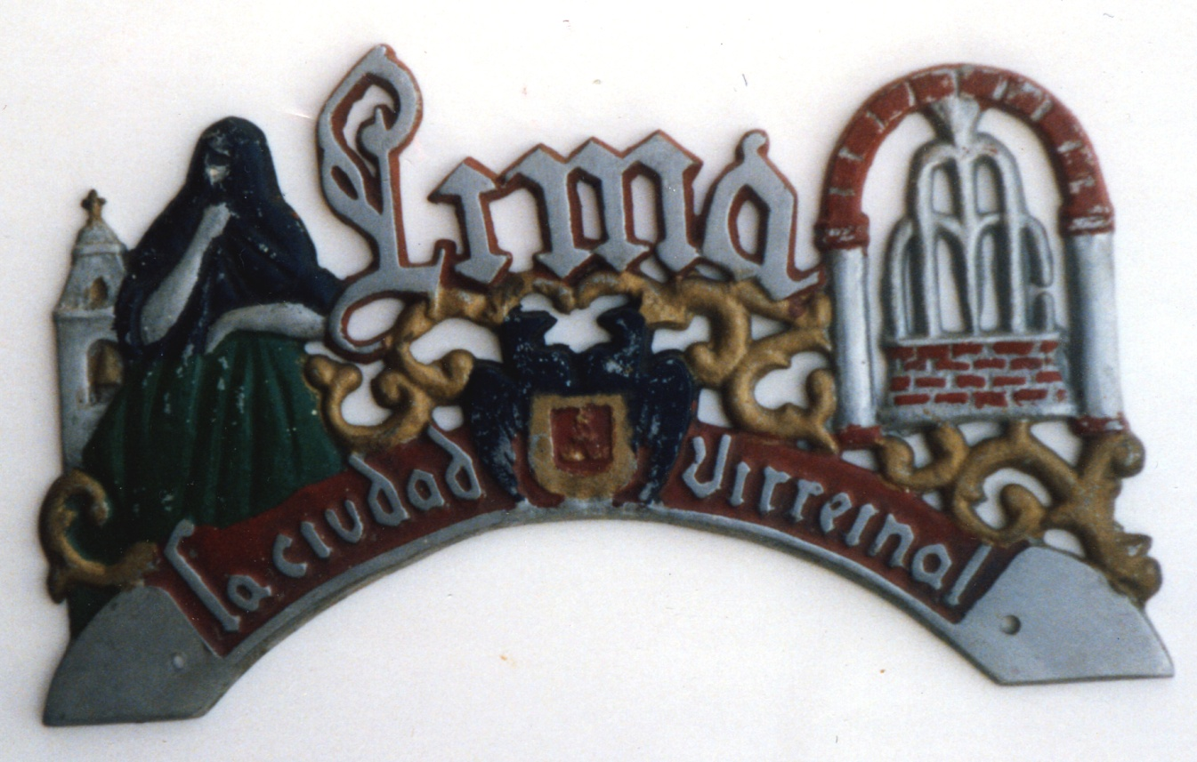

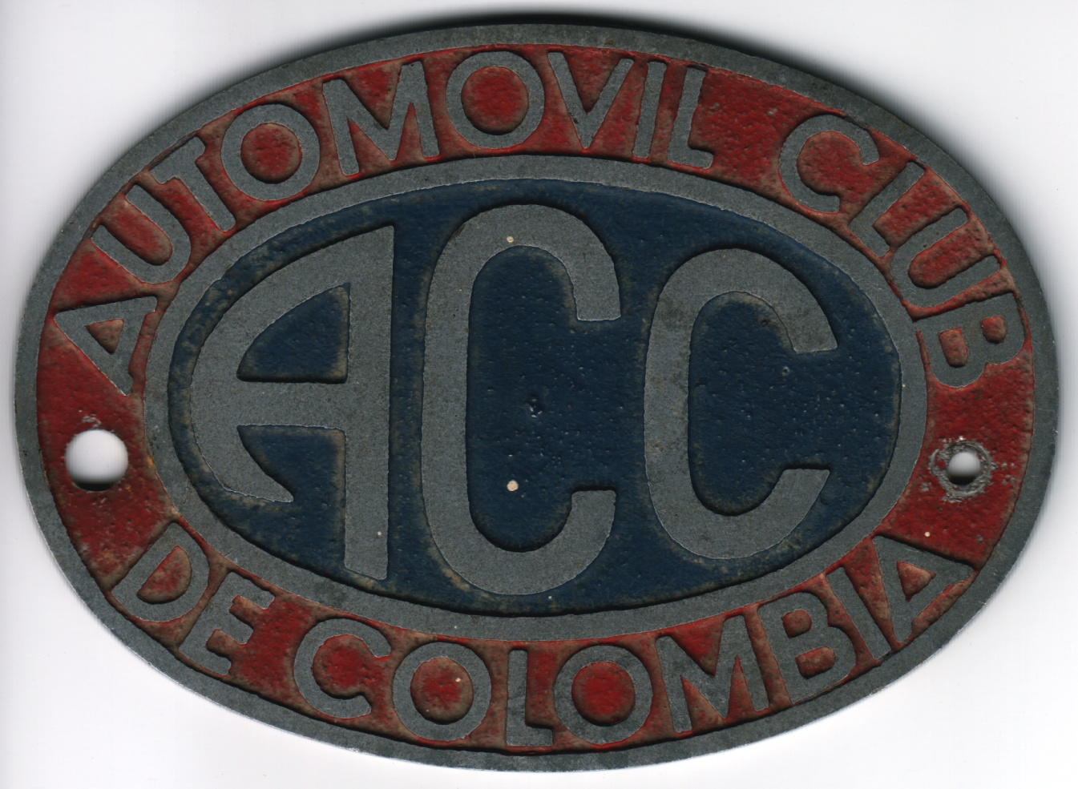
Insignias for Jeep used for identification on trip to Peru.

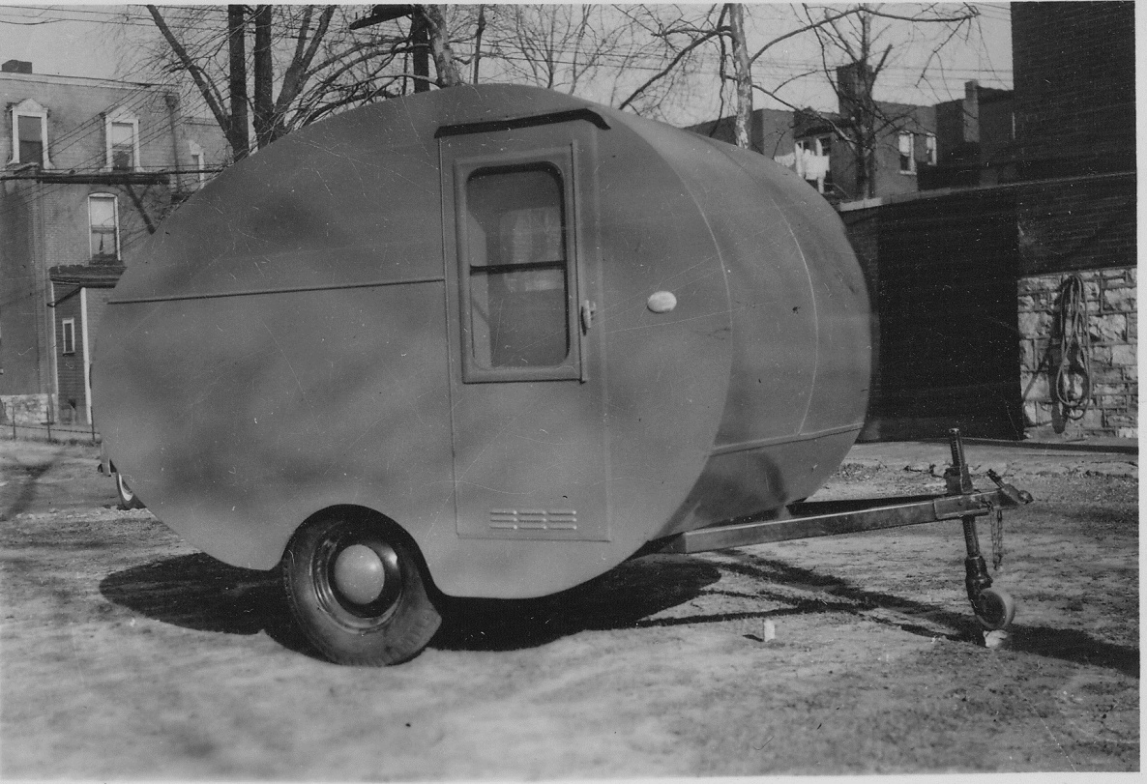
Bought this second trailer to make trip from Caracas down Pan American highway but made trip only by jeep in 1947.
