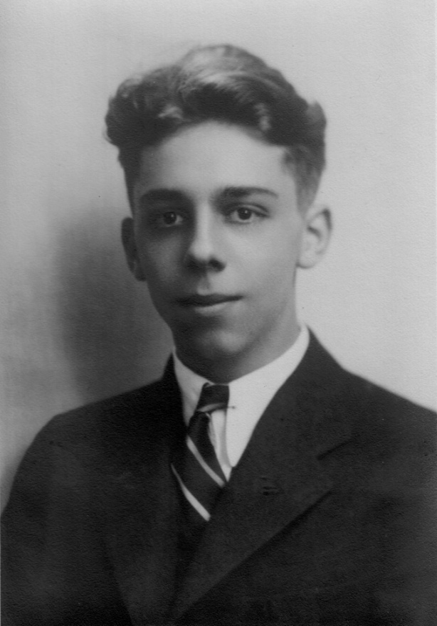 | This photograph was taken of me in 1932 at the time of my graduation from John Burroughs School in St. Louis County, MO

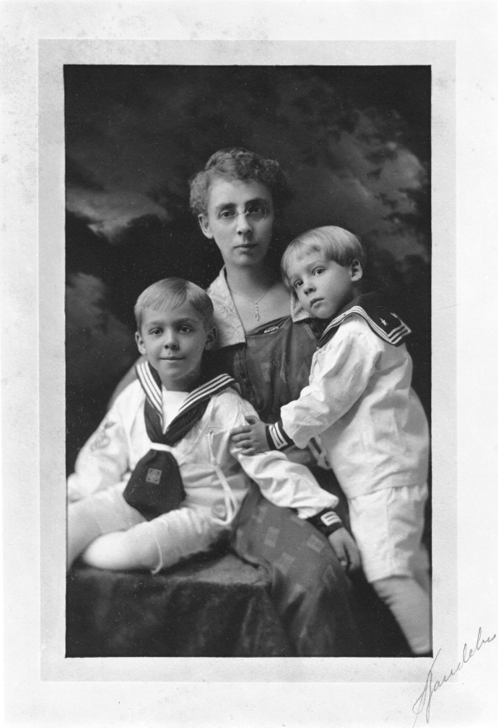 | Left to right:  Frederick P. Baggerman  Our mother  William Francis Baggerman

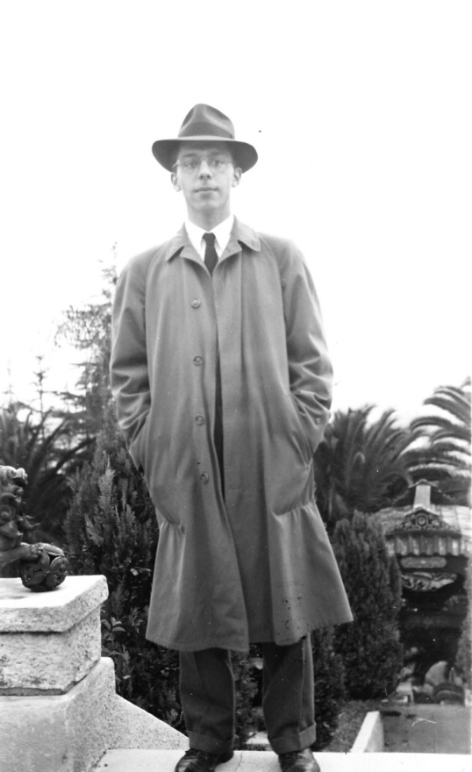 | Dec 1941  California
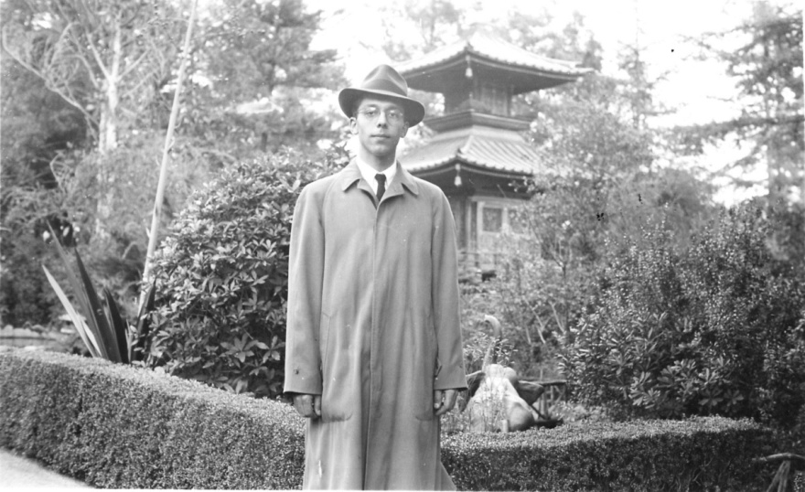 | Dec 1941  California
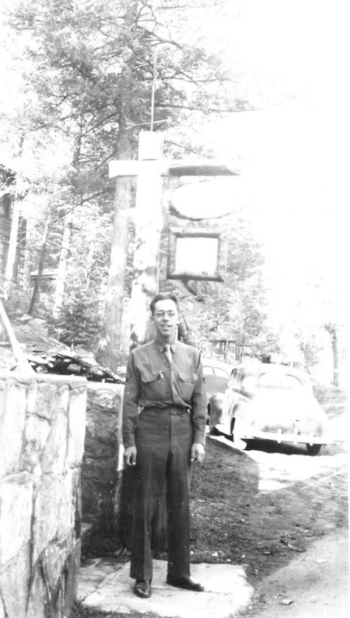 | April 1943  At Noisy Water Lodge, Ruidoso, NM
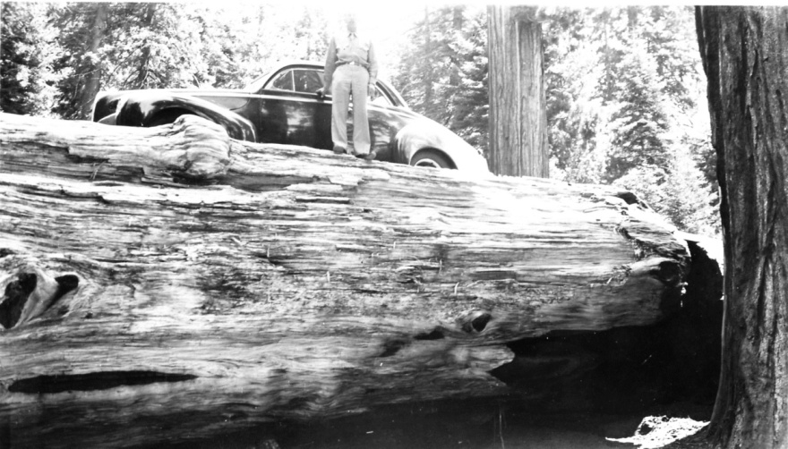 | May 1943  Car driven up on a giant log at Sequoia National Park
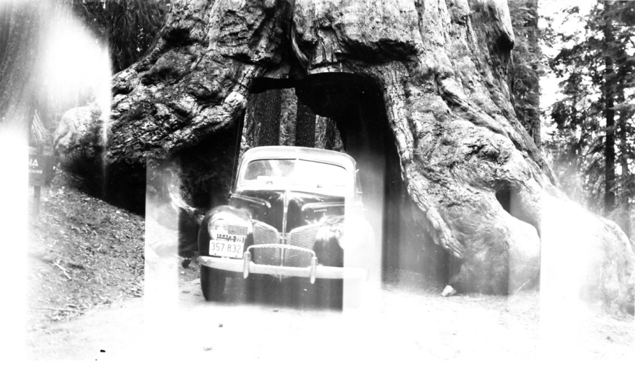 | May 30, 1943  Tunnel tree at Yosemite National Park

