THIS SERIES OF PHOTOGRAPHS TAKEN IN JUNE 1973

PHOTOGRAPH NUMBER (1) - 7848 Cornell Ave., University City. The home William N. and Vivian M. Halliday, parents of Jean Halliday, from 1933 to June 1942. Jean was in 6th Grade when her family moved there and student in Junior High School when her family moved to 1834 Kentucky, Quincy, Illinois in 1938.

PHOTOGRAPH NUMBER (2) - 731 Radcliffe., University City. The home of Vu/lam J. and Emma L. Baggerman, parents of William F. Baggerman, from June 1922 until about 1960, when the house was said and an apartment taken at Frontenac Apartments. It was the home of William F. Baggerman until marriage in 1951. This was the family home after moving from 4238 Russell Ave., St. Louis. W F B was about 9 years old when moving to this home. Attended nearby Delmar School until 6th grade, then John Burroughs School. Grew up here as a boy. It was a good place to live. Beyond Yale Ave. it was all open fields and the later spoiled River Desperes was a clean enough stream for us to fish and catch muskrats. The frequent Saturday fun for my brother Fred and I was to take our beagle, "Sport" and go hiking to "chase" rabbits.

PHOTOGRAPH NUMBER (3) - 9090 WEST SWAN CIRCLE, BRENTWOOD, MO. The part-time apartment home of William F. and Jean Baggerman. Rented this apartment from 1957 to 1962. It would have been necessary for us to send the children to the school in Augusta, MO. where we had been living the year around, so we rented this apartment when Anne was to start kindergarten and stayed here during the school terms. We usually went out to the Augusta farm in weekends. We were living in this apartment when Robert was born. That evening we had tickets for the performance of the "Scots Guards" at Kiel Auditorium. Just as the program ended Jean suddenly believed that the birth was near and I took her directly to St. Louis Maternity Hospital. Bob was born about 2 a.m. the next morning, October 20th. Anne attended her kindergarten year at the nearby school. Jim started junior kindergarten at Community School while we lived here.

PHOTOGRAPH NUMBER (4) - 4238 RUSSELL AVE., ST. LOUIS, MO. The home of William J. and Emma L. Baggerman from the date of their marriage until June 1922. William and Frederick Baggerman were born here and according to Mother we were born in the front bedroom, with the bay window, on the second floor. The Moore family lived next door on the east. Mr. Moore was then a Justice of the Peace. His son, Norman, was several years older than I, and I remember going out with him to tack up political posters for his father's campaign. I attended Bryan Mullamphy School on Shaw Ave. while we lived here. My weekly allowance was one penny and we owned an early model automobile, a "Dorris", it was manufactured in St. Louis.

PHOTOGRAPH NUMBER (5) - 2236 St. Louis Ave., St. Louis, The home of F. H. and Eliza Peters, who were the parents of Emma Louise (Peters) Baggerman, the mother of William F. Baggerman. This became the Peters family home after they moved from quarters above Peters Dry Goods Co. on 14th and Warren Streets. Events that took place here are deep in my memory. The event I remember most in detail were the Christmas gatherings of the family. Each would get a stocking and I believe when the group was the largest about 55 stockings were hung on the special mantel. Aunt Martha (Peters) Urbach who was a widow and lived here was a beautiful and vivacious woman and did much to create a spirit of fun and family bond. In earlier years those of us who were younger received five or ten-dollar gold coins as gifts from Grandpa Peters. We were reminded too that bad children might get coal in their stocking. There was always a jolly Santa, who really looked the part, we learned in later years that the part was taken by the faithful family chauffeur, Harry Volgt. There were always lots of homemade German cookies, such as the tooth breaking "Springalies". Grandpa Peters had a deep interest in the church to which he belonged, first the "First German Presbyterian Church" and later continued as "Sidney Street Presbyterian Church". Visiting ministers were never without home here and I remember meeting them when I visited as a boy. I also remember being at the house at the time after the death of Grandpa Peters in I believe 1922. His body lay in state in the living room and with my older cousin, Walter Urbach I spoke to persons as they cc-me in to pay their last respects. Grandpa seemed somewhat formal to me, but he was not that way in the extent of his help to others. it was wide and unknown to even close members of his family. Many persons seemed to come in from the street that we did not know, so well was he regarded in the area. I. especially remember a raggedly dressed brother and sister, probably younger than I, who kneeled before the coffin. In later years Aunt Martha, with I thought a great deal of courage lived alone in the large house.

THE OLD FIRST GERMAN PRESBYTERIAN CHURCH, PHOTOGRAPH 6) at 10th and Rutgers Streets, St. Louis, MO. This church was probably the most important Influence In the life of my mother, Emma (Peters) Baggerman and her parents Mr. and Mrs. F. H. (and Eliza) Peters. Grandpa was the ninth member of the congregation. My mother told how she walked from their home on 14th and Warren to attend events such as teaching Sunday School and a sewing class. The devotion of the founding members was great and to get the money for the building went without butter for their bread where needed to increase their contributions. Mother’s favorite stories about the church centered about the "pumper" organ. No electricity was then used and the person who worked the bellows by hand had to follow the service closely so that the organist could play at the times needed--the most frequent difficulty was that of the pumper going to sleep, the sermons In German went on for well over an hour. In later years the congregation moved to Sidney and Minnesota, and the old church slowly declined as The Tenth Street Mission and passed to the Catholic Church and then to the Lutheran Church before falling into disuse.

Written by: W. F. Baggerman

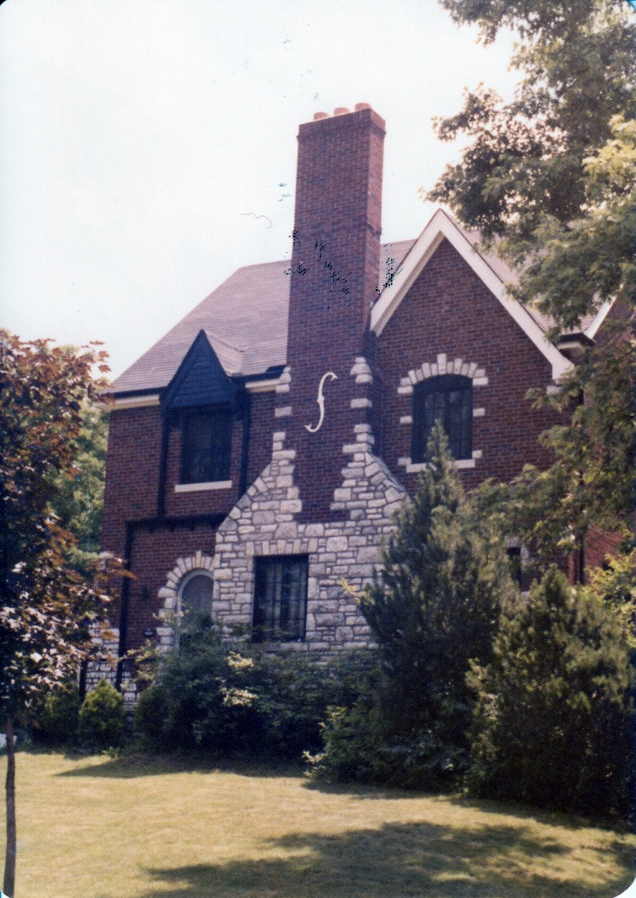

Photograph 1

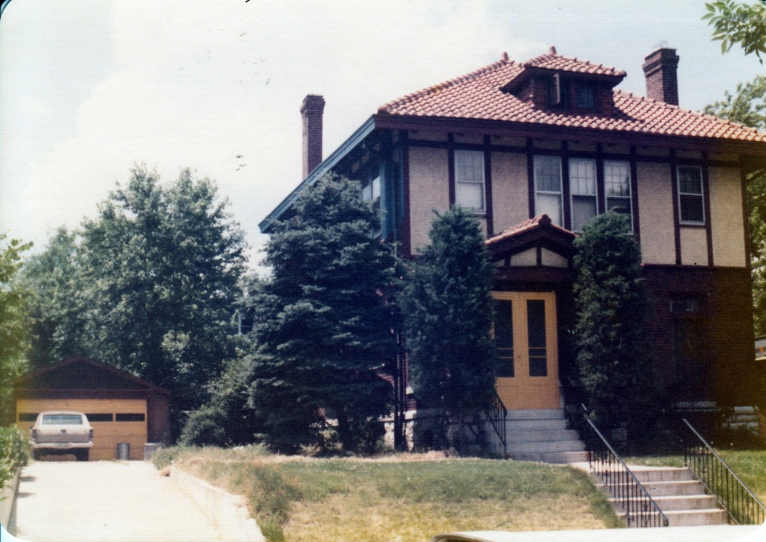

Photograph 2

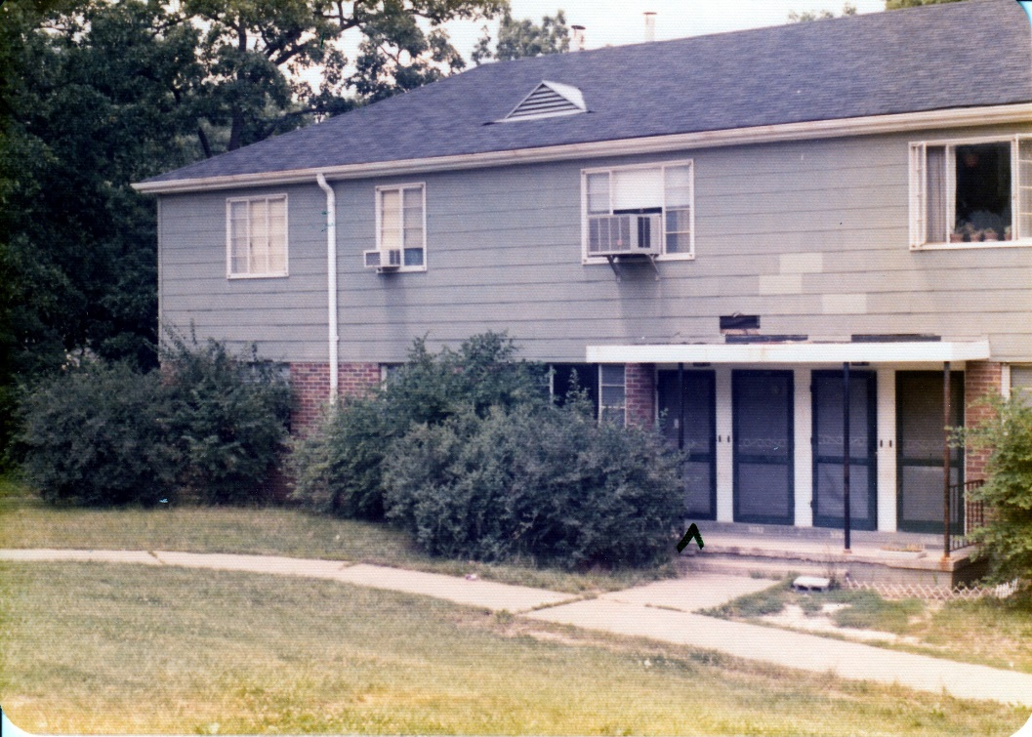

Photograph 3

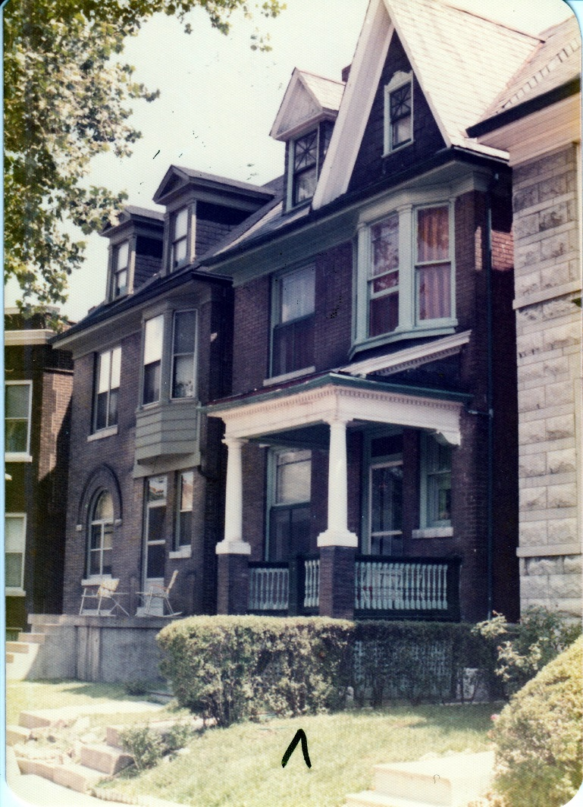

Photograph 4

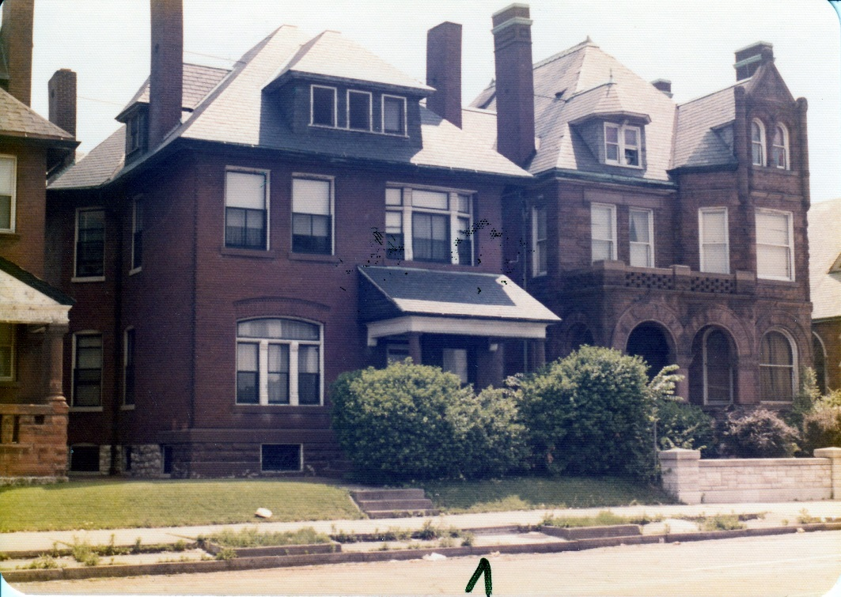

Photograph 5

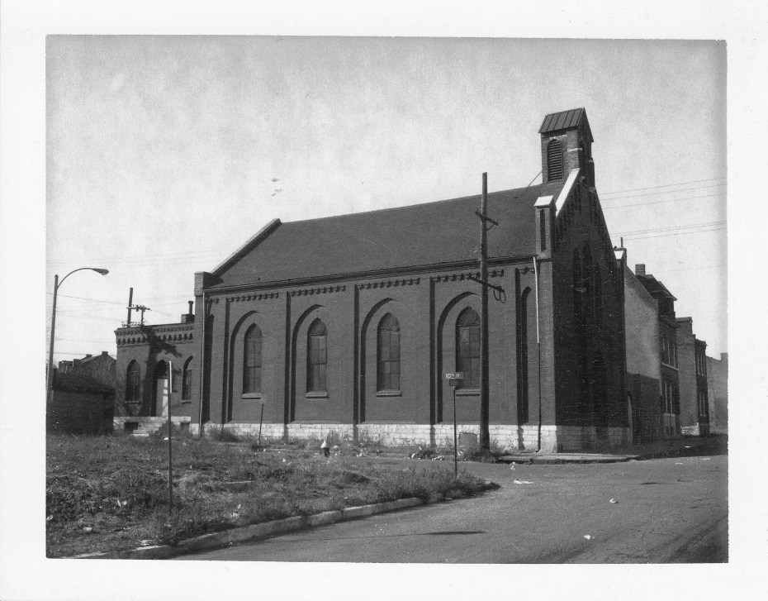

Photograph 6

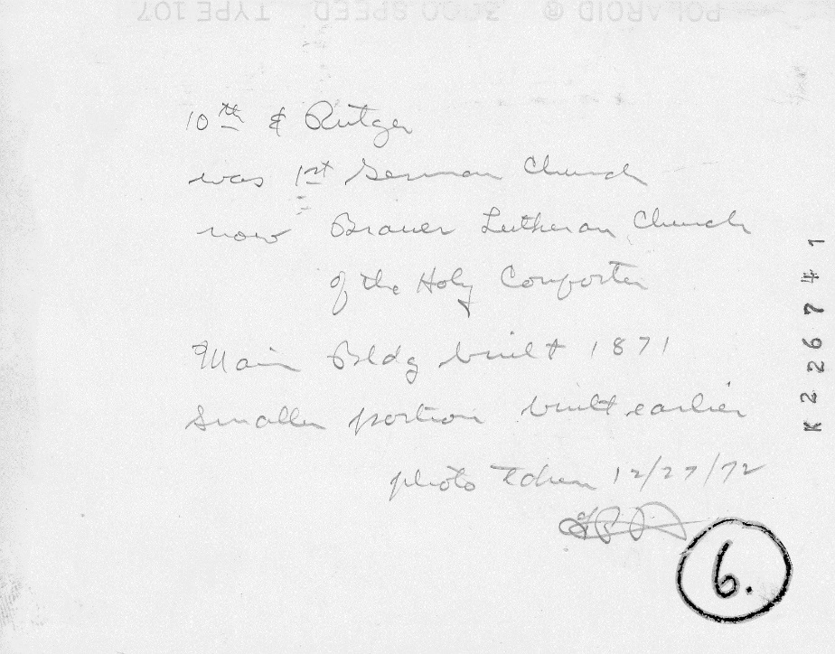

Photograph 6 (back)