Military Photo Notes
William F. Baggerman

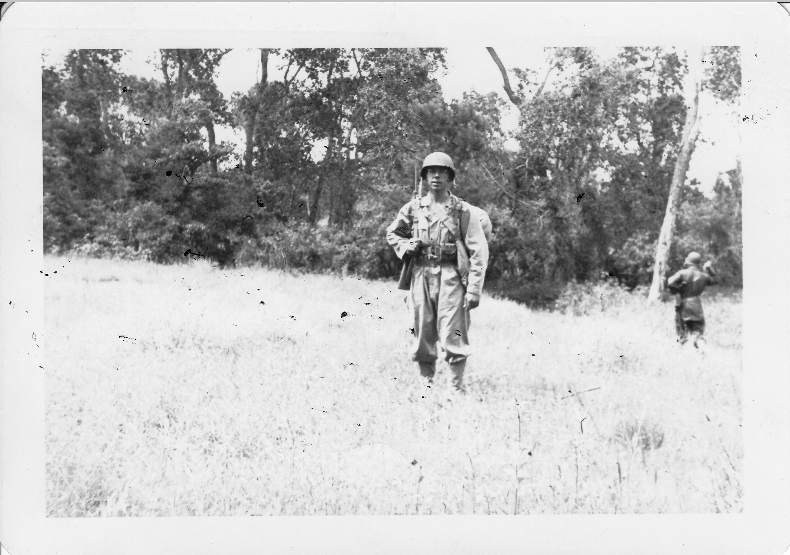 | Colorado Springs, CO  July 1944  Full 45 pound field equipment including steel helmet, gas mask, carbine, web belt, field bag, and blanket roll, etc.
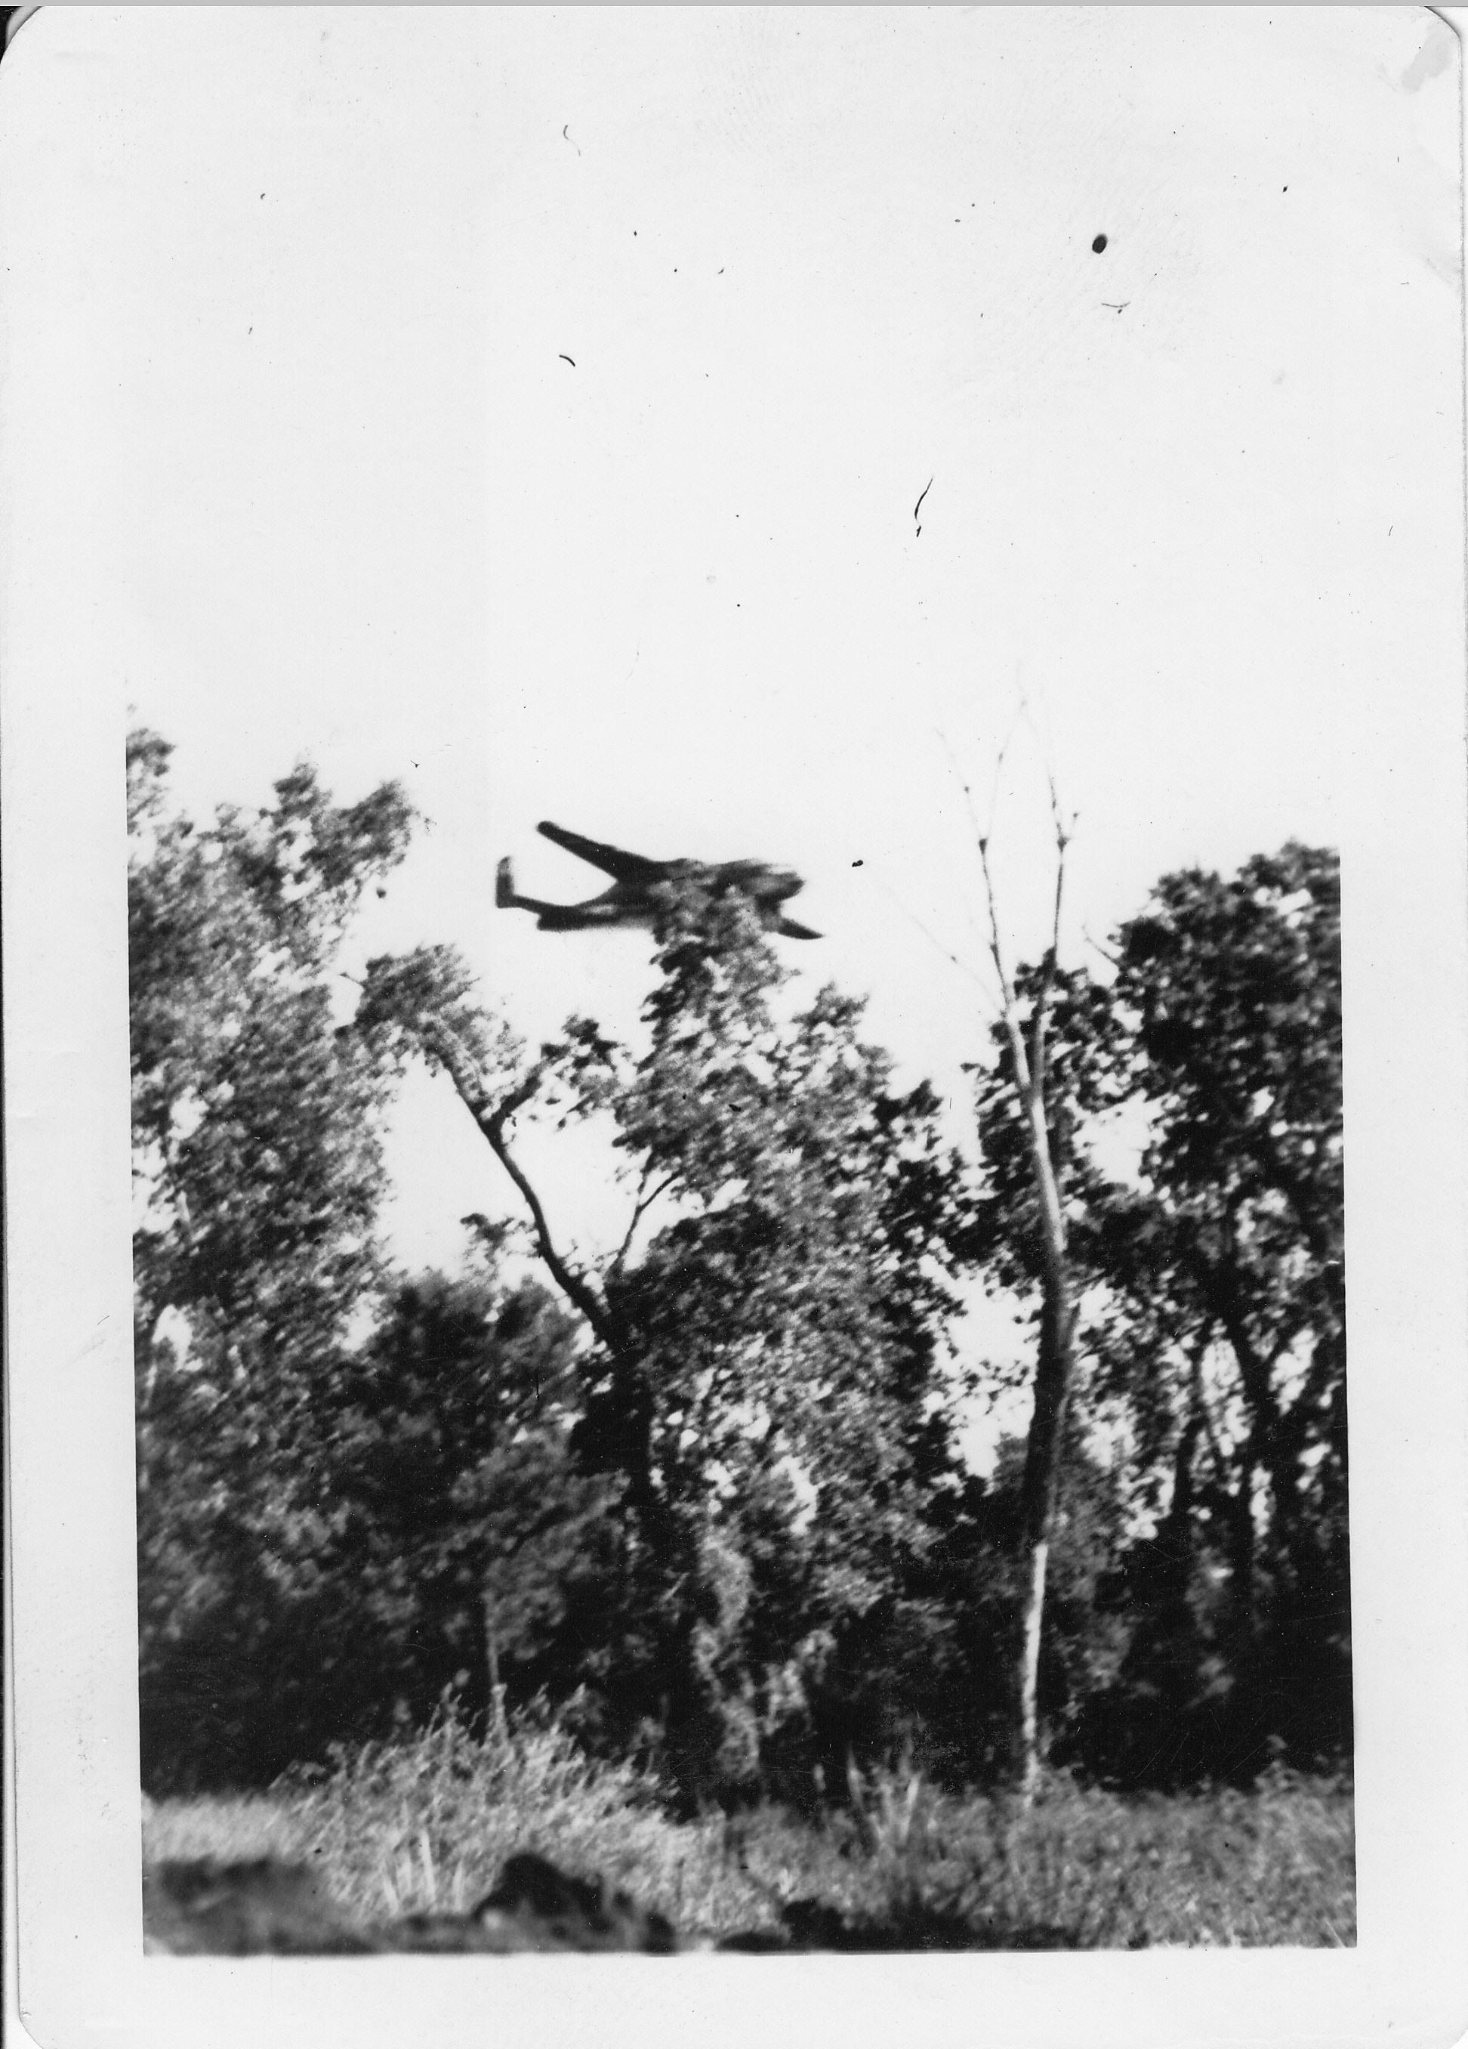 | Colorado Springs, CO  July 1944  Simulated air attack by a B-25 flying about 250 MPH at tree top height and dropping paper flour sack bombs
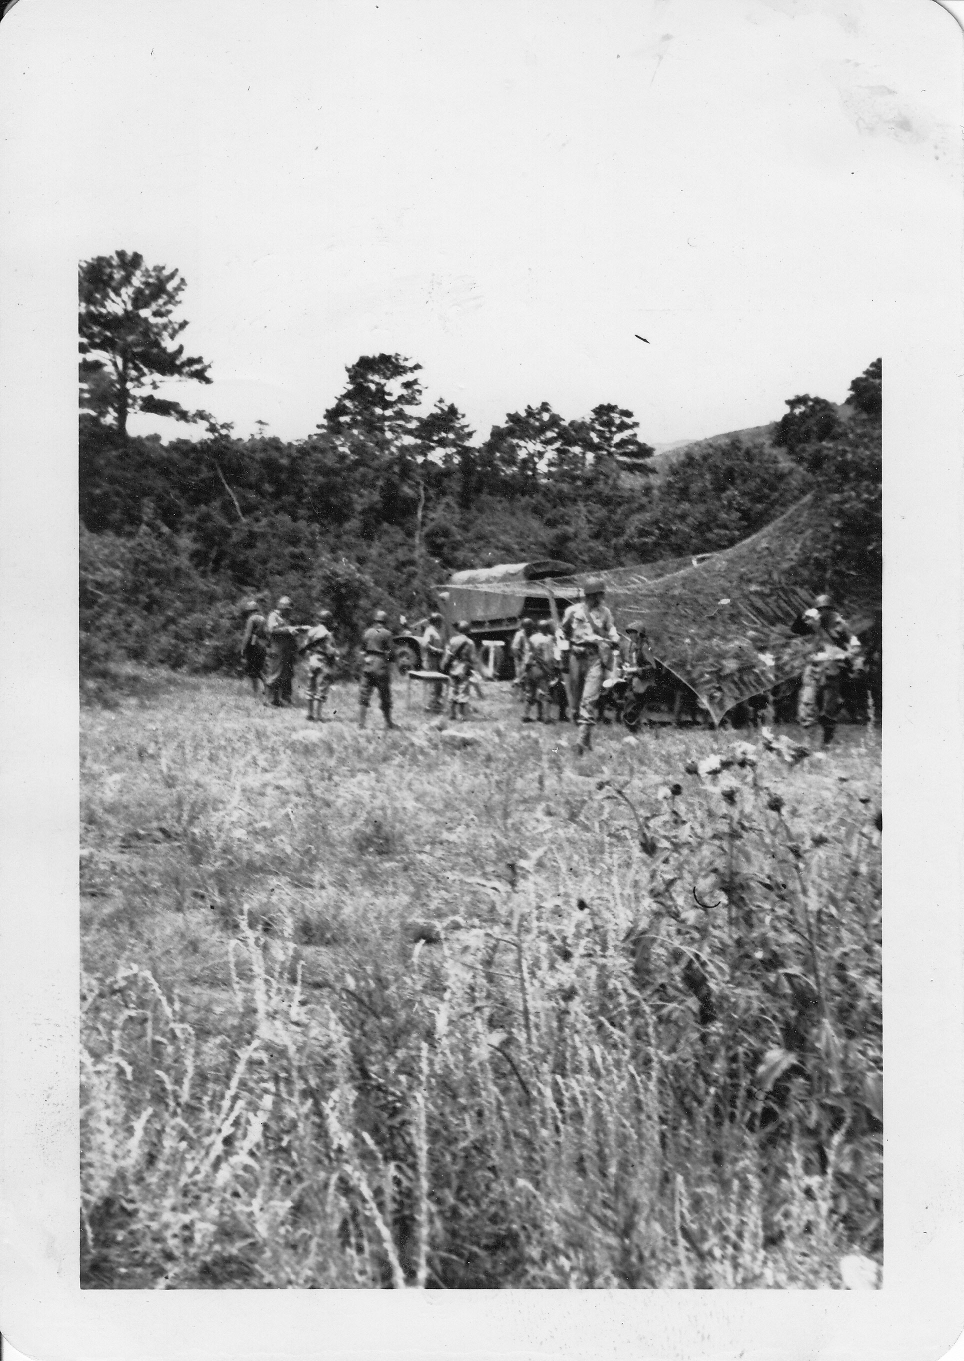 | Colorado Springs, CO  July 1944  Mess area, serving tables hidden under camouflage net.
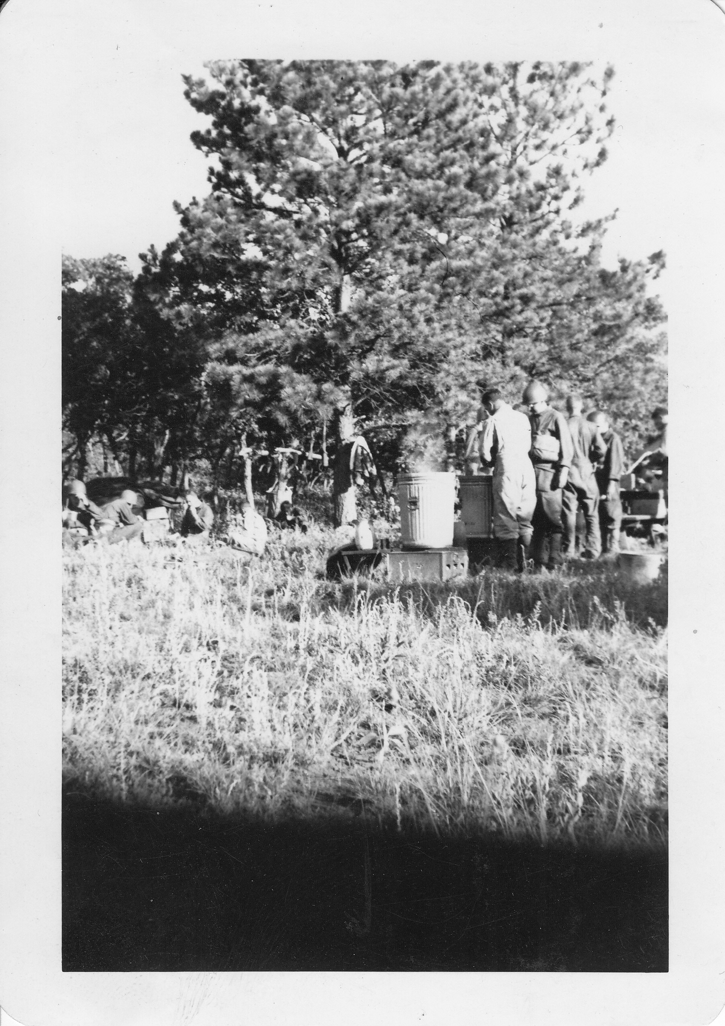 | Colorado Springs, CO  July 1944  Cleaning mess gear in boiling water after chow. Stoves are new smokeless gasoline type.
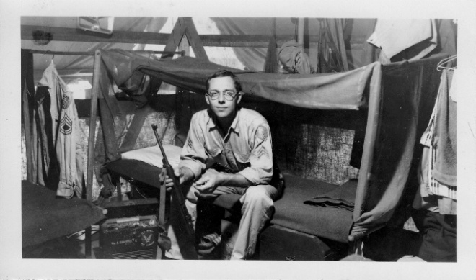 | WFB in our tent on Guam
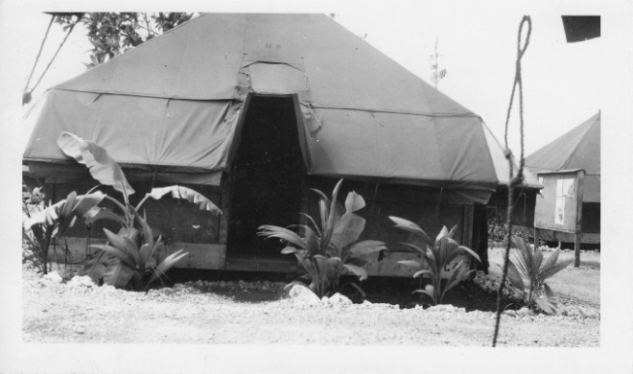 | Our tent on Guam
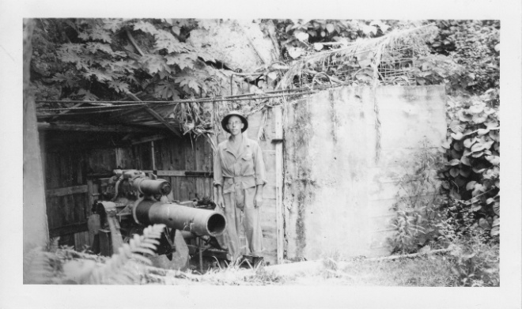 | 1944  Jap gun emplacement just below our camp (XXI Bomber Camp) on Guam
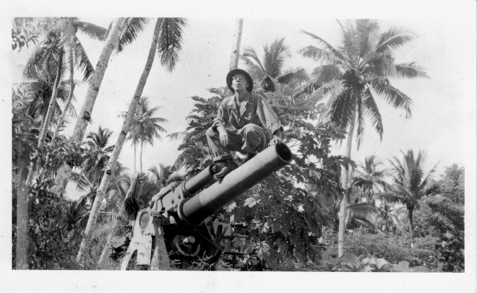 | 1944  Jap gun emplacement just below our camp on Guam.
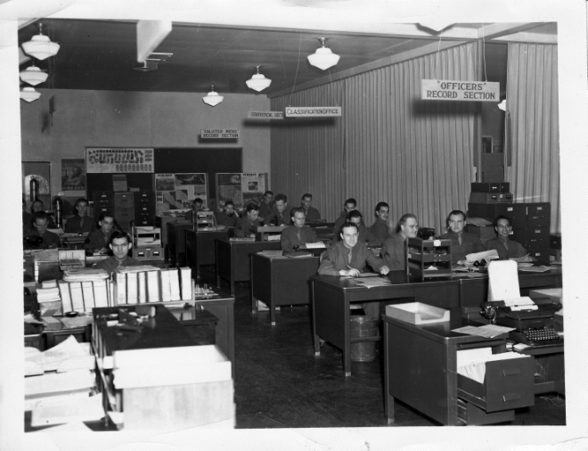 | 10 Feb 1944  Base S-1 Office, Army Air Base, Salt Lake City, Utah
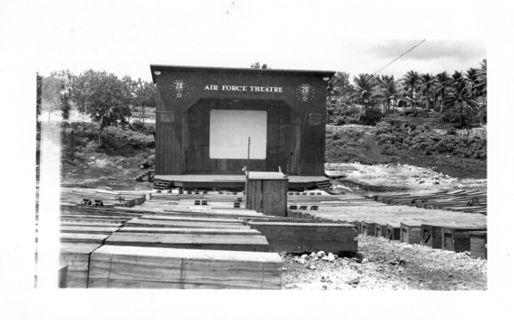 | Our movie screen on Guam. The seats were boxes that held the 500 pound fire bombs that burned Tokyo.
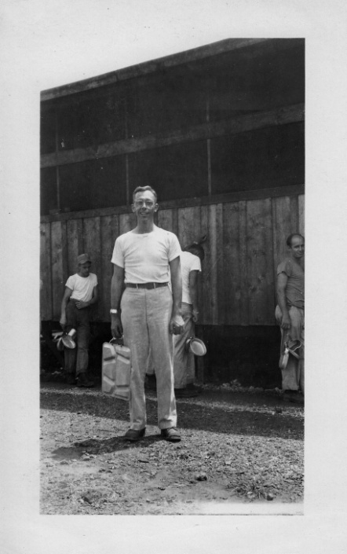 | Mess hall at Guam
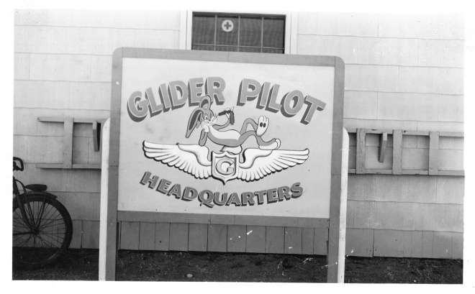 | March 1943  “Bugs Bunny” the reclining rabbit insignia of the glider pilots at R.A.F.S., Roswell, NM.
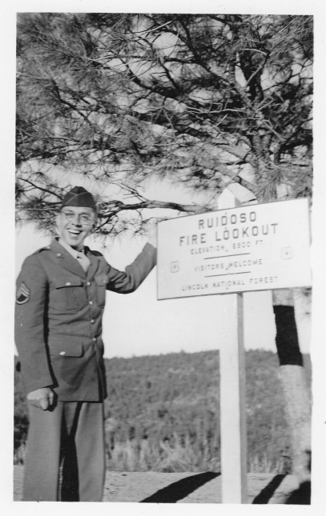 | March 1943  At fire look-out tower at Ruidoso, NM.
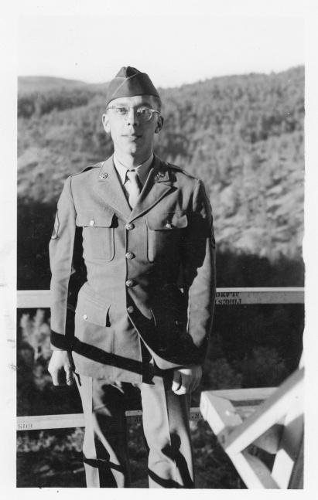 | March 1943  On fire look-out tower at Ruidoso, NM.
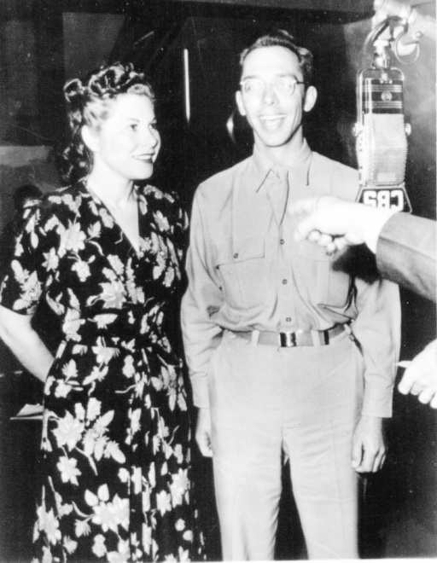 | 1944  Taken with “Beverly the Reveille Girl” while training as a glider pilot in Twenty Nine Palms, CA. This was take in CBS Studios in Hollywood.

