**Enlistment**

First photo after enlistment on 2/2/1942. This was taken at Jefferson Barracks near St. Louis. This was taken in front of my dad’s Packard car. I was soon sent to Sheppard Field, Fiel, Texas (near Wichita Falls, TX) for recruit training. I ended my service in the Headquarters, Twentieth Air Force, Guam and was sent back to California and discharged about the first week of August, 1944.

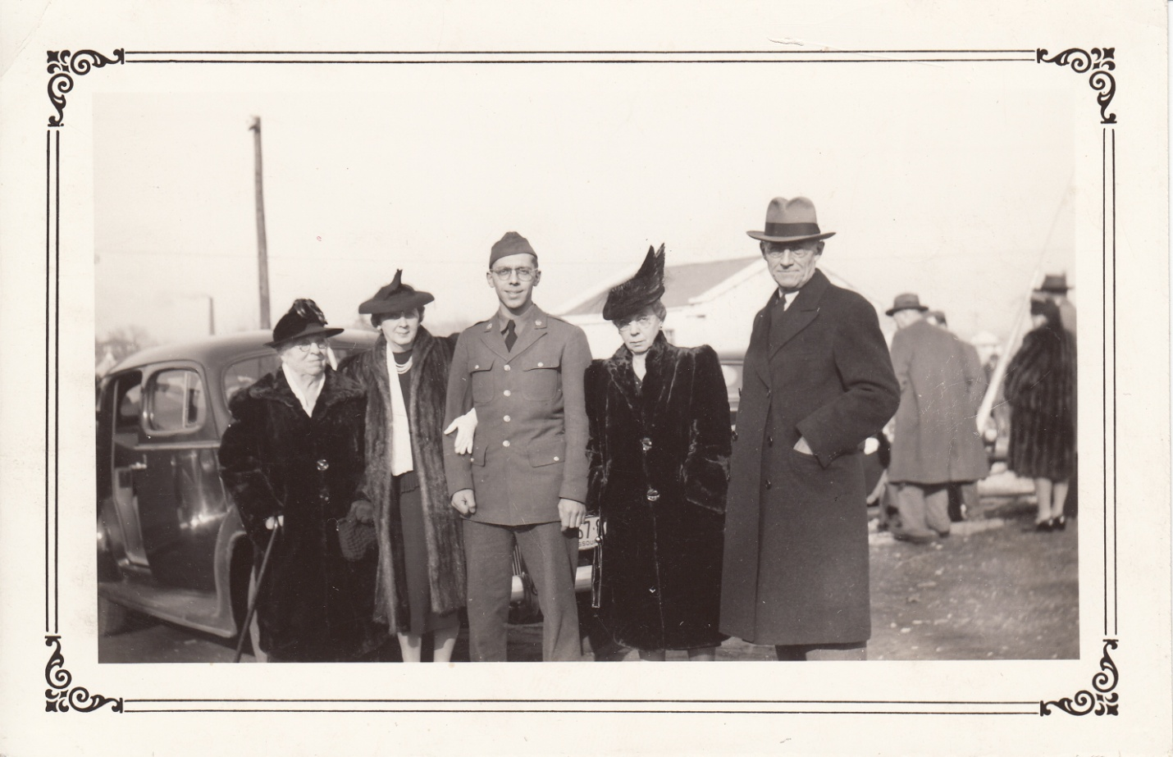

Left to right:

Nellie Baggerman

Martha Urback

WFB

Emma Baggerman

Wm. J. Baggerman

