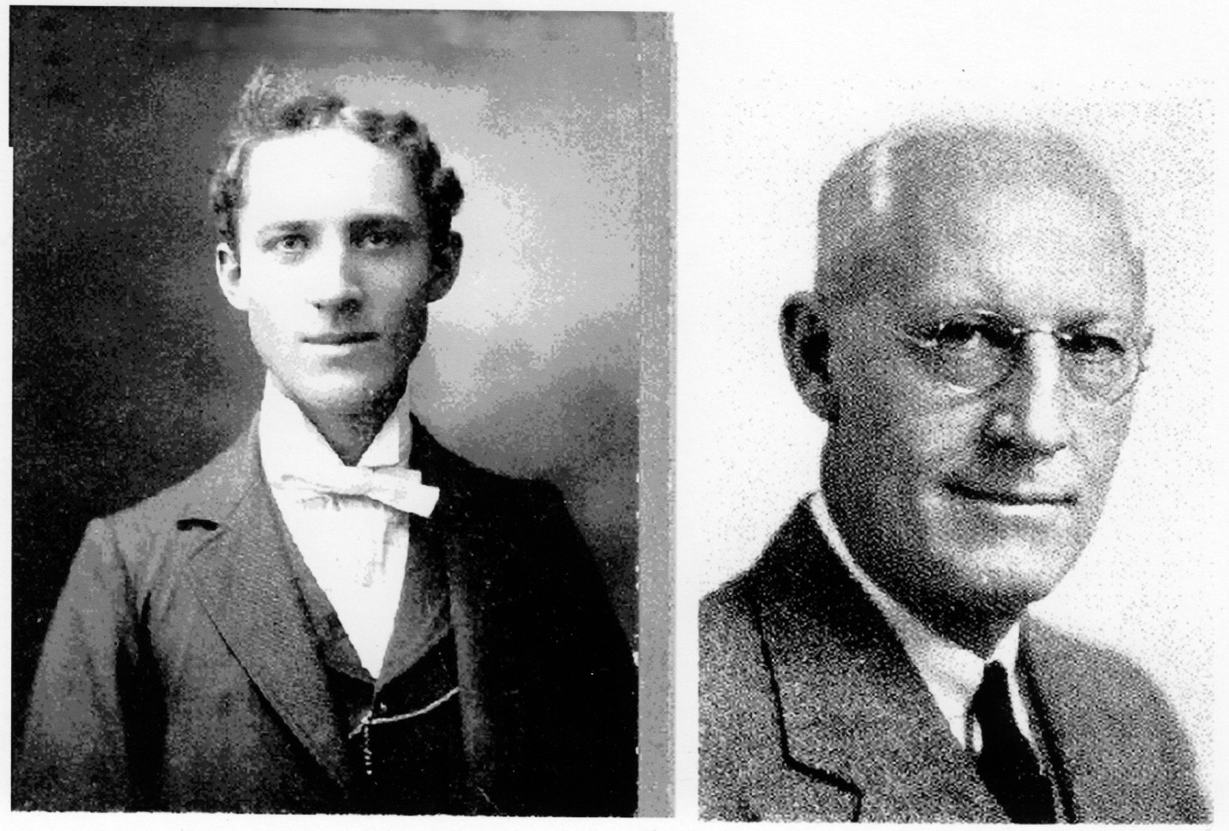

Photographs of William John Baggerman, husband of Emma Louise Baggerman (nee Peters), children were William Francis and Frederick Peters Baggerman. WJB was born October 20, 1873, probably near Alton, Illinois. His parents were Jon Baggerman and Nellie Baggerman (nee Hoekstra). Both were born in The Netherlands, in the Friesland area, near Leurwarden. The grandparents lived on a rented farm near Bethalto, Illinois. WJB had a sister Yetta. At an early age she contracted scarlet fever and was deafened and never married. Even with her deafness she attained the position as a supervising teacher in the Oklahoma school for the Deaf, in Sulfur, Oklahoma. Jon B traveled to Holland as a young man and while on return, shipboard, contracted typhoid fever and died in Johnstown, Pennsylvania.

ADDITION: Nellie B had to leave the farm, and moved to a flat on 12th Street in St Louis. She made a meager living as a seamstress. At age fourteen, WJB secured a job as an office boy at Gauss-Langenberg Hat Company. The company manufactured men's hats. He attended Benton Law College, a night law school. He graduated (probably when the left photograph was taken). WJB continued working for the hat company as attorney. Before retirement he became the largest stockholder other than Langenberg family members. After retirement he became a company director. He guided the company through a major reorganization, coincident with the 1930's depression. For many years he served as an elder of the Sidney Street Presbyterian Church, later to become co-chairman of the building committee of the large new edifice, which became Peters Memorial Church. As a once-farm boy he always enjoyed rabbit hunting and once shot a deer. Later the family moved to 1618 Knapp Street and I believe WJB attended nearby Blair school. lt was near the YMCA on St. Louis Avenue. Is my supposition that my mother and father met at this YMCA. The first owned family home was at 4238 Russell Avenue , St Louis and the two sons were born at this location. The next family home was at731 Radcliffe Avenue , University City. After retirement his business interest turned to real estate investment and at one time owned the Howard Apartments, 5617 Clemens Avenue and then with courage in 1934, during the depression, bought the then Garden Court Apartments at 5328-30-32 Delmar Boulevard, St. Louis. William John Baggerman passed away at the age of 89 and is buried in the family plot at oak Grove cemetery, St. Louis County.

Written by Wm F Baggerman (11/18/01)