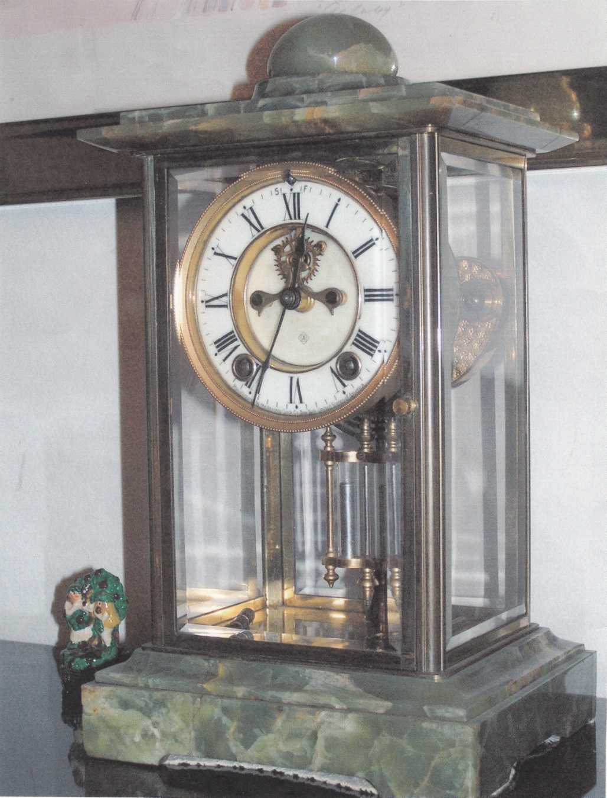

Manufactured by the Ansonia Clock Company, New York

Written by Wm. F. Baggerman April 15, 1999

The attached picture was made of a clock now in place in the living room of our home (note: now with Bob Baggerman, 2017) at 3814 Ballantrae Drive Sarasota. This clock originally was a wedding present to my parents William J. Baggerman and Emma Baggerman (nee Emma Louise Peters). My parents were married at the home of my grandparents Peters at 2236 St. Louis Avenue, St. Louis MO. The clock was the give from H W Peters on the wedding of my parents (in 1912).