MY AIRCRAFT

Curtis Robin

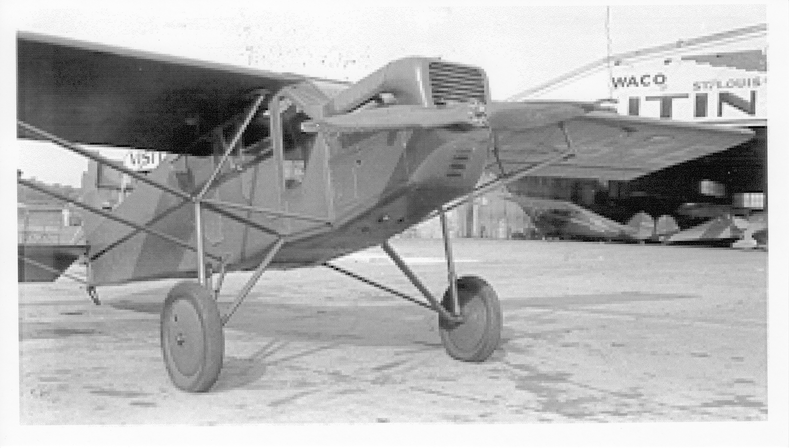This was my OX-5 "Robin". It was built in St Louis on the factory edge of the airport. The aircraft was good, but the engine was terrible. It had a World War I 65 hp water cooled engine. I was careful not to fly it very far from the airport. I had it in the late 1930's. ①

This is a photograph of the Curtis Robin airplane. It was built by the Robertson Aircraft Co. in St. Louis MO. I owned and flew this airplane in the mid-1930s. The airplane had an OX-5 engine and was a World War I engine it was a V8 water cooled engine and was usually installed in the so-called Jenny training airplane. The engine was very undependable and I had several forced landings while flying it. ②

Nicholas-Beasley NB-3

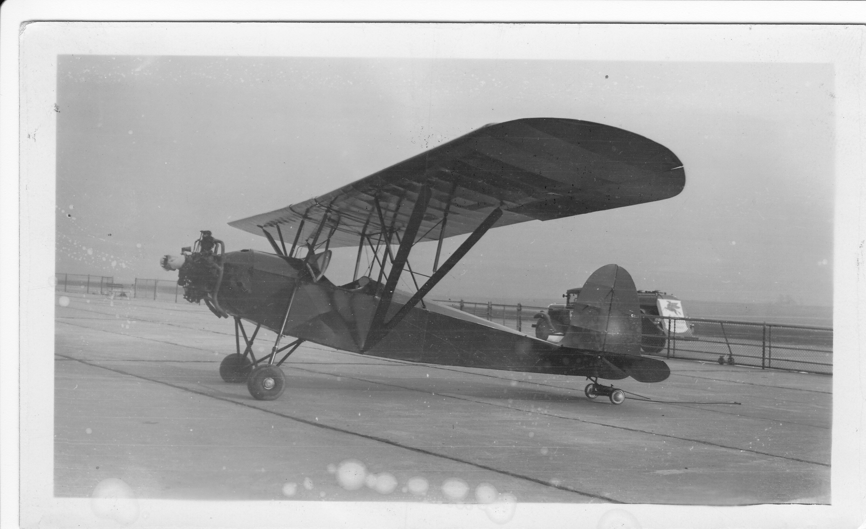

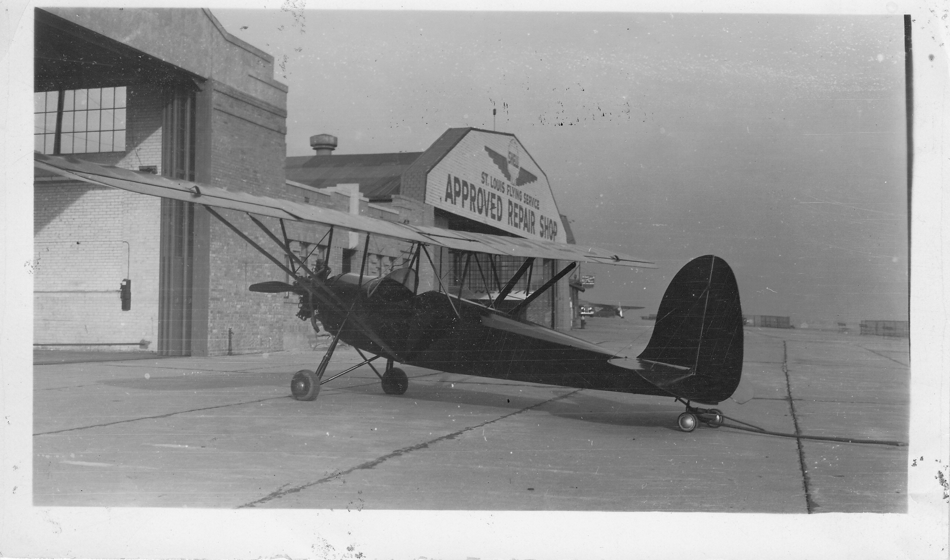

This is a Nicholas-Beasley model NB-3. It was made in Missouri, probably in Fulton. I don't know why I bought it. Its flying characteristics were bad. To climb it I had to put the nose up about 45 degrees. It took only one bolt on each wing panel and each of the panels. You could bolt them to the wing and to a car -- one winter I stored it in the Garage on Radcliffe. ①

Buhl “Bull Pup”

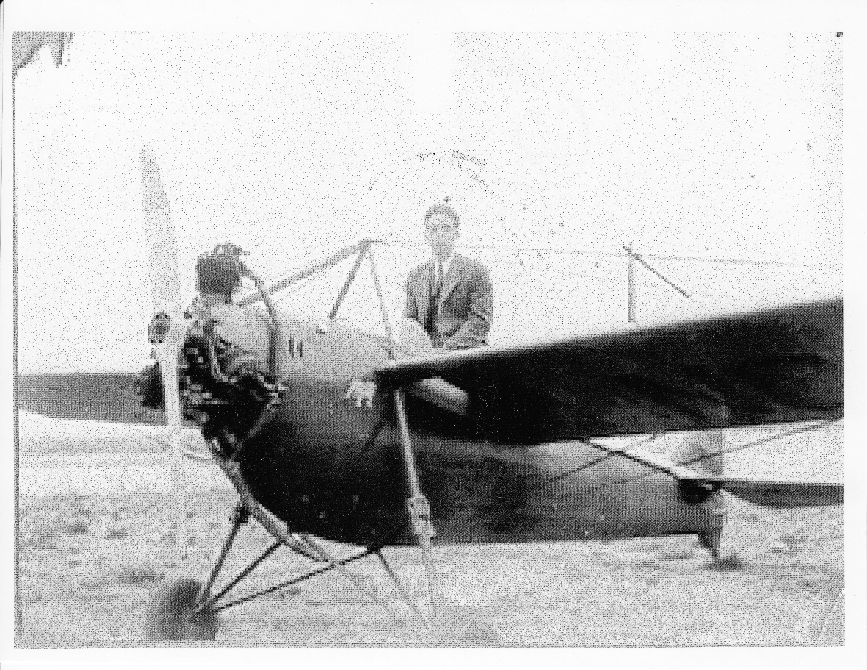
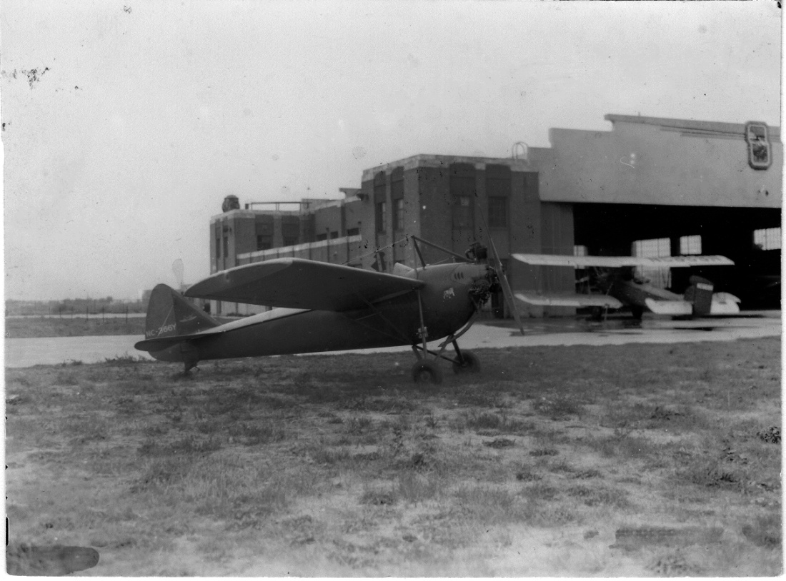

This was my Buhl "Bull-Pup". I don't deserve to be alive after owning and flying it - there were at least three incident in which I should have been killed. I tried to test spin it once. The spin became so tight I couldn’t stop it and I tried to jump with my parachute. The spin was so tight that I could not jump. In a couple of minutes it cleared itself. "Number Two" I took off for Lake Geneva, WI to visit my folks. I got lost and began following trucks along the highway. That kept on the right route, but I ran low on gas. I had two gallons of gas. Seeing a Tri-Motor Ford hopping sight seer I landed in the field. I landed alright, but the field was too rough for my little plane and it slowed my take-off speed, so that by only inches I cleared the fence at the end of the runway. ①

This airplane was known as the Buhl "Bull Pup". I also owned and flew this airplane in the mid
1930s. It was very unsafe and dangerous airplane to fly. I had one forced landing because of a broken rocker arm on the engine and another time I came within seconds of a fatal crash. I tried to spin the airplane and it would not come out the spin and I was unable to get out with my parachute because it was spinning so tightly. I also had a humorous experience in flying this airplane to Lake Geneva Wisconsin to visit my folks at a resort. The engine had only 45 hp and in any kind of wind it was almost impossible gain ground speed. During the period on this trip I was following the trucks on the highway and they were passing because I had a slight head wind. ②

WW II Glider Training

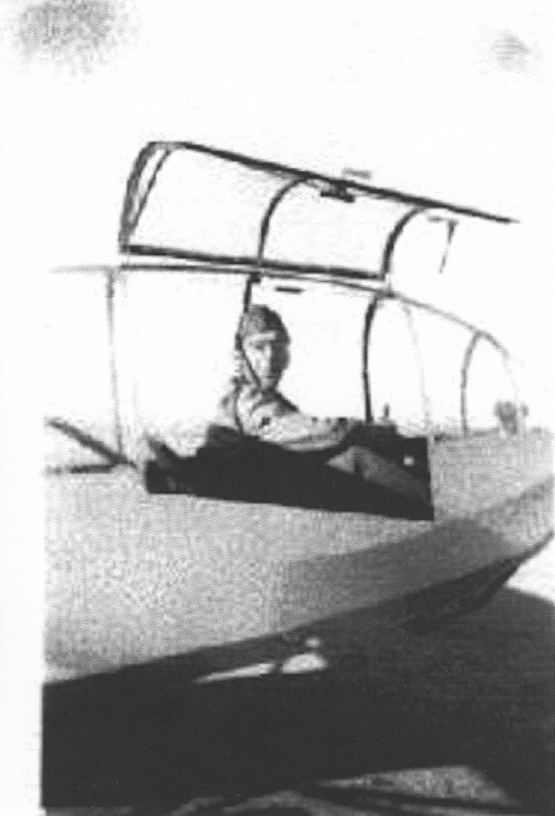

This was the glider I flew for basic training. The field was near 29 Palms, CA a desert location. An airplane would tow us up several thousand feet and cut us loose for landings. This was not difficult flying. It was something else when the night flying began. We were towed aloft. There was no light on the tow plane, we were towed in V-formation with another glider without lights and there was a strong force pulling the two aircraft together. The landings were without lights, only several smudge-pot oil lamps along the runway. I passed all my flying, but just about this time the terrible glider crash happened in St Louis. All pilot requirements were increased and I did not pass the eye test. That was when I asked for over-seas duty and was sent to Guam for service in the Twentieth Air Force. ①

A high school classmate of mine flew for the "F1ying Tigers", and then later flew in the European Theater. In this operation and later went on to shoot down 28 German fighters. He received the Congressional Medal of Honor. After my 100 hours of glider pilot training, on my final physical I did not pass the eye test and was washed out. A good friend with whom I took my pilot training went on to combat. He flew in the two disastrous operations in Holland. He said they suffered 20 percent casualties. After my washout I volunteered for overseas service and ended up in the Twentieth Air Force on Guam. ③

Cessna 140

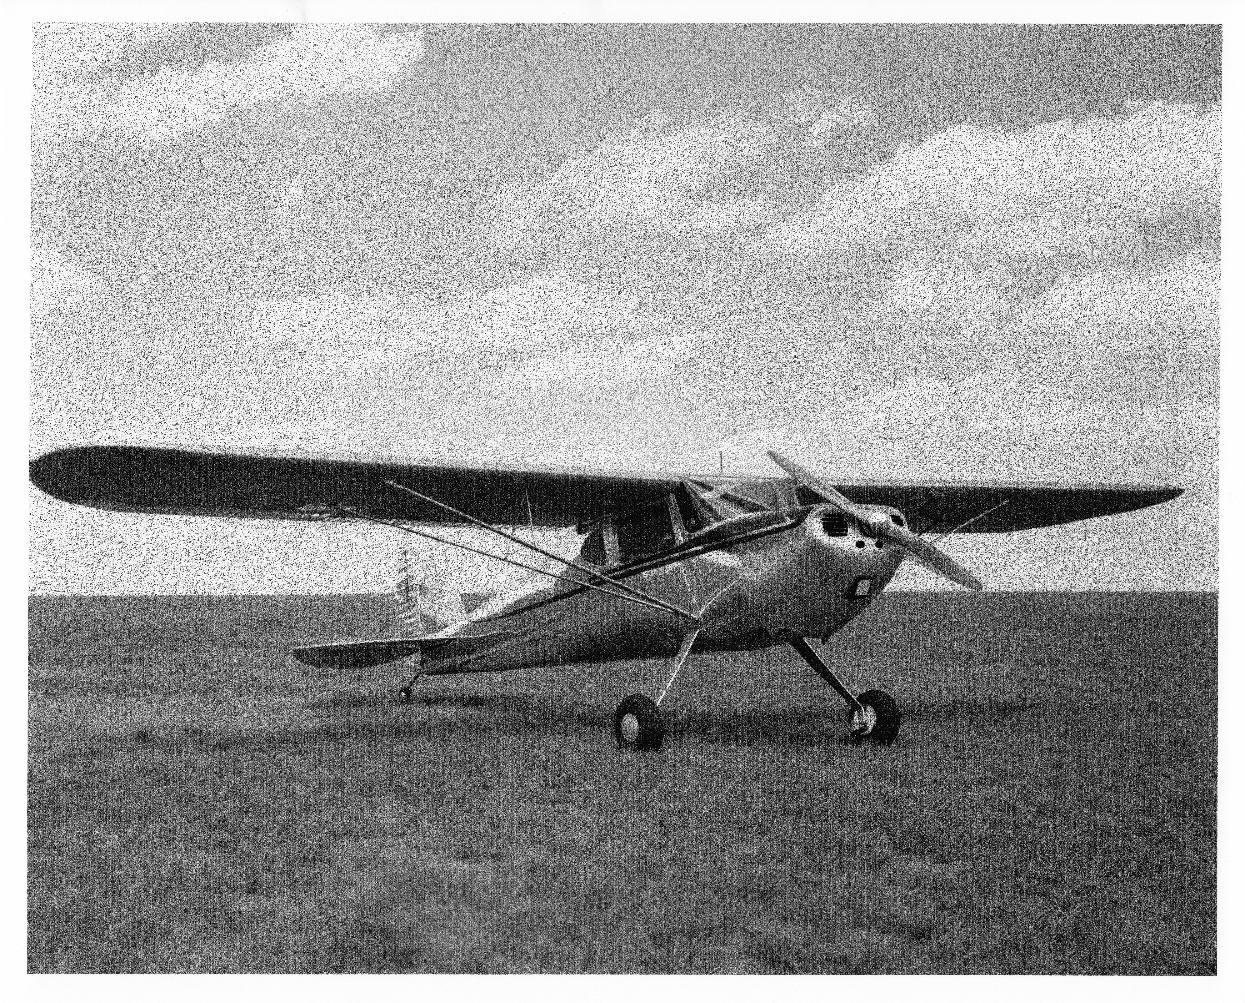

This is a photo of the Cessna 140, 1946 model. It was the best and only safe airplane that I owned. I bought it from Mercantile Bank, St. Louis. It was a "take-back" and I paid $1600 for it. It was a beautiful, like new. It had just about every accessory that the factory had to offer, including instrument flying equipment. ①

OX-5 Engine

This photograph is a photo of a scale model of the OX-5 engine. It is a tiny, but very accurate replica of the original size OX-5 engine it is an operating engine and sold for approximately $3800. These original engines were sold after World War I for probably less than hundred dollars. ②

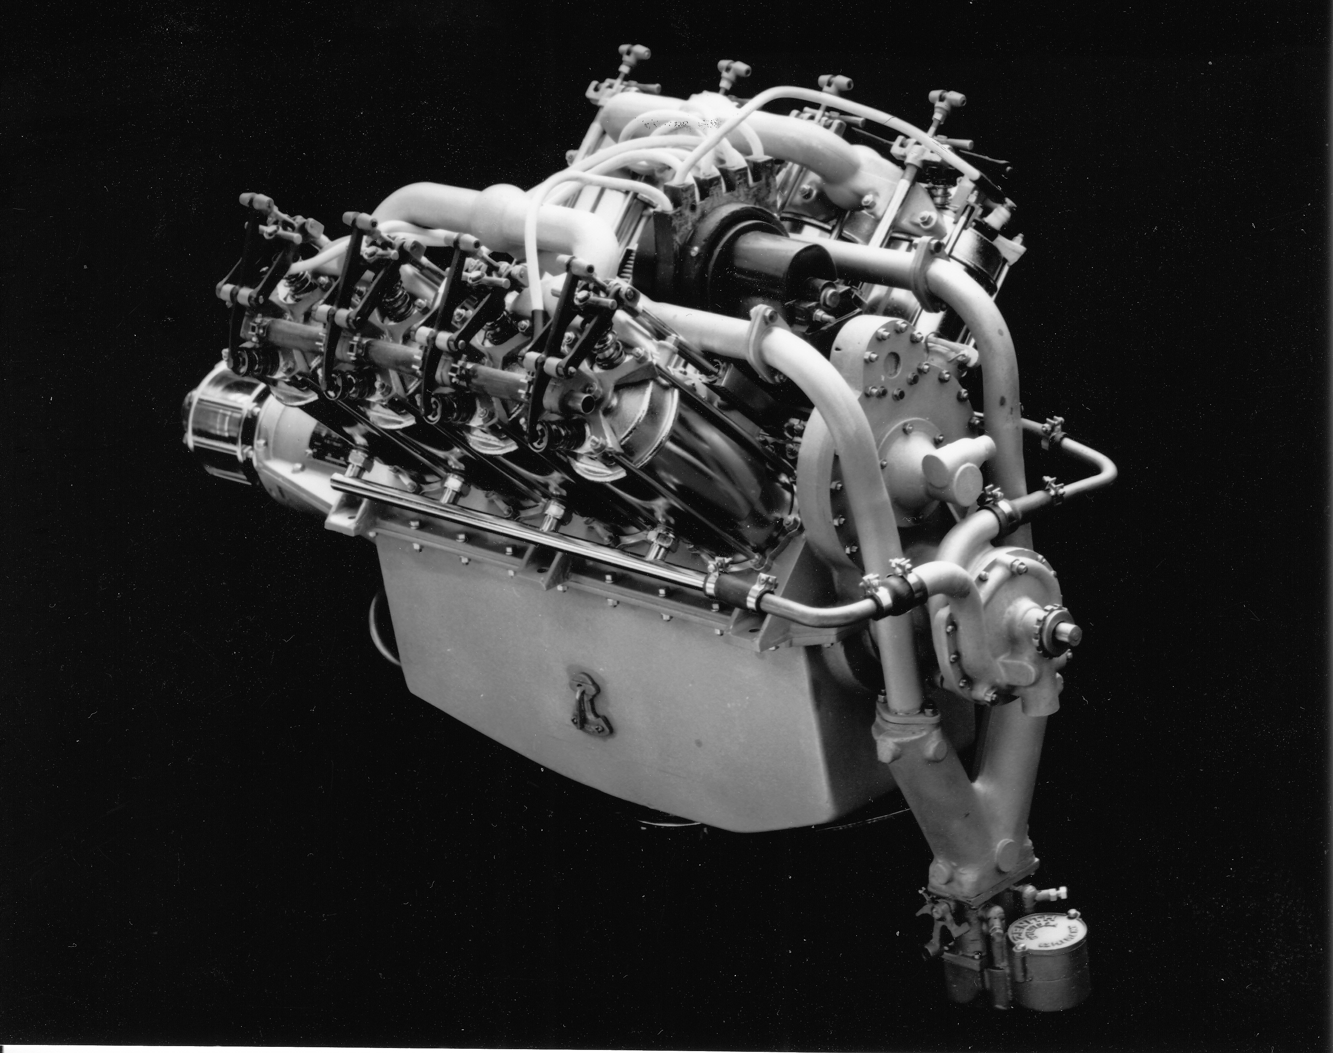

Licenses and Ratings

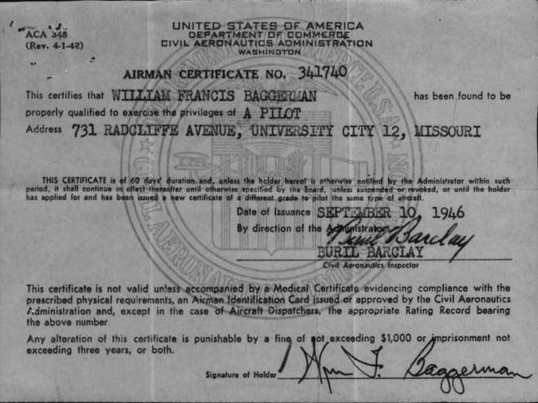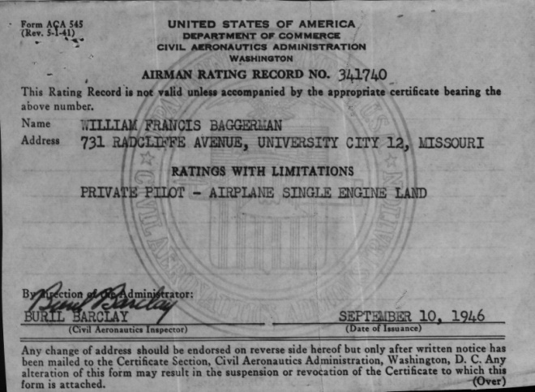

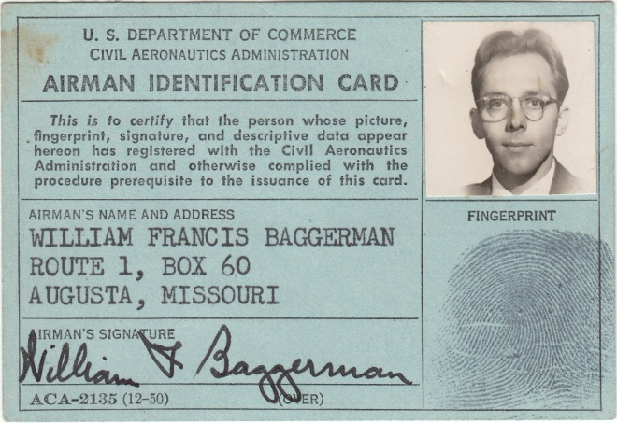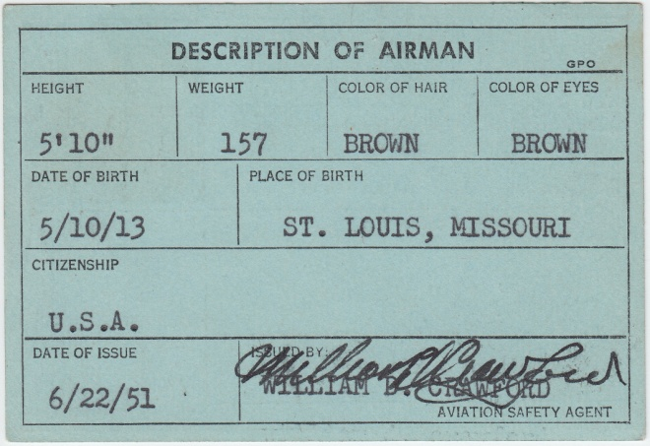

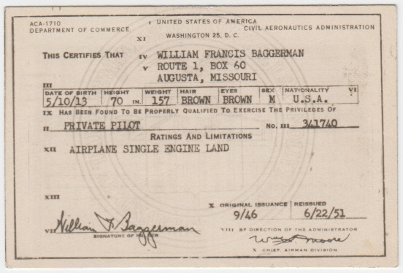

Notes:
① - Written 2/17/2003
② - Written 6/21/1999
③ - Written 2/12/2001

