John Holliday
A Forthright Man

“He was a forthright man,
who knew what he wanted,
and never hesitated to say it.

by
Clarence Halliday
November, 1962

Text retyped by Tom Carmody,
grandson of Elizabeth Maye Holliday
1997

Further edits by Bob Baggerman
son of Jean Hallliday
2016
Published 7/7/2016

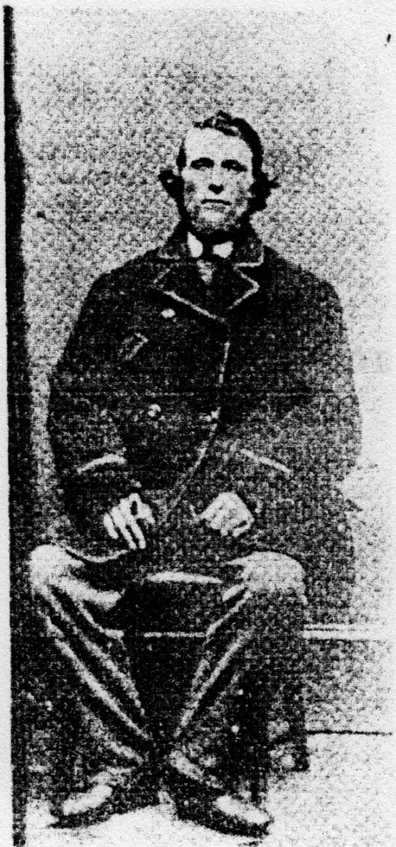

JOHN HOLLIDAY

TO
BRUCE

FORWARD
Writing this story of my great-grandfather has been a hobby of my retirement years. It makes no pretence to be important. John Holliday was not a national figure. Only his descendants - and not all of them - can be expected to have any interest in the story of his life. That story has, however, prompted an interest on my part in the Hallidays who are his descendants. Perhaps some day I may complete their family tree already begun and issue another booklet, a companion to this one.
I am indebted to many individuals without who help the story could not have been written. Chief among them are the descendants of the Scotch Line pioneers - the Hallidays and others. Since they are too numerous to list here, I hope they will collectively accept this expression of my thanks.
From four public institutions I received courteous treatment as I searched for relevant material. There were the Public Archives of Canada, Ottawa; Queen's University Library, Kingston, Ont.; the Burgh Museum and the Ewart Library, Dumfries, Scotland. To their respective curators my thanks are due.
A visit to Scotland was the most rewarding single effort. There I had the privilege of exploring Annandale and locating specific places associated with John Holliday's life in his native land. My success was largely due to the help generously given me by local residents. I cannot hope to repay them, I can only try to thank them. To Mr. and Mrs. William Orr, Boreland; Mr. and Mrs. J.H. Alexander, Corehead; the Rev. J.C. Lough and Rev. Geo. C. Campbell, parish ministers of Hutton and Moffat, respectively; the Rev. Adam Forman, Dumcrieff, and Major W.A.J. Prevost, historian of Dumcrieff, my indebtedness is great and my thanks sincere.
Finally, I wish to acknowledge the support I have had in this project from my son, Dr. Bruce Halliday. Not only was he an efficient chauffeur as we travelled the roads of Annandale and an invaluable colleague as we read the family records in library, church, or church-yard there, but he has maintained a continuing enthusiasm for the family history. It is only fitting that this story of his great-great-grandfather should be dedicated to him.
Cobourg, Ontario
November, 1962
Clarence Halliday

CONTENTS

Chapter Page
I. A Forthright Man 1
II. The Halliday Family 6
III. Early Life in Scotland 14
IV. Emigration 34
V. A New Life Begins 40
VI. Pioneering on the Scotch Line 50
VII. The Schoolmaster 62
VIII. His Religion 70
IX. The Family He Founded 78
Notes 83

Chapter One
A Forthright Man
Two kinds of immigrants came to Upper Canada from Britain.
One consisted of people in authority, exercising power directly or indirectly and expecting obedience. This group included the government officials, their authority coming from the Crown. These officials ranged from the Governor himself to the petty appointees in local areas. The latter were drawn largely from the commissioned or warrant officers of the discharged soldiery. In this group also were civilians who, by reason of their place in professional or business life, expected a measure of deference from the immigrant community. Usually people with authority lived in the towns and villages.
A much larger group in the pioneer society consisted of those commonly known as "the settlers". They were the immigrants hungry for land and the relative independence which ownership of Britain. Some of these were civilians, some discharged soldiers. They were a virile people. They were capable of unremitting toil, or enduring much hardship. Their eyes were set upon the day when the woods would have become farms and a cleared homestead would assure them the necessities of life. Freely accepting this as their role in the community, the majority conceded to "the officials" the particular role these latter had been assigned or had assumed.
But not all! For among these "settlers" in almost every community were a few who did not accept so readily the class distinctions subtly establishing themselves in the new world. They were at one with their fellow "settlers" in the struggle for daily living. They differed from the majority, however, in being less willing to receive without question the dictum of "the officials" in matters which would affect them vitally. Some of them may have had more formal education than their neighbours, yet seldom were they highly educated men. Most of them became the spokesmen for their group simply because of some personality characteristic. They were, naturally, singled out for criticism. Their moderate claims, no less than their more excessive demands, were often denied with strictures upon their persons rather than their requests. It was from this element that there ultimately arose many of the leaders who established representative democracy in the Canadas. They might even be considered a third group in any immigrant settlement and not an unimportant one.
John Holliday was one of these independent pioneers in the settlement of Perth.
It is difficult to discover an unbiased opinion of John Holliday's character. Most surviving descriptions of him were made by people in conflict with his opinions or his conduct. These may fairly be considered less than objective. To reach a fair conclusion about him one must take into consideration the person making the statement and the circumstances which called it forth, as also the degree of support his position was receiving from his peers.
John Holliday emerges as a man with strong convictions whether they were concerned with Church or State, a man determined to state these convictions openly and forthrightly, and ready to pursue a given course of action in the matter to the ultimate. In any such conflict of opinion there was no "sweet reasonableness" in this matter. Rather, there was a directness of speech which angered the other party. So that is could be described by a military official as "insubordination" or by his minister as "insolence."
The unfavourable characteristic implied in these descriptions of John Holliday's manner is modified by consideration of two or three concomitant factors. First, the settlement was being administered by half-pay army officers. Their idea of the "settler" - "official" relationship was that of the private-officer relationship in the army. In 1817 after a few months of life in Canada, Reverend William Bell, the Presbyterian minister at Perth, could write:"None but those who have felt it can understand what an aggressive and tyrannical course some of the underlings of Government in the colonies sometimes pursue towards those who are not inclined to fall down and worship them....Woe to the unhappy wight that dares to gainsay their mandates". (1)
Now, according to Andrew Haydon "John Holliday, like most of his companions, doubtless thought that saying good-bye to the old land meant a farewell also to a time and a country overwhelmed with military demands, and certainly sick of everything that savoured of war. Coming as a civilian settler, little wonder that he became restive under the military discipline" (2). Given these conflicting attitudes on the part of the administrator and the settler it is small wonder that a settler of John Holliday's temperament should react vigorously or that the administrator should consider such independence as "insubordination".
Another fact which modifies the unfavourable description of John Holliday's character is that most of the descriptive adjectives come from the Reverend William Bell. They include such uncomplimentary remarks as the following:
"It is natural to him to be insolent to everyone in authority in church or state." (3); "This bigot gave me much trouble." (4); "Mr. Holliday had for some time past discovered a very turbulent disposition." (5); "Mr. Holliday is an enemy to all improvement". (6)
On more than one occasion Mr. Bell included other settlers on the Scotch Line in similar criticism, as when he wrote:
"Some of (the Scotch settlers) were of a very factious and troublesome disposition". (7)
Mr. Bell's sharp comments appear to have been influenced by his concept of his own place in the community as a clergyman. He expected unquestioning acceptance of his rule in matters of faith, order and conduct, so that he could be described by his biographer as "a man muffled up in positive sureness" (8). This applied equally to the members of his own communion and, as he himself said, to "the half-pay officers (who) wished to enjoy the privileges of the Church though they neither submitted to its discipline, nor attended to the duties of religion" (9). Mr. Bell not only expected submission to his discipline, he was always severe, perhaps not even fair, in his assessment of any individual who refused to submit, who refused obedience to his dictum or questioned his ruling. And undoubtedly John Holliday was one such. Devotedly religious though he was, John Holliday was assuredly a non-conformist. As Senator Haydon put it, "If military establishments were not to his liking in 1815 (back in Scotland), ecclesiastical establishments, according to the practice of the time, brought even less cheer before many years passed over the settlement" (10). Mr. Bell's portrayal of John Holliday's character must certainly have been influenced by the latter's open criticism of the minister.
Over against these unfavourable descriptions of John Holliday are some facts of his life, recorded by disinterested parties, rather complimentary than otherwise. Before the emigrants left Scotland their departure was being organized by the government agent in Scotland, John Campbell. He reported to Henry Goulbourn, Under-Secretary of State for the Colonies, on June 28, 1815, "I beg to send the enclosed recommendation from Settlers whose children amount to 128 in favour of John Halliday (sic) to be their Schoolmaster. His certificates for character and ability as an ordinary School teacher are satisfactory". (11) The choice of John Holliday by his fellow emigrants, as well as the favourable character references, must surely modify some of the later strictures made on his character.
This confidence in the man they had selected as schoolmaster did not change after the settlers arrived in Canada. At Cornwall during the winter of 1815-16 he was recognized as the "ringleader" who placed the colonists complaints about conditions there before the authorities. (12) Later, at Brockville, he was an organizer of the petition made by twenty-six of the thirty immigrant families to be placed west of Kingston rather than in the Rideau Lakes region. (13) After the settlement on the Scotch Line, when his schoolmaster's salary had been withheld because he was alleged to have charged fees from the scholars, "the settlers concerned, by certificate which they all signed, vindicated Mr. Holliday". (14)
Perhaps the most unusual tribute to the regard in which his fellow settlers held him was paid, probably unwittingly, by Mr. Bell himself. In 1828 a bitter controversy had raged between Mr. Bell and John Holliday over the use of hymns in the church. When it had been settled officially in Mr. Bell's favour, he decided to report the decision at a church service. Of it he wrote, "Next Sabbath there was a large congregation..... For tho' (the Scotch Line settlers) saw nothing wrong in (the hymns) themselves, yet when a knowing man like Mr. Holliday had denounced them, it created doubts". (15) This description of him as "a knowing man" whose opinion carried weight must surely be more than an acknowledgment of his intelligence and of his competence to form a judgment. on a matter of religion, though both these are implied. It indicates also a willingness on the part of his neighbours to accept his leadership tentatively even against established Church authority and their disinclination to accept his detractors' estimate of his character. And this twelve years after the Scotch Line settlement had been founded!
Finally, his position among the Scotch settlers was summed up by the biographer of Mr. Bell in these words: "(John Holliday) had turned out to the too independent a civilian to live in a military settlement where, as the spokesman for the men on the Line, he had had more than one clash with the authorities". Doubtless John Holliday was a difficult person to get along with, yet one cannot but wonder if a man rightfully described as insubordinate, a bigot, insolent, turbulent, would have retained through the years the confidence of his fellow settlers, so that he could be described as their "spokesman".
A clue to this continuing confidence may be found in the closing statement of one of his letters to Sir Peregrine Maitland, Lieutenant-Governor of the Province, about his unpaid teacher's salary. It makes clear that John Holliday, while anxious to get the moneys due him, while denying the allegations about his conduct, and while requesting a complete investigation of the charges, was unwilling to have the matter settled 'on the quiet'. He concluded his letter thus:
"(The writer) wishes to have the privilege of knowing and facing his accusers". (17)
Here was summed up John Holliday's determination to have his character vindicated where his fellow citizens could see it done. He was ready to place the facts as he conceived them against those alleged against him, and this in public. He seems to have had some understanding of the basic right of a citizen in a democracy.
All aspects of John Holliday's character will never be clear. Doubtless there were, by twentieth century standards, some undesirable features about it. Doubtless, also, by any standards, there were features in it which commanded the loyalty and probably the respect of his fellow immigrants to Upper Canada. As his story unfolds, many of these, desirable and undesirable alike, are pointed up by the events of his life and the way in which he met them. One indisputable element in it, however is the fact that it could be said of John Holliday as it was once said of a contemporary Scot, - the architect David Bryce of Edinburgh "He was a forthright man, who knew what he wanted and never hesitated to say it."

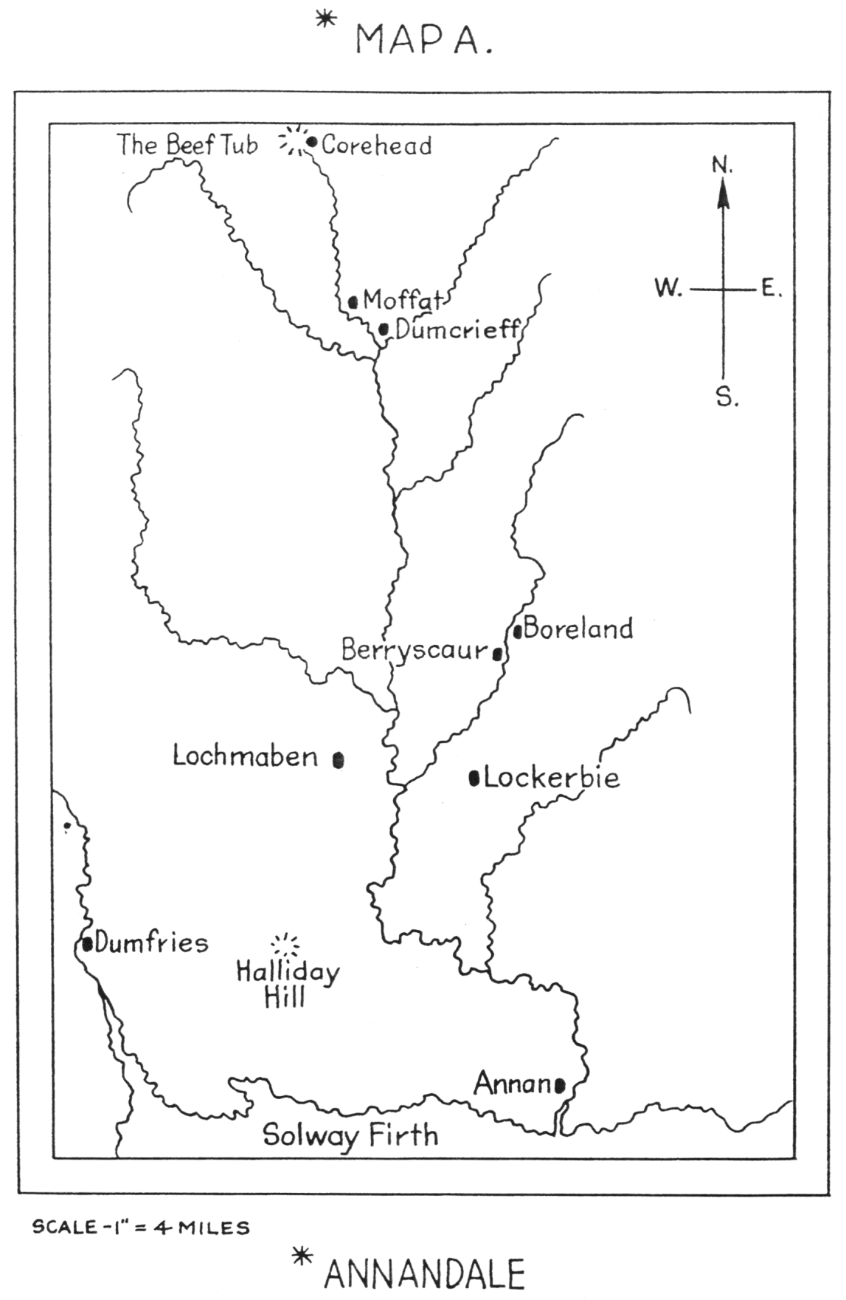

Chapter Two
The Halliday Family
The Halliday family originated in the valley of the Annan River in South Scotland. (1) The word "Annan" is Celtic, its old spelling was "Annand", and probably meant 'slow running water'. That is an accurate description of most of the river's flow through comparatively low-lying country. It has its source in an area of rugged hills some six miles north of the town of Moffat and its mouth thirty-two miles farther down when it empties into the Solway Firth. At its source the hills form a startling recess, approaching so near each other as almost to exclude the sunlight. Only to the south is there exit from the hollow by a narrow gorge. Through this the tiny stream begins its southward flow. The awesome hollow in the hills is known as the Devil's Beef Tub.
A few hundred yards below the Beef Tub the glen begins to widen. Almost immediately it takes on the characteristic features of the Annandale watershed, a gently flowing stream bounded by water meadows, with the rounded hills flanking the valley. At this point where Annandale begins stands the first farm homestead of the dale, Corehead, its name indicating its primary position at the top of the corrie. Here, at Corehead, the Halliday family had its historical beginnings.
Long before recorded history identified a Halliday family, however, the name was known in Annandale and tradition had tales of its deeds. The name itself appears to derive from the Latin word 'allodil. The supposition is that when the Roman legions penetrated the valley of the Annan they were struck by the fact that the peoples there, - a mixed race of Pict, Celt, Dane and Saxon, lived on lands owned by themselves. That is, no near-feudal system existed, but one more nearly like freehold tenure. In their surprise at this social system the Romans called the inhabitants 'the allodil , or 'those who cultivate their own land'.
Whatever the source of the surname, apparently a large proportion of the inhabitants of Annandale were known as Hallidays. A tradition concerning this exists from the time of the crusades. According to it, about the year 1190 A.D. Richard I of England had gone to Palestine on the Third Crusade. William I of Scotland, known as 'The Lion', had become a temporary vassal of Richard and was called upon to provide troops for the latter's assistance. He raised five thousand men whom he sent under the command of his brother, the Earl of Huntingdon. An old record states "one thousand were from Annandale, and nearly all of them Hallidays" (2) Allowing for some patriotic exaggeration by the narrator (possibly himself a Halliday!), still the name must have been well established in the area and its numbers more than considerable.

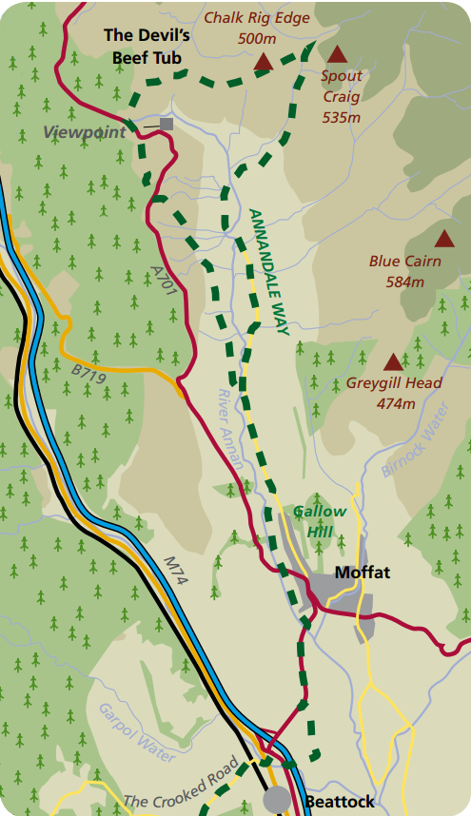

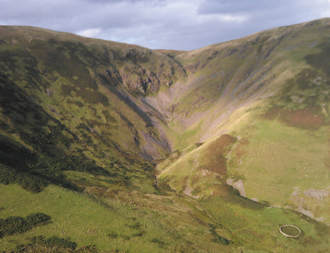
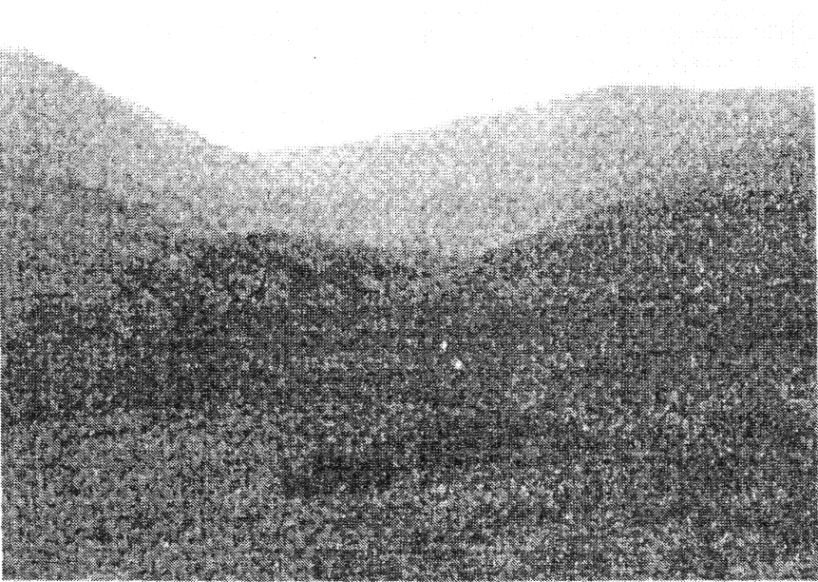
The Beef Tub

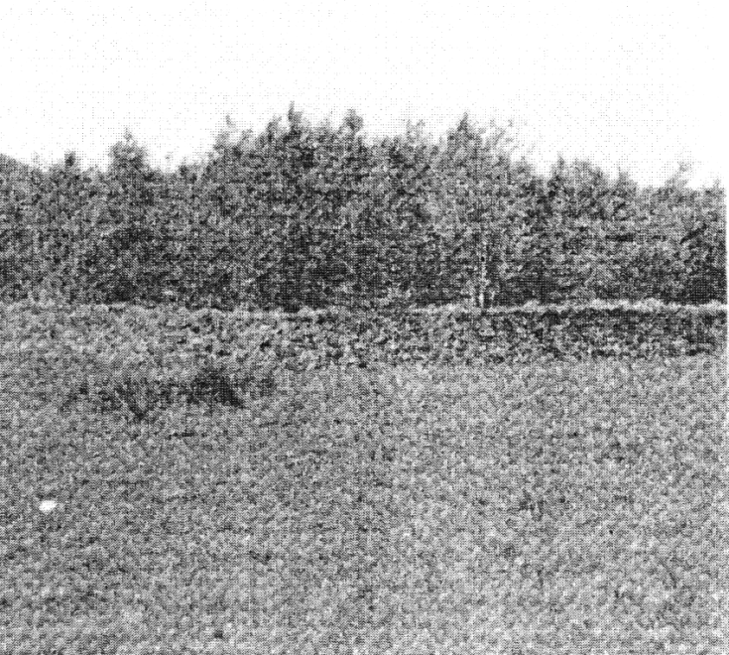
Sight of the Halliday Tower, 1297

Sometime later than the Crusades and when tradition was giving way to verifiable history, another glimpse is given of the extent of the Hallidays in Annandale. It is in the form of a quatrain of folk-verse. It speaks of the wide distribution of the family in the dale, from where Annan joins the Solway Firth to the hill at the Beef Tub called Ericstane.
"Frae Annan-fit to Errickstane
Man and horse lang syne hae gane,
Neth greenwood gay; and a' the way
Upon the lands of Halliday." (3)
It is not until the year 1297 that an individual Halliday of Annandale be (known to verifiable history. He was Thomas Halliday of Corehead. He o the peel-tower there. Such towers were commonly built by the chieftains Annandale as a common fortress and residence. The Halliday tower at Corehead stood on a slight eminence within sight of the Beef Tub and just below Great Hill, which rises to a height of 1,528 feet. On such a site, protected on the north by unassailable hills and commanding the one approach up the corrie from the south, the Corehead tower was ideal for defence and safe for living.
Thomas Halliday of Corehead was married to one of the two daughters of Sir Malcolm Wallace of Elderslie. He was thus a brother-in-law of the famous Scottish patriot Sir William Wallace. Thomas Halliday had a son, also Thomas who was referred to by Sir William when speaking of his devoted followers as "Thom Halliday, my sister's son so dear".
The family relationship to Sir William Wallace was never forgotten by the Halliday descendants. It was a source of pride to many of them. Even six centuries later, when the Wallace blood had been diluted beyond estimation, a William Halliday in Canada, in humourous yet none the less prideful verse, made the relationship a poet's theme. He could speak of himself as "a brither Scot who bears Sir William's name"; and "in my veins pure rins the bluid that warmed that man of might"; and "rouse the Wallace bluid! for bluid shall all my wrongs repay". (4)
The Halliday association with Sir William Wallace had, however, a more far-reaching effect upon the family fortunes than to be merely the boast of a minor poet. It may well have been the reason why the Hallidays were never to become landed lords of Annandale or perhaps even titled members of the Scottish nobility. To understand the tale of cause and effect one must consider elements in the earlier history of Scotland and particularly of the border area where Annandale lay.
In the years when William the Conqueror was establishing a feudal rule of Norman barons in England, David I was king of Scotland. David admired the ability of these Normans and invited several of them (perhaps thereby shrewdly assuring his own position) to take up lands in Scotland. Already various Lairds in the southern area had built their towers and it may be that David mistrusted the degree of their independence. When the Normans accepted his invitation he made them overlords of various areas in his kingdom.
Thus, one of the ablest Normans was Robert de Brus. David made him Lord of Annandale and Keeper of Lochmaben Castle, situated midway down the Annan valley. One of his descendants, Robert Bruce, tenth Lord of Annandale, was to become the most famous of these Norman Scots. Over time they became loyal to their adopted country, anxious to defend their privileges. So when Edward I of England interfered in the dynastic affairs of the Scottish kingdom these Scots nobles were prepared to resist. The leader of the resistance was Sir William Wallace. Wallace was not of Norman-noble birth. But his passion for freedom of noble and commoner alike, allied with his known valour, marked him as the acknowledged leader of the Scots forces.
Much slaughter and rapine accompanied the struggle. Sir Malcolm Wallace, father of Sir William and of the wife of Halliday of Corehead, was killed when invaders captured the castle at Lochmaben, the home of the Bruces. "Not long out of his teens, Sir William, with four of his followers, came to Corehead. Here (at the home of his sister, Mrs. Thomas Halliday) was mustered the small devoted band who struck the first blow for Scotland's freedom from England". (5) The Hallidays of Corehead were among the first of those "Scots wha hae wi Wallace bled".
At Stirling, Wallace's army defeated the English and drove them from Scotland. Following the victory, Wallace regulated the affairs of the country with wisdom and vigour. He was not to be a power for long. In 1298 Edward led his army of revenge into Scotland. It now appeared to the Scots nobles that victory would probably lie with Edward. So, concerned more about freedom for their own class privileges than for the commonalty of Scots, the nobles for the most part deserted Wallace and made their peace with Edward. At Falkirk Wallace's army was defeated and he was forced to retreat north. Later he was captured, largely, it is believed, as a result of treachery on the part of some of his erstwhile noble followers. His death in the Tower of London followed.
Of course some who had fought with Wallace from the beginning had remained loyal to the end. Among such were the Hallidays of Annandale. Now, however, they were out of favour, out of favour with the powerful nobility who had honours to bestow in the form of lands and titles. Apparently the family lost much of its earlier pre-eminence in its native dale. Its members took up the quieter pursuits of the farmer, the artisan, or the professional career. Any preeminence in the future was to be connected with the arts of peace.
This is not to say that the Hallidays took no active part in the troubled life of the Border. Two major social convulsions shook the Border in the following centuries. One was 'The Reiving Times' of the sixteenth and seventeenth centuries, the other the 'Persecution of the Covenanters' in the late seventeenth. In both the Hallidays must have played a part.
The lawless period of the reivers was marked by ravage, rapine and slaughter throughout the border counties of Scotland and England. Bands of mosstroopers organized in their family groups to steal from neighbouring clansmen and to attack the settlements across the national border. The forces of law and order appeared powerless to control the disgraceful situation, possibly because in any given area all families were represented among the trooper bands.
The part played by the Hallidays of Annandale in the reiving is not clear. One tradition would make their part a considerable one. According to it the family got its surname from its activity. An old Anglo-Saxon word which may well have survived in the border country was the word 'Haligdaeg', meaning ‘a festival'. This tradition declares that when a plundering expedition on the English was being organized, the clansmen of Annandale used to sound the rallying cry, "A haligdaeg, a haligdaeg", and gather on a small hill in the lower reaches of the dale not far above Annan town. As a result, the hill became known as Halliday Hill (6) and the reivers who gathered on it as the Hallidays.
In some respects the tradition may be well founded. Such a hill does exist even to this day. It is more than probable that any gatherings upon the hill world include members of the Halliday family who were and have remained numerous in the area. But to connect an activity of the seventeenth century with the origin of the Halliday name is to fly in the face of history. The name existed in Annandale centuries before the reiving times.
While, therefore, participation by Hallidays in these lawless activities is not to be categorically denied, it is still true that the family as a whole seems to have been surprisingly absent. During the reigns of the latter Jameses and Queen Mary, when the national authorities were trying to check the reivers, long lists of Border families were drawn up by the Privy Council of Scotland for punishment. These were sent down to the Chiefs of Annandale for action. The name of Halliday does not once appear on these lists, though numerous in the dale. One record (perhaps written by an apologist for the family) says, "It would seem as if that sort of thing did not suit their ideas of warfare". (7)
When the story of Covenanter activity is told, however, the participation of the Hallidays is never in dispute. The family were fervent supporters of the National League and Covenant of 1638. So when the Crown of the now united Kingdoms tried to force the Covenanters to conform to a contrary form of worship, the Hallidays resisted. Some of them paid for their temerity with the lives.
The widespread support for the Covenant by the family is attested by an unusual incident. In 1679 King Charles II sent the Duke of Monmouth to Scotland to enforce compliance with the law by the Covenanters of the Border. Among Monmouth's officers was Thomas Halliday, a grandson of one of the Hallidays who lived in Dumfries. Thomas had gone to England, as Scots have frequently gone. In 1679 he found himself returning to Scotland as a member of the King's punitive forces. Upon arrival in Annandale Thomas Halliday discovered that all his kinsfolk in the dale were Covenanters.. He forthwith deserted the King's service and joined his covenanting relatives. More striking proof of the position in the struggle could scarcely be found.
If there be such, it is the record of martyrdom for their principles some of the Hallidays endured. Since towns and their churches were forbidden to the Covenanters, they were forced to the moors for their religious services. There they were frequently surprised by the forces of the Crown, which usually dealt with them in a summary fashion. On February 21, 1685, a little band gathered for worship on Kirkconnel Muir where they were surprised by the notorious Grierson of Lag. David Halliday of Mayfield was among them. He and a companion were barbarously shot on the spot, "without so much as allowing them to pray, though earnestly desired". (8) Another David Halliday, of Glencape was also shot under similar circumstances on July 11th of the same year.
As has been noted, later generations of the Halliday family showed pride in belonging to a clan who had "bled" with Wallace: more of them remembered their martyred Covenanter forefathers and held with so much the greater zeal to their ancestral faith.
Meanwhile, the direct male line of the Hallidays of Corehead had failed in the fifteenth century. Before then, however, younger members of the family had fared forth from Upper Annandale, some of them going far afield. In 1470 Walter Halliday, a younger son of the Corehead chieftain, had found his way to the court of Edward IV of England where, as 'Walter the Minstrel', he became Master of the Revels. He founded a line of Hallidays in England, which numbered among its members several who obtained distinction in the professions, the business world, or the political.
One branch of this English family returned to Scotland, establishing its seat at Tullibodie Castle in Clackmannanshire. Descendants returned to Annandale, where in Dumfries, Berngaw, Copewood and Whinnirig the family has persisted to the present.
One line never left Upper Annandale. Their direct descent from the Corehead family cannot be traced, but their continuing residence in the upper reaches of the dale is attested by many records. They were largely farmers or tradesmen artisans serving on the landed estates of the area. They have lived or still live in the parishes of Moffat, Johnstone, and Wamphray; and specifically on farms estates at Corehead, Ericstane, Lochbrow, Panlands, Woodrow, and many others in that part of the valley.
Early in the XVIII century one such family was living on the estate of Dumcrieff, a mile or two from Moffat. (9) In 1728 its owner, Sir John Clerk, carried out many improvements to it. Among them was the establishment of a corn-mill to grind flour and a wauk-mill to process cloth. By 1730 the wauk-miller was paying his rent to Sir John; by 1733 a new house had been built for him; and in December of that year Sir John's agent reported to him, "The millar (sic) is most diligent". (10) This wauk-miller was apparently a Halliday, brought to establish the mill in Dumcrieff about 1728. He seems to have had a son named George.
Certainly, in 1739 George Halliday, a wauk-miller, was living in Dumcrieff. In that year he married Mary Hastie and presumably lived in the miller's house there. Four sons were born to them, the fourth son, John, in 1745. (11)
Seventy years later John's son, also a John Halliday, left Scotland for Upper Canada. There he became the founder of a branch of the Hallidays of Annandale in the New World.

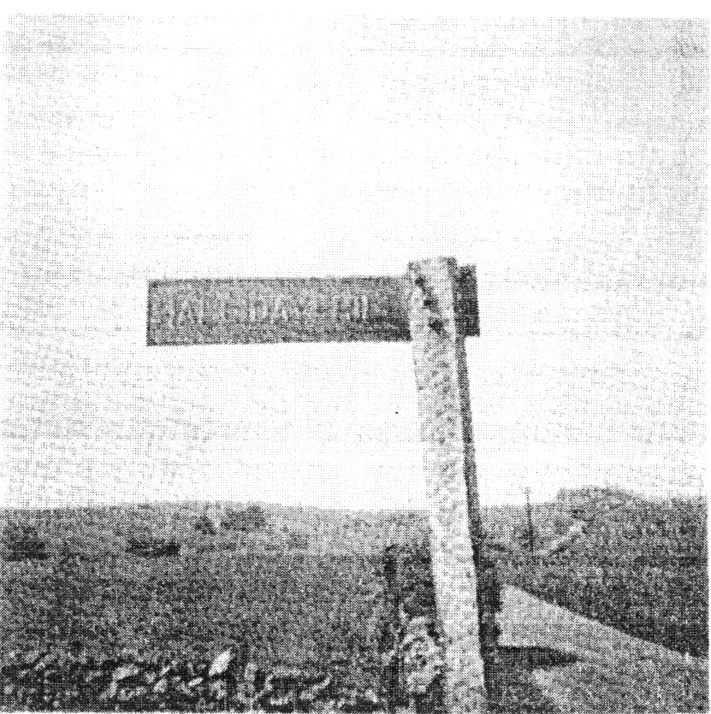
Distant View of Halliday Hill

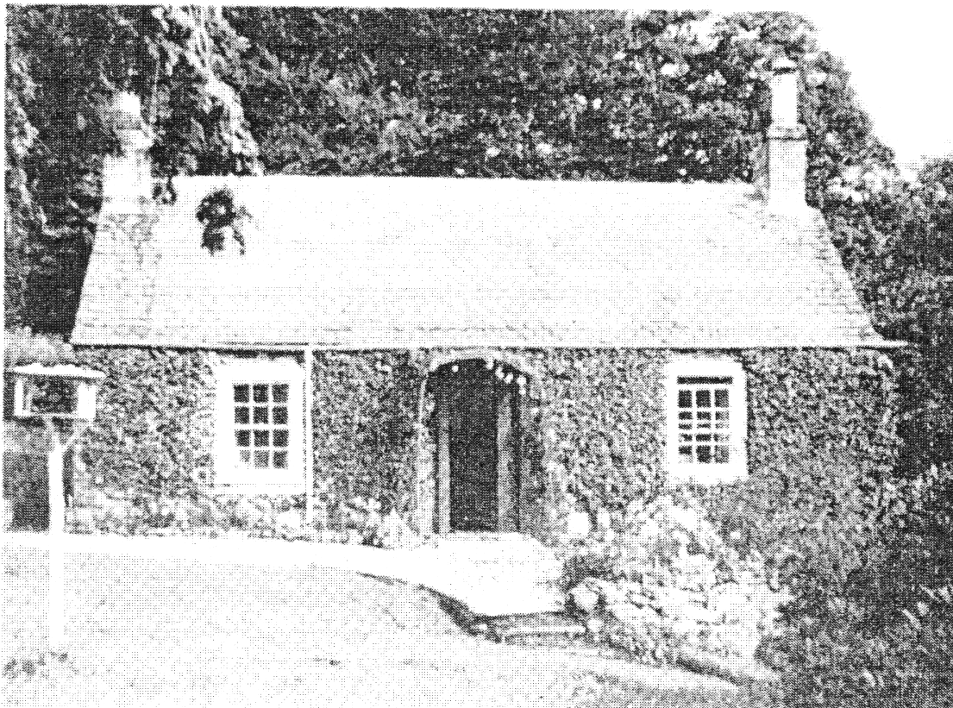
Wauk-miller’s House, Dumcrieff

Chapter Three
Early Life in Scotland
Early in 1746 George Halliday left Dumcrieff, Moffat Parish, and removed with his family to Berryscaur, Parish of Hutton and Corrie. One of the first acts of a Scot when he moved from one parish to another was to transfer his certificate of church membership, his "testimonial". There exists in Hutton Parish a Session record-book with entries from 1746 to 1769 headed "A list of testimonials taken in and given out by the Session of Hutton since ye 2nd. of June, 1746". The first entry in it reads, 1746, June 2 - taken in one from George Halliday in Berryskare from Moffat".
Hutton parish is the largest in area of the Dumfriesshire parishes. Much of it, however, is moorland. Hence it has been by no means the most prosperous part of Annandale. In 1755 its population was 993. By 1793 this had decreased to 583, the decrease being due, it was alleged, "to laying farms together". Serving this population commercially there were two corn millers, one dye and wauk miller, one shop keeper and fifteen weavers. The parishioners of Hutton were said to be "regular in conduct, well disposed to government, (while) in industry and sobriety they excell". (1) The statistics of the parish may have been slightly different when George Halliday became its one dye and wauk miller, though the general picture would be substantially the same, especially, one would hope, the fine character of its inhabitants.
Map C (Berryscaur)
The parish church stands on the outskirts of the village of Boreland. The name was originally Bordland, or Board-land, from the Danish "bord", meaning "table". Bord land was land held on the rental of food for the Bishop's table. Since the parish was organized separately at that point in 1220, the name must date back to the XII or XIII century.
The village is on the Dryfe Water, a tributary of the Annan some twelve miles long. (2) The valley of the Dryfe is similar to that of the Annan, though probably somewhat narrower, its water meadows being less extensive. The same beautiful hills flank the dale. The name derives from the Anglo-Saxon "drifeaig" which means "hurry" or "tumult". In its upper reaches the little stream is placid enough, its name scarcely appropriate. Then "the Dryfe finds its way to the rocks at Boreland and, leaping like a mad thing, drives down its glen to join the Annan at Dryfe Sands". (3)

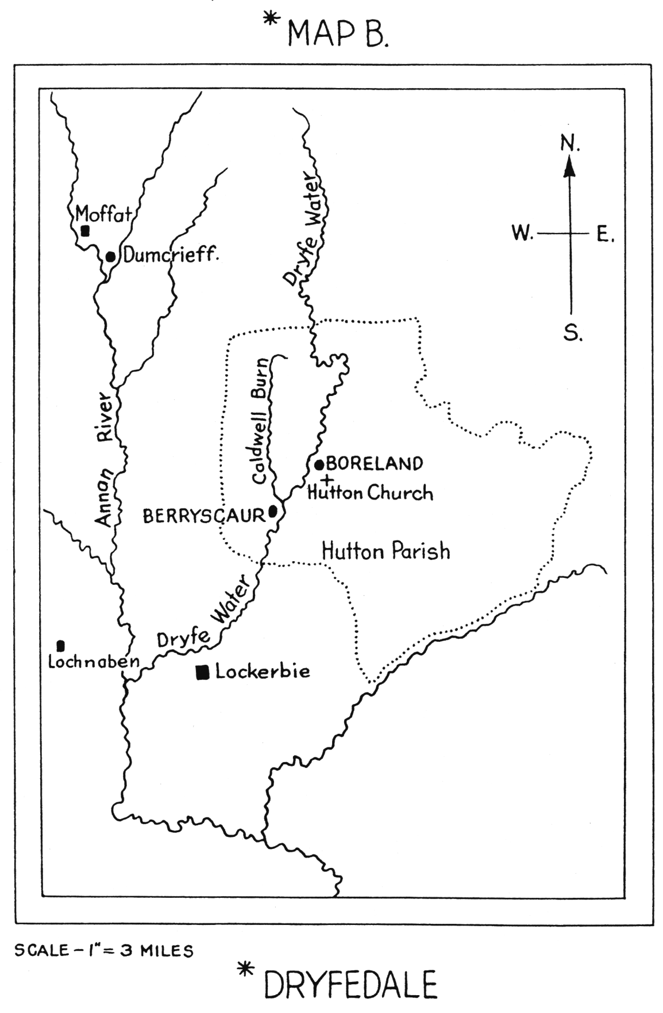

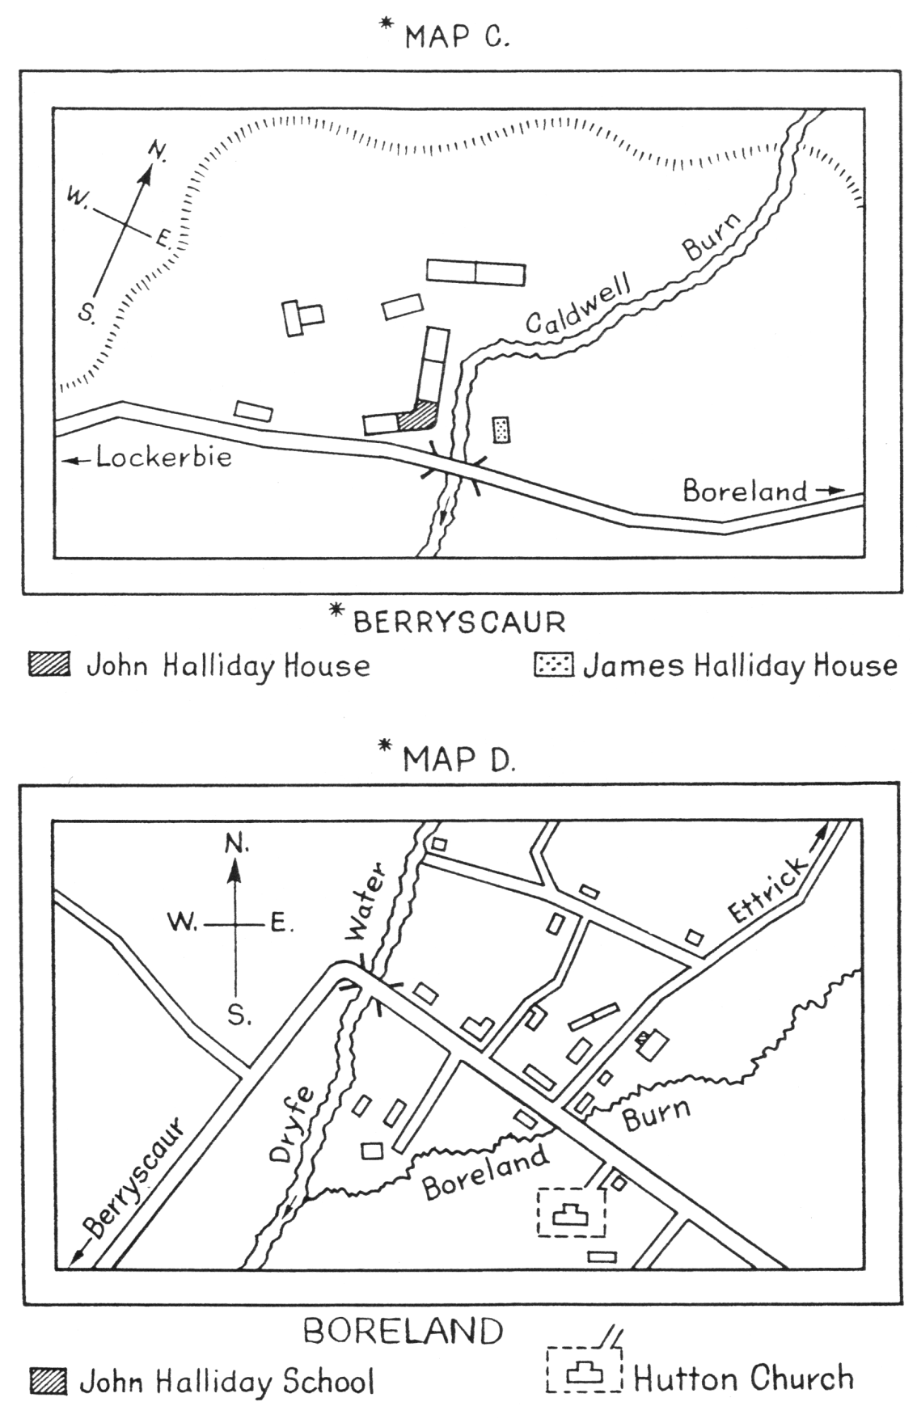

Map C
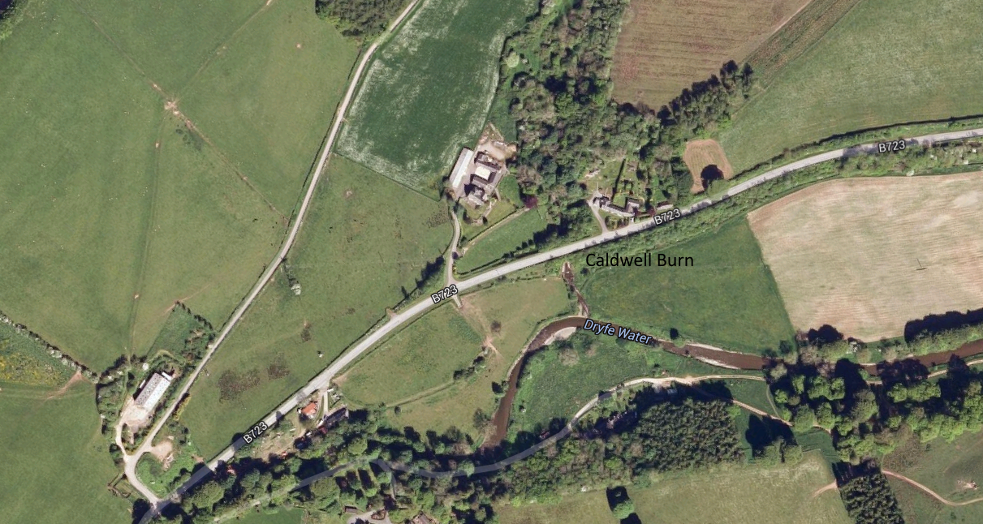

Map D
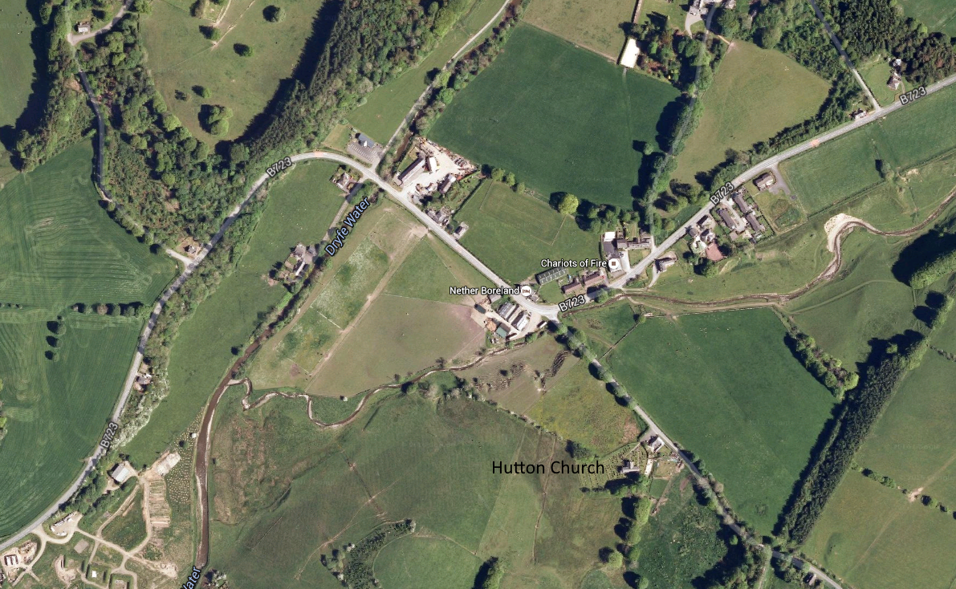

A mile below Boreland the Dryfe is joined by a small tributary stream, the Caldwell Burn. At this point is a little hamlet of fewer than a dozen cottages, - Berryscaur. The name comes from the Norse. Its first two syllables, "berry", can be traced through the earlier form "berrier" to the Norse "beorg", meaning a small hill. .(4) The last syllable, "scaur", is also Norse from the word "sker", a cliff. (5) The combination of the two - "berrier-sker" suggests a precipitous small hill. That is a correct description of the hill immediately behind the hamlet. Berryscaur is on the estate known as The Shaw, whose manor house stands on the hill. The hamlet became the home of independent artisans who lived in the very modest houses available there in the XVIII century. Here it was that George Halliday took up residence in 1746.
Not much can be discovered about George Halliday. In the records of Moffat Parish there are three references to him. The first states that on Sunday, January 21, 1739, the banns for his marriage to Mary Hasty (sic) were proclaimed for the third and last time. On that occasion he "consigned (to the Session) 10s. sterling as "pawns". In the Church of Scotland of that period the pawns were moneys handed over to the Kirk Session when banns of marriage were finally proclaimed. If the first child of the marriage were born not earlier than nine months later, the moneys were returnable to the father. The marriage took place that week, apparently at the bride's home, for on January 28, 1739, "George Haliday (sic) gave to the poor, conform(able) to the act of Session for being married out of the church - 2s.6d."; another interesting financial procedure of the Scots kirk of that time. The third entry is dated December 2, 1739, some ten months later, when the Session reported receipt of "baptismal money from George Haliday in Dumcrief - 1s." Presumably the ten shillings of pawns were returnable to the proud parents.
The child born in 1739 was baptised 'Francis', the entry in the baptismal register being dated December 10, 1739. Three more sons were born to George Halliday and Mary Hastie in Dumcrieff, registered respectively as James, baptised November 19, 1741; Patrick, January 14, 1743; and then John, whose registration reads, "March 11th, 1745, George Hallyday (sic) and Mary Hastie had a son baptised named John". John was to become the father of the Halliday who emigrated to Canada.
Presumably George Halliday had learned the trade of dyer and wauk-miller on the estate of Dumcrieff. His father may have been of the same trade. Dumcrieff was not a large estate when the Hallidays lived on it. At that time a small community of tradesmen lived in the grounds. They earned their livelihood by running two mills, one a corn mill, the other a wauk mill. The latter would probably be operated in conjunction with dyeing vats, the two operations being commonly carried on together. The mills operated in Dumcrieff for many years. The millers are supposed to have occupied a building later known as 'The Gardener's cottage'.

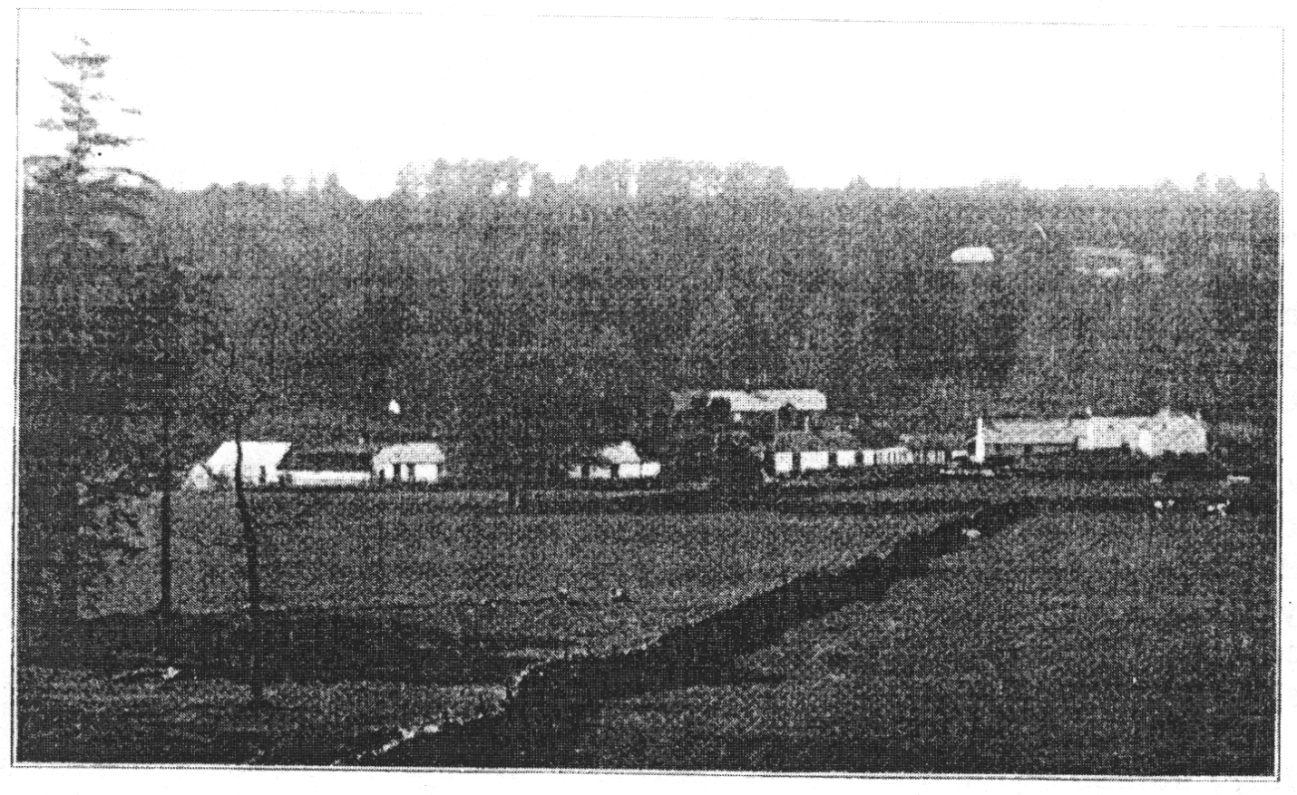
(From a photograph by Mr. J.B. Edgar)
Berryscaur and Shaw.

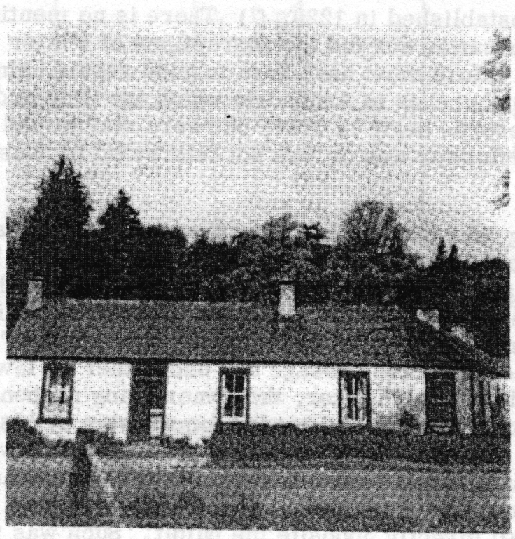
John Holliday’s Birthplace, Berryscaur

The trades of dyer and wauk-miller were practised in most rural areas of Scotland in the eighteenth century. Not much equipment was needed. The industry had to be near a stream of water, for water was used in considerable quantities. Two stone-lined vats were built, one for each process, and usually in the yard of the dyer's house. The raw, 'homespun' woollen cloth - and to a lesser extent sometimes linen - was first placed in the wauking vat. There a trampling of the cloth under water shrunk it, removed its coarse roughness, and gave it a reasonably smooth surface. The webs were then dried, the water being drained away by the nearby stream. When dry the cloth was put into the ‘litting' vat - the old Scots term for 'dyeing'. The dyer had two sources available for his dyes, England and Holland. Traditionally, two colours only were used, blue for the ordinary clothing of Scots citizens, black for the less commonly used garb of special occasions. The cloth was allowed to steep in the dye until the colour was fixed, then dried, the residue in the vat being drained away.
The dyer and wauk-miller of the eighteenth century had two kinds of customers in need of his product. One of these was the weaver of 'homespun' cloth. She might be a housewife who wove cloth for her family on the household loom after spinning the yarn on her wheel. Up to that point she was competent, but wauking and dyeing the cloth (and sometimes the yarn) required equipment and skill she did not possess. So the dyer of the neighbourhood was called upon to practise his trade, for a fee. On one occasion the Session of Hutton church had to have cloth dyed for one of the parish's indigents; Session Record states, "Paid an account ... for dyeing to John Halliday - 4s. 6d". Not all weaving was done by local housewives, however, for professional weavers, either resident or itinerant, were available. In Hutton in 1793 there were 15 weavers resident in the parish. (1) These too would require the services of the wauk-miller and dyer. A dyer's income may well have come largely from these two sources.
It appears, however, that a dyer might also have quantities of his dyed material for sale. One living in Berryscaur world have two markets available as retail outlets. Weekly markets were held in Dumfries and Lockerbie in the eighteenth century. To obtain a license to sell on these markets a tradesman had to be registered ("entered" was the word used then) as a burgess of the town. On June 11, 1792, James Halliday, "a dyer" was so 'entered' at Dumfries. In 1793 James Halliday of Berryscaur, one of George Halliday's grandsons and the one dyer in Hutton Parish (1), may well have been the new burgess of Dumfries. Such markets would be a second source of income for dyers.
Dyers were, thus, independent traders. They usually rented their property from the land-owner of the neighbourhood. The Hallidays of Berryscaur would be tenants of Graham of Shaw. While not affluent, they would in all probability have an adequate income, more especially in view of their monopoly of the trade in Hutton. This seems to be borne out by the Hutton Session records listing relief payments made by the Session to members of the parish "in straightened circumstances". The record exists for the period 1742 to 1772. There were at least fourteen Halliday families in the parish at that time. Among them some required financial assistance from the Session Poor Fund from time to time. Not once over the period for which a record exists did the Hallidays of Berryscaur require such help.
No record of George Halliday's death has been found. The churchyard contains no existing headstone to his memory, nor do Session records report the payment of "mort-cloth" money on the occasion of his death. Four generations of his family lived in Berryscaur between 1746 and 1898. In that latter year another George Halliday, great-grandson to the first one and the last to reside there, died in Berryscaur. When the first George Halliday came to Hutton he had four children. Hutton Parish baptismal registers list five children baptised after the family arrived there, namely, Janet, 1747; Christian, 1749; Isobel, 1751; Jean, 1753; and William, 1755.
George's fourth son, John, followed his father's trade of dyer, continuing to reside in Berryscaur. He lived in the corner unit of an L-shaped terrace of four cottages. The shorter arm of the terrace faced Dryfedale, the longer arm the Caldwell Burn. (6) Thus, John's house had two windows looking on the road from Boreland to Lockerbie while its door and one window looked on the Burn. It was ideally located for the practice of his trade and the marketing of his goods.
John had married Jean Dinwiddie (also spelled Dinwoodie). Unfortunately, in Scotland at that time, registration of marriages and births was voluntary and either the principals or the minister might fail to record the event. No contemporary registration was made in Hutton for John's marriage (which might, of course, have taken place in a neighbouring parish) nor for the baptism of his children. From the headstone in Hutton churchyard, however, it is learned that he had a son, James, born in 1775. A second son, John, was born in 1778. A delayed registration of his birth was made either by the son himself or by his mother in 1801. It read, "April 25th, 1778. John, son of John Halliday, late dyer in Berryiscare (sic), and Jean Dinwiddie". On May 5, 1778, John, Sr., died at the youthful age of thirty-three, his newly-born son being about ten days old. According to the Statistical Account of Scotland, 1793, in the year 1778 "fever and consumption carried off thirteen young people". Apparently an epidemic of some kind struck the parish, John Halliday being one of its victims.
Since the two sons were still infants, their widowed mother would be dependent upon others for the operation of the family business. It was normal for a widow to carry on under such circumstances by employing a journeyman dyer. Whether this was Jean Dinwiddie Halliday's procedure or not is unknown. Her father-in-law, George Halliday, may still have been living. Her youngest brother-in-law, William Halliday, appears to have been a dyer and may have been the William Halliday "entered" a burgess of Dumfries in 1786. Either of these relatives may have operated the business. The family continued to live in the Berryscaur cottage, where the dyeing vats were and where both sons learned their father's trade in due course.
Ultimately, James became the chief operator. He married Jessie Rogerson and six children were born to them. They lived in a cottage directly across the Caldwell Burn from his mother's house. According to one of his descendants, James used the dyeing vats "across the burn", which would be those in the yard behind his mother's house.
The younger son, John, broke with the traditional family occupation. Though he had learned the dyer's trade and practised it for a brief period, he moved into a professional career. This career ultimately led him far from the ancestral home in Scotland to a new home in Upper Canada. What influences there may have been in the Berryscaur home to lead to this break is unknown. It is clear, however, that there were two in Hutton Parish which did much to mould him, the Parish Church and the Parish School. His associations with both were close ones.
Hutton Church was established in 1220. (7) There is no mention of it in the turbulent days of the Reformation nor did the Disruptions of a later day have much effect upon it. In 1602 its fabric must have been in good repair, since it is not included among the twelve churches in Annandale which the King ordered rebuilt at that time. Its extant records begin in 1744, but were maintained only spasmodically according as its minister was or was not interested in Session Minutes and Parish Registers.
The present building was erected in 1710. It was built of local, brown stone, the roof being thatched, with slate substituted in 1763. The building was rectangular, 67 feet long and 15 feet wide. Down the centre from the east door to the west one ran a "passage", or aisle. This was gravelled, while the rest of the church's floor was earthen. On either side of the passage the "rooms" (box pews) were built, separated from the passage and each other by low partitions. One "room" was reserved for each heritor, the owner being responsible for supplying the chairs, benches, and desks needed for worship by his family, his servants and his tenants. The "room" occupied by Graham of Shaw (where the Hallidays as his tenants had a right to worship) was in the south-east corner. The pulpit was built midway down the south wall. In 1763 an extension, - the jamb - was added on the north wall directly opposite the pulpit. Such was the church where John Halliday was baptised, where he attended school and worshipped, where he taught the parish school for a brief period, and where, in all probability, he was married.

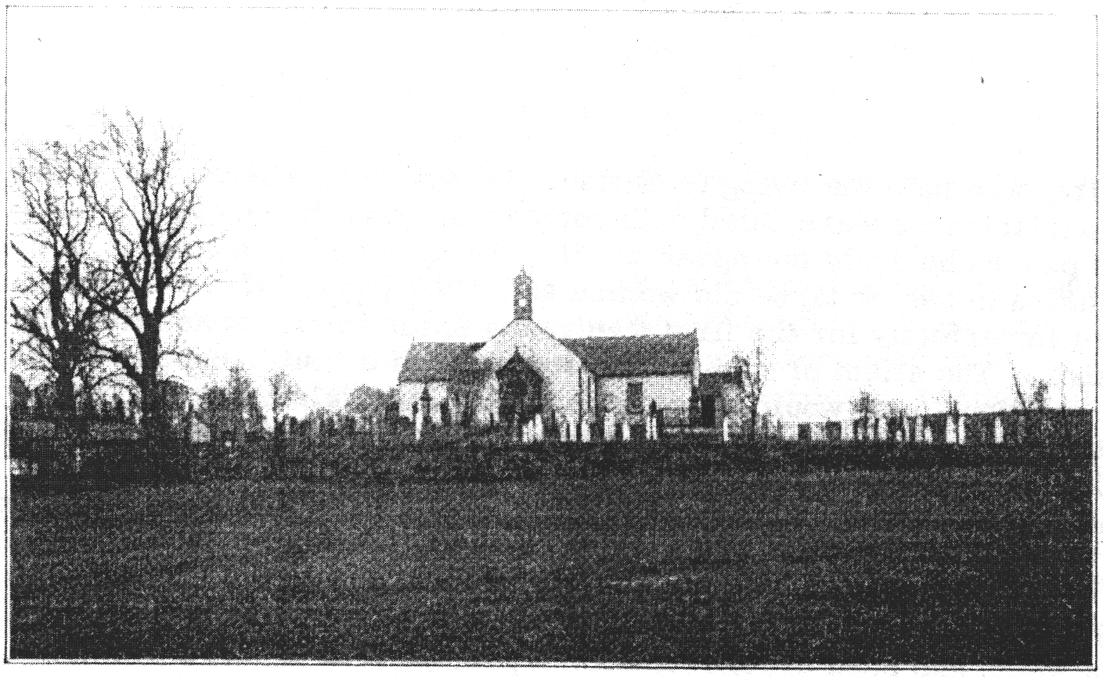
(From a photograph by Mr. J.B. Edgar)

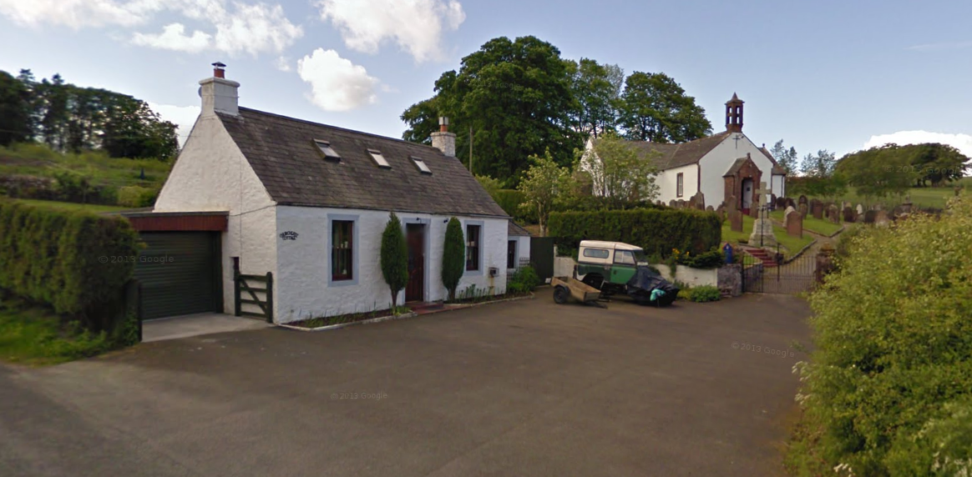

(Google Maps, June 2009)
Hutton Kirk.

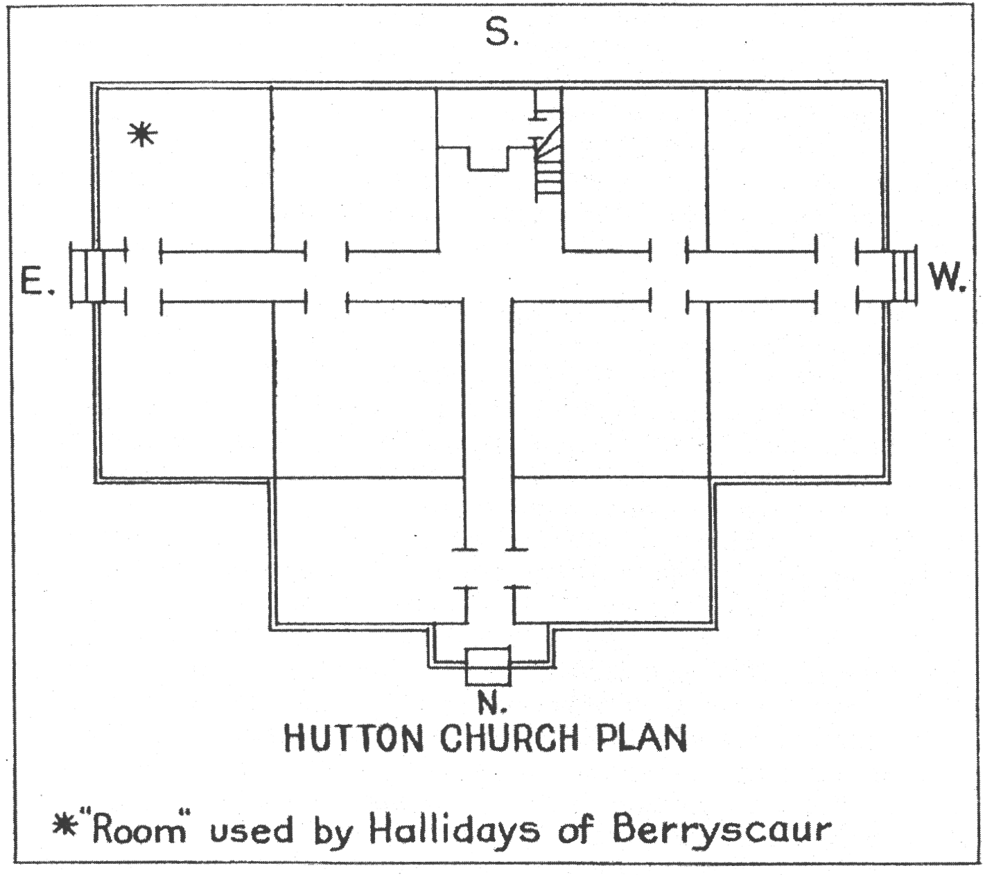

John Halliday was unfortunate in the calibre of his minister during his youth. This was the Rev. Patrick Nisbet, who was minister of Hutton from 1767 to 1799. Mr. Nisbet had been a merchant of Glasgow, became bankrupt, and was placed in Hutton Parish as its minister by his brother-in-law, the Principal of Glasgow University, who held the living of Hutton. He was not a success as a minister. "The parishioners were filled with consternation at discovering that if deprived of his papers he could not speak for five minutes commonsense. The congregation dwindled to two or three old women and a few boys." (7) Parish records were kept imperfectly for the first five years of his ministry and then discontinued altogether. The effect of such incompetence upon a youth, especially if his home were a religious one, would be considerable. In revulsion at the laxity John Halliday may well have become sympathetic to the sterner theology and practice of the Cameronian dissenters. And Mr. Nisbet's dependence upon a manuscript in the pulpit may have had an echo in a Church of Scotland congregation in Canada many years later. (8)
In July, 1799, Mr. Nisbet was succeeded by the Rev. Jacob Wright. He came to a church which had been brought to such a pass that no elders were left in the Session. Mr. Wright was a more competent minister and so built up the parish that he was able to hold his congregation firmly to the Church of Scotland during the Disruption. He would have a considerable influence upon the twenty one year old John Halliday, whom he probably married to Margaret Johnstone in 1801. He would also be instrumental in having him appointed as schoolmaster in Boreland in 1803. If John Halliday had already been favourably inclined toward the Cameronian discipline, the influence of Mr. Wright may have been such that he continued in the Established Church. It may explain his readiness to return, temporarily, to that Church years later in Upper Canada. (8)
The Hutton parish school was another major influence in the life of John Halliday. Responsibility for public elementary education in the Scotland of the eighteenth century rested upon the heritors of each parish. They had to employ teachers and maintain the schools, which were commonly held in the church building. The earliest school record for Hutton Parish states that in 1745 ten shillings and threepence were paid to John Graham "who taught school in the kirk last winter". (7) He was succeeded by three other Grahams and by Robert Moffat. These would be the schoolmasters for the family of George Halliday of Berryscaur.
If John Halliday of the next generation began to attend school about the age of five years, his schoolmasters would be William French (who taught from an unknown date to 1786); David Irving (1786 to 1790); and William Scott (1790 to 1796). The last named teacher was considered particularly well qualified because he was able to teach Latin and French. Presumably, John Halliday studied these languages in addition to the usual school subjects. He appears to have been an apt pupil. For in 1796 at the young age of eighteen he was appointed schoolmaster to succeed William Scott, at a salary of eight pounds, six shillings, and eightpence, sterling. There is no suggestion that any pedagogical training was required of teachers at that time.
It may be that John Halliday was already giving indications of a personality characteristic quite marked in his mature years, namely, his propensity to object openly to any situation not to his liking. In any event, whether instigated by him or by his pupils' parents, a complaint was lodged with the heritors soon after his appointment. Heritors' minutes read, "It being complained by the inhabitants that the church where the school is presently taught is cold for the children, it was agreed to take for a rent not exceeding 15 s. for one year the house of David Mundel". (7) Whether John Halliday originated the complaint or not, the success of the method may have set a pattern for him when later in life he faced unsatisfactory situations. His first term as schoolmaster did not last long. Without any reason being given in the records, his tenure of the position ended in 1798.
The erstwhile schoolmaster, now twenty years old, returned to the trade of dyer. On December 25, 1801, he married Margaret Johnstone. No parish registration was made of the event, but it was recorded in the new family bible in the groom's handwriting. The next year the parochial register of baptisms recorded the birth of their first son thus, "October 4, 1802, John, son of John Halliday, dyer in Berryscare, and Margaret Johnstone". In the following year a second son, William, was born. He was baptised December 29, 1803, but on this occasion his father was registered as "schoolmaster of Hutton". During that year John Halliday had been reappointed the parish schoolmaster. The circumstances surrounding the appointment and the resulting change in life for the Halliday family had their origins in changes which had taken place in the Scottish educational system. These were described in a history of the period as follows: (9)
“At that time every rank and profession was recruited from lads who had got their Latin and their training in the parish schools; while the teachers, to whom they largely owed their success, lived in hovels, and their families were clad in rags. In spite of their powerful claims, the schoolmasters were obliged to wait till this century (the nineteenth) before they got partial remedy for their success. At last, in 1802, the long sought, long needed relief came, though by a most modest installment. The Schoolmasters' Act was passed. After a quite superfluous preamble, stating that "the parish schoolmasters of Scotland are a most useful body of men and their labours have been of essential importance to the public welfare", it ordains that henceforth their incomes are not to be under 300 merks (£ 16. 7. 6), nor above 400 merks (£22. 4. 6); that they are to be provided by the heritors with a house, which need not contain more than two rooms, including the kitchen, and with ground for a garden of not less than a quarter of a Scots acre, or two balls of oatmeal as its equivalent. So ends not too brilliantly a dismal period of scholastic poverty; so begins on not too prodigal a scale of liberality the new area of educational history.”
The narrator of this bit of pedagogical history adds that the Lord Advocate had told later of his difficulty in getting even two-room accommodation for the schoolmasters. A great many of the lairds and Scotch members were indignant at being obliged "to erect palaces for dominees".
Meanwhile, in Hutton, the heritors had been somewhat in advance of the Act of 1802. In 1800 they decided that the church was no longer a suitable place in which to house the school. So it was agreed to build a school "and an apartment for the teacher". A modest building was erected on the Lockerbie - Ettrick road where it goes through Boreland, a few score yards beyond the main village corner. The "apartment for the teacher" was the room above the school-room. Here Robert Graham, who had succeeded John Halliday as teacher in 1798, lived and taught until 1803.
With the passage of the Act in 1802 the heritors of Hutton were confronted with legal requirements which they found financially difficult to carry out. The story is not clear, but it did involve appointment of another teacher. John Halliday was reinstated with a salary of £16. 17. 6, - the minimum called for by the Act, but more than double what he was receiving in 1798. In addition, he was now provided with housing accommodation. Presumably, John Halliday moved with his wife and infant son from Berryscaur to Boreland. The birth of his other children in Scotland must have taken place in that village. (10)
Improvements were made to the school property almost immediately. The Act had not only prescribed a minimum salary and an apartment, it had also ordained that a garden be provided. This the heritors did at Hutton in 1804. They "laid off" one rood of land (the quarter-acre ordered by the Act) beside the school, for the schoolmaster's garden. John Halliday made good use of this, planting in it above twenty fruit-trees, besides small fruit bushes", and erecting "outbuildings" in it. Only one trace of the garden now remains, a copper-beech of great size, reputed to be from 150 to 200 years old, and therefore planted by or certainly known to John Halliday. When he resigned the position in 1815 the heritors gave him a bonus of ten pounds because he had tended this garden "in a beneficent and exemplary manner". (7)
At the same time as they provided the garden the heritors put a ceiling on the school-room "to prevent the wind blowing up through the floor, and to render the dwelling-house above more inhabitable". Since the school-room floor was earthen and the heating depended upon each pupil bringing a peat daily for the fire, the temperature in the school may frequently have been low and the room above affected considerably by "the wind blowing up through the floor". Apparently John Halliday found the apartment too small. It was described as "only twelve feet; an inside passage and a bed leaving hardly room for the family... to sit down. The farmers gave five pounds to help for an addition". (7)
Once again, therefore, John Halliday being the schoolmaster, uncomfortable conditions in Hutton school were remedied. The school sufficed in this condition for thirty years. Not until John Halliday had been gone from it for sixteen years was this original school demolished in 1831. Then a new, one storey school, twenty-two feet by fifteen, was built on the same site. This still stands, presently serving as an annex to the schoolmaster's house.

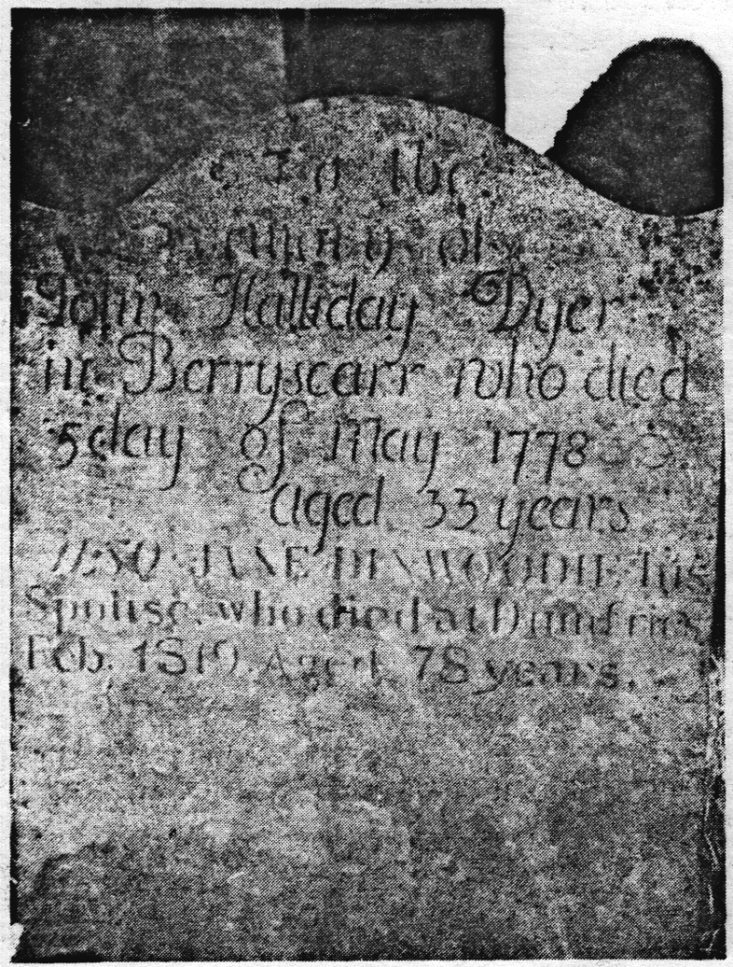
Headstone, John Halliday, Sr.,
Hutton Church-yard

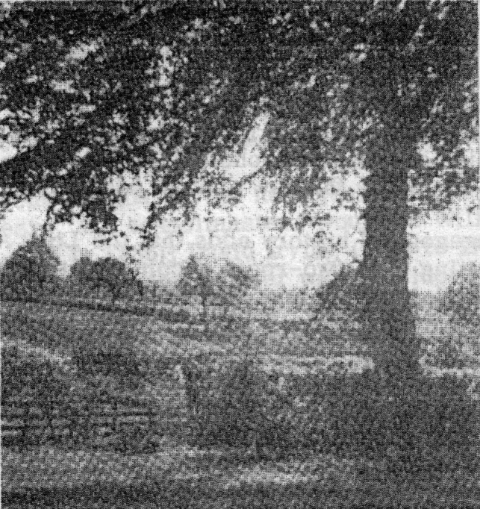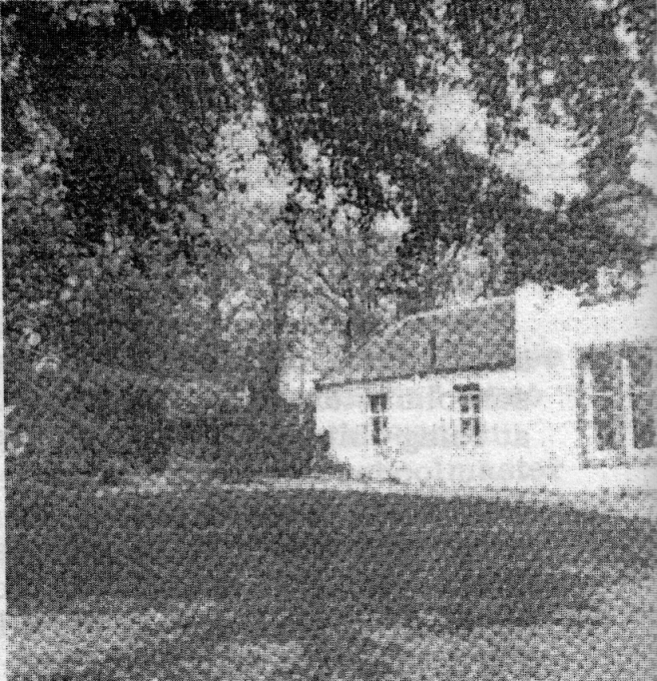
Beech Tree and Site of School,
Borland

It was either during his second term as schoolmaster at Boreland or immediately following his resignation that John Halliday changed the spelling of the family name. He changed the "a" to an "o". In the twentieth century world, with its increased use of legal 'paper', upon which a family signature is of considerable importance, the exact and consistent spelling of a name must be followed. In the eighteenth and early nineteenth such consistency was not so important and certainly was not followed. It has been observed already that common nouns were found with a variety of spelling: examples include scar, scare, skare; walk, wauk, waulk; and there are others. The same liberty was taken when writing proper names. Parochial registers exist in which the Halliday family name is variously spelled Haliday (Moffat parish), Hallyday (also Moffat), Holiday and Holliday (Dornock parish). The same variety is found in the spelling of it on headstones in Annandale churchyards, thus: Holiday (Hutton), Holliday (Wamphray), Haliday (Johnstonebridge). The significant fact about the spelling of the name, however, is that the spelling 'Halliday' far outnumbers in frequency all the other forms combined. Thus, in Wamphray churchyard one stone has the spelling 'Holliday', while twelve inscriptions are 'Halliday'; in Hutton eleven headstones commemorate that number of different families, one spelled 'Holliday', one spelled 'Holiday', and the other nine spelled 'Halliday'. In the parochial records of Hutton, whether those of the Registers or of the Session Minutes, the spelling 'Halliday' so far outnumbers any other that the variation can almost be considered a slip of the scribes pen.
In addition to such evidence from the contemporary eighteenth and nineteenth centuries, there is similar evidence from the earlier history of Annandale. True, the alternative forms of spelling exist. But again the weight of evidence favours 'Halliday'.
Certainly, John Halliday's immediate ancestors must have used it. With the exception of the Moffat parish spelling 'Haliday' in its Session Minutes and 'Hallyday' in its baptismal register, the family name was always 'Halliday'. (Even the Moffat spelling retained the "a" which John Halliday changed.) It was so when George Halliday transferred to Hutton Parish; it was so registered for his six children born there; it was so spelled on his son John's headstone and on that of his grandson, James, father and brother, respectively, to the schoolmaster. Even in 1801 when the birth of John Halliday the schoolmaster received a late registration, his mother or he himself must have believed 'Halliday' to be a correct spelling. All his children born in Scotland were registered at baptism with that spelling. When the heritors of the Parish appointed him 'Officer' of the Parish in 1808 the record states that they paid "Mr. Halliday" the wages of the office. And when in 1815 he was giver certificates of character so he could be recommended as schoolmaster for the emigrants to Canada his name was spelled "Halliday". (11)

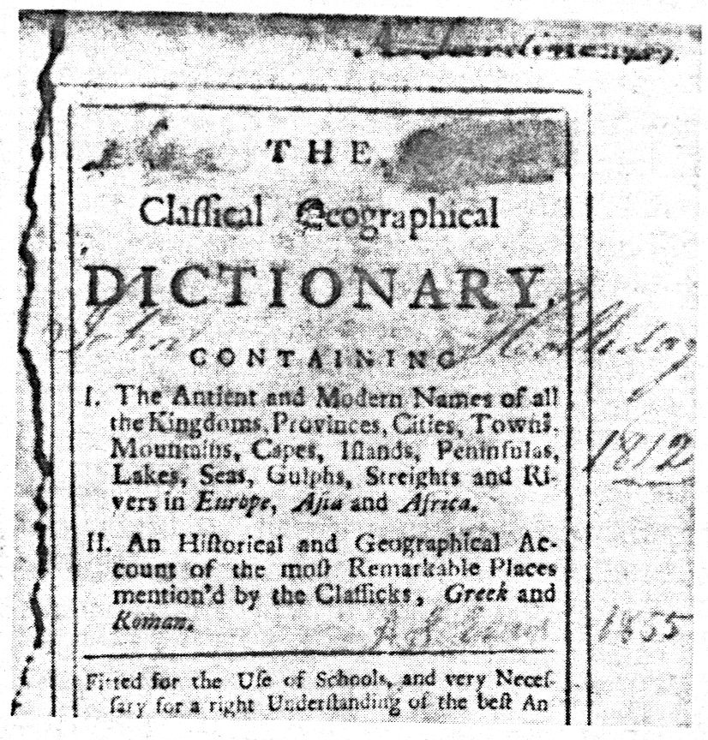
Signature “John Holliday”, 1812

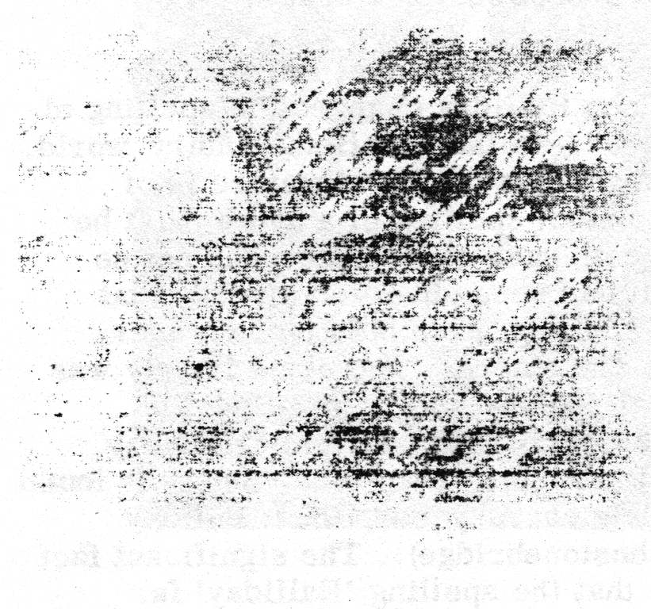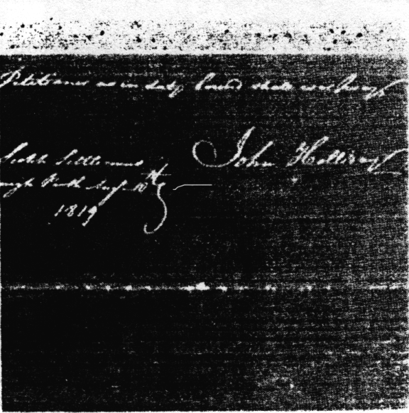
Signature “John Halliday” 1815. Signature “John Holliday”, 1819

It is tempting to believe that John Halliday took advantage of a major break in his career, emigration to Canada, to change the spelling to John Holliday. Existing and dated signatures, however, make such an assumption untenable.
There is some evidence for believing that the latter "o" was used by him during his term as schoolmaster at Boreland. The oldest existing book known to have been in his library, "The Classical Geographical Dictionary", bears on its title page his undoubted signature spelled with an "o" and dated in identical ink "1812". The history of Hutton parish (7) always refers to him as "John Holliday". This work was not published until 1908 and contains no references to original authorities. Presumably, however, its author had some, such as heritors' minutes. If so, and they were correctly transcribed, the spelling "Holliday" was being used by him during his tenure of the schoolmaster's position from 1802 to 1815.
His next surviving signature, however, raises a doubt. It comes from 1815 after his arrival in Canada. In December of that year while at Brockville, Upper Canada, the immigrants petitioned for leave to settle westward on the lake. (12) On that petition his signature was clearly "John Halliday". (13) From that date onwards existing copies of his signature show it to be "John Holliday". (14).
The conflicting testimony leads to the conclusion that in the later years of his residence in Scotland the schoolmaster did use an alternative spelling of the family name; that the new spelling was recognized by some local authorities but, as the emigration records show, not, by all; that even after his arrival in Canada he could revert, possibly unconsciously, to the older family spelling "a"; but that from the time of his settlement on the Scotch Line he consistently used the form "John Holliday". No reason for the change is apparent. Since, however, it was a deliberate choice his action should be respected and his name so spelled, at least from the date of his settlement in Canada.
Strangely enough, and with no evidence available as to when or why they did so, John Halliday's children, with two or three exceptions only, changed the spelling back to the traditional and historical "Halliday".
During his second period as schoolmaster seven children were born to the Hallidays. They were baptised as follows: William, Dec. 29, 1803; Jane, Aug. 9, 1805; Janet, Mar. 21, 1807; James, Nov. 28, 1808; (he died in infancy); Mary, May 8, 1810; George, Apr. 5, 1812; and James, Jan. 29, 1814.
In 1808 and for three years thereafter he received some financial assistance by acting as 'officer' for the parish. In the eighteenth and early nineteenth centuries a parish was maintained by the payment of the teinds (tithes) levied on the landowner heritors. These moneys had to be collected by the Session. But since the teinds were in large part devoted to the stipend of the minister it was not thought fitting that he should go around collecting it. Yet the task involved book-keeping and quite a bit of travel in the parish. In those days usually the only other parishioner who would have the required mathematical education would be the schoolmaster. Apparently the fact that his salary also was paid from these funds did not prevent him being the collector. For on May 8, 1808, the Session reported "Paid Mr. Halliday one-half year's wages for acting as officer ... 7s.6d. 11 He received this annual wage of 15s., additional to his salary as schoolmaster, up to 1811. It may have been continued for later years, but the record is silent about it.
With a larger family and even with the addition of the officer's wages, both the two-room apartment above the school-room and the salary for the position must have been less than adequate. Nor did future prospects appear too bright, for the Act of 1802 had set a maximum salary of £22.4s. 6d. John Halliday must have wondered what the future would hold for his fair sons, Scotland's present and future alike clouded by the existing war conditions.
Then, in February, 1815, the minister of Hutton Parish and the Post Office at Boreland received notice of a government-sponsored plan whereby Scots were encouraged to emigrate to Upper Canada. Each emigrant would receive a free grant of one hundred acres of land and each son a like amount on attaining his majority. The family of the Hutton schoolmaster could become land-owners to a total of five hundred acres, an impossible achievement for a schoolmaster's family in the Scotland of 1815. An additional inducement might even exist for John Halliday. For among the emigration terms was one promising a salary of £50 sterling to any schoolmaster whom the emigrant body might select. Set against the prospects in Scotland, either for himself or his sons, this emigration plan was attractive indeed. A decision was made.
On May 26, 1815, John Halliday, his wife and family of seven children left their relatives in Berryscaur, the schoolmaster's position in Boreland, the Parish Church of Hutton, and joined the band of Scots in Glasgow awaiting embarkation for Canada.

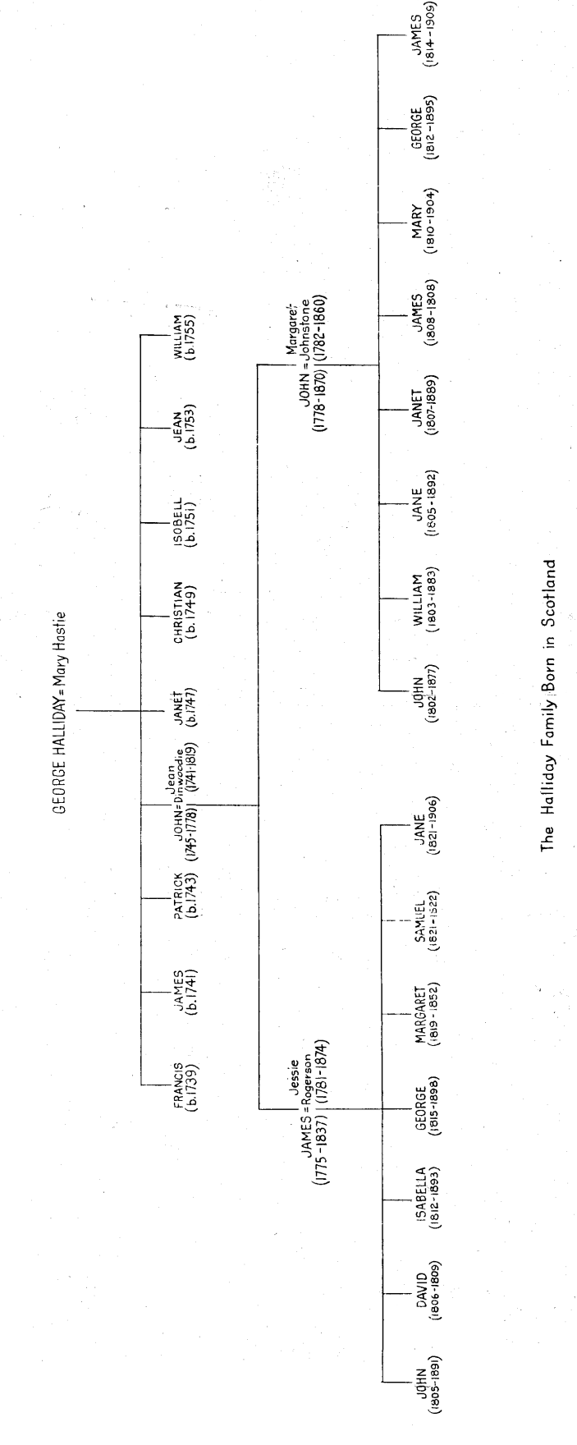

Chapter Four
Emigration
It is not to be supposed that emigration to such a far-off land as the Canadas was to be undertaken without preparation. Such preparation had been considerable.
On February 22, 1815, a Proclamation was published at Edinburgh which set forth the government's plan "to encourage settlers to proceed to the British Provinces in North America". This was the first time emigration had been given organized assistance by the government. Extracts from the Proclamation make the plan quite clear:
"It is the intention of His Majesty's Government to encourage settlers to proceed ... to the British Provinces in North America, and for this purpose a certain number of vessels will be appropriated for the conveyance of such persons as may be properly recommended.
"Lands will be granted to them, either in Upper or Lower Canada (where there is) a choice climate and a soil adapted for every branch of cultivation.
"A grant of one hundred acres of land will be secured to each family,
and all their male children will be entitled on attaining the age of twenty-one years, to a similar grant.
"For the first six or eight months ... in order to enable the settlers to establish themselves ... they will be allowed rations from the public stores.
"Axes and other necessary implements will also be furnished ... at a fixed price not exceeding the prime cost.
"Should any number of families... be desirous of settling in the same neighbourhood in Canada, care will be taken to allot them lands as nearly as possible contiguous to each other; and a sufficient portion of land will be appropriated in the midst of such settlers for a church and for the maintenance of a clergyman and a schoolmaster; and in case a sufficient number of settlers so united should be accompanied ... by a person of either of the above functions, who possesses their confidence and can be well recommended, a salary will be provided of £100 per annum to such minister and £50 per annum to the schoolmaster.
"In order to prevent persons from making an ... improper use of the liberality of the Government, it will be required that every person embarking for Quebec, should at the time of embarkation deposit ... the following sums: Every male above sixteen years of age, £16 sterling; every woman, being the wife of any person so embarking, two guineas. Children under sixteen years of age will be conveyed free of expense.
"Settlers ... will do well to send by post their proposals and certificates without delay. These testimonials must certify the general good character of applicants, their professions, former pursuits, whether married or widowers, the number of their children,... and the ages of all. These must be obtained either from a justice of the peace, clergyman or elders of the parish, or other respectable persons." (1)
No reasons are set forth in this Proclamation for the liberal assistance thus offered to encourage people to emigrate to Canada. Doubtless the economic and social reasons already described would be apparent to applicants, but the real reason for the government's generosity would be unknown. This might, indeed, have affected adversely the desire of some (among others, John Holliday) to emigrate.
For as far back as October, 1813, Lord Bathurst, Secretary for War and the Colonies, had suggested an emigration of "Scotch peasantry" who would be invaluable both for the present defence and the future protection of Upper Canada by offering them grants of land in that province and a free passage for themselves and their families". (2) As Senator Haydon said, "These words almost fully interpret the meaning of the settlement at Perth in 1816." (3)
This purpose behind the government's scheme was also implied, though not explicitly, in an official explanation published in the Caledonian Mercury, Edinburgh, March 27, 1815, in these words: "The wishes and intentions of His Majesty's Government are directed, not to an increase of emigration from this part of the United Kingdom (i.e. Scotland), but to divert to the British Provinces in North America the surplus population, which would otherwise proceed to the United States."
Since this plan for defence of the Colony was a prime reason behind the emigration scheme, a reason known and approved by the Upper Canada authorities (4), it is not surprising that civilian settlers found some administrative attitudes in Canada far from their expectation, far from their liking, and calculated to create dissatisfaction on the settlers' part.
One British citizen's idea of a good reason for the emigration, along with a method of locating the settlers in Canada, was advanced on April 22, 1815, in a letter from "Pro Patria" to the Secretary for the Colonies. The letter read, "As a person well acquainted with the Canadas ... I take the liberty of offering a few remarks on the subject of the colonization which government seems to have recently in contemplation I would therefore recommend chiefly to settle British Protestants in the Interior of Lower Canada .... By interspersing British Protestants among the Canadian Papists intermarriage would ensue, the population be gradually brought to Protestantism and the French character by degree lost in British descendants." (5) One can only speculate upon what the results would have been had an emigrant of John Holliday's character and religious views been so located in Canada. The advice of "Pro Patria" was not accepted by the government as a reason or a method for the scheme.
Whatever the basic reasons, however, the plan was a very attractive one. It offered a relief from present unsatisfactory conditions for many in Scotland and a reasonably good prospect of future conditions in Canada. The Government's assistance was considerable. Moreover, John Campbell, the government agent in Scotland charged with the organization of the scheme, proved to be competent and conscientious. Not only had he posted the Proclamation officially in Edinburgh: he had "communicated (it) in a variety of letters unto all the Newspapers that are published in Scotland" where it had been announced for several weeks; he had prepared a signed "handbill" which he circulated widely, sending it to every clergyman and having it posted in every post-office throughout Scotland. "It is my wish", he wrote, "fully to explain especially to the lower orders (sic) every circumstance in order that there may not arise any misconception of the nature of the compact."(6) So it is not to be wondered at that the response was quick and numerous.
As an immediate result the two administrative offices in Edinburgh and Glasgow were inundated with enquiries and tentative applications. By March 4, "at Edinburgh the number that have applied including children ... and dependents is already little short of 500. Here (in Glasgow) we have today had what I reckon about 200." (7) It had been decided to limit the emigrant party to 2,000 persons (8), and now, only eleven days after the first Proclamation, more than a third of this number was in sight!
The response to the scheme, however, soon ran up against a practical difficulty. This was the cash deposit which required £16 plus £2.2 from each family unit. The reason for the deposit appears reasonable enough. "This is intended", the Government explained, "both as a pledge that the settlers shall perform the conditions on their part, and to prevent persons from availing themselves of a passage to the United States. It also prevents persons of bad character obtruding themselves among respectable settlers." (9) In the event, it did not prevent a few emigrants from passing from Canada immediately upon their arrival there to the United States; (10) while some of the Colony's administrators later believed that at least one settler was "insubordinate" and presumably therefore "of bad character". What it did prevent was many would be emigrants, those who, in John Campbell's phrase, were "those poor but worthy respectable persons." So it was soon apparent that there would be no 2,000 emigrants ready to sail in April as the plan proposed.
On April 25th "the number of persons to this date who have lodged their deposit stands as follows: Men 62, Women 61, Children 181, - total 304". By May 6th they were. Men 80, Women 73, Children 230, - total 383. By May 24th, the statistics were: Men 108, Women 90, Children 276, - total 474. "Still", says Mr. Campbell, 'very few compared with what might have been expected". (11)
Another unexpected development was the congregation in Glasgow of many of these accepted emigrants. Glasgow was to be the port of embarkation. April had been set as the date for sailing, so many prospective settlers had given up their employment and repaired to Glasgow to be on time. But no transports had arrived. As a result the waiting emigrants found their scanty store of money and supplies fast disappearing. A good deal of bitterness arose over the situation. On May 26th, through Alexander McNab as spokesman, they expressed their feelings of disappointment with the delay and called for living expenses for the period since the end of April. Not until June 23rd did they receive the allowances requested.
On the same day, May 26th, the emigrants in Glasgow were joined by John Holliday, who had left his schoolmaster's position in Hutton parish ready for embarkation. Since that would appear to be too late for him to join in the petition for expenses, it was at least one protest by the emigrants for which no blame could be attached to John Holliday. It was, however, probably the last such.
It was during his stay in Glasgow that John Holliday was appointed schoolmaster for the settlers. According to one of their number, a Mr. Gibson, "They met regularly twice a week, many a plan respecting their future proceedings was discussed with more zeal than unanimity." (12) The subject of who should be designated their minister and who their schoolmaster was among the many. On the former they could not agree, on the latter they did. On June 12th, Mr. Campbell notified the Under-Secretary of State that he had "been applied to about a schoolmaster said to be picked upon by families amounting to 140 souls." (13)
Apparently Mr. Campbell thought an appointment rested with the Canadian Government, for he so advised the applicants. He was set right in this, being told from London that the Secretary would receive evidence of the appointee's ability and character. This Mr. Campbell obtained and remitted to Lord Bathurst on June 28th with the memorandum already quoted above, "I beg to send the enclosed recommendation from Settlers whose children amount to 128 in favour of John Halliday (sic) to be their Schoolmaster, his certificates for character and ability as an ordinary School teacher are satisfactory." (14) Before July 11th the appointment was completed. On that date Mr. Campbell reported, "I have acquainted Mr. John Halliday (sic) of Earl Bathurst having approved of the recommendation of him to be Schoolmaster to the Settlers, and that the necessary instructions were to be forwarded to the Governor of Canada." (15) The notification was made in writing and was still in John Holliday's possession in 1819. (16) This recognition by his fellow emigrants must have given him some considerable satisfaction.
Meantime, about the middle of June the transports began to arrive at Greenock, at that time the farthest point up-river for ocean going vessels. They consisted of four ships, the Atlas, the Dorothy, the Baltic Merchant, and the Eliza. The emigrants were to be towed on a schooner down the river from Glasgow to Greenock. The first contingent was to leave Glasgow at 3 o'clock a. m. on June 24th, the hour of a favourable tide. Mr. Gibson gave a vivid account of this departure. "Many of the families departing had met with much kindness and attention from the good inhabitants of Glasgow, hundreds of whom now accompanied them to the river, and saw them safely aboard the steamboat and schooner employed to convey them to Greenock. As they were to leave Glasgow at three o'clock in the morning, many of them came down to the Broomielaw the evening before, and remained on the wharf all night. The air was calm and serene but few were disposed to sleep. Interesting conversation filled up the passing hours, and the social glass went round oftener than once, for the "tee-total", scheme had not then even been thought of. At two in the morning the embarkation commenced amidst hurry, noise and confusion. Soon after three, the steamboat taking the schooner in tow passed down the river amidst the shouts of thousands who lined the shore bidding Adieu to their departing friends. The scene to many of the emigrants was the most affecting they had ever, witnessed. They were bidding a final farewell to their native land." (17)
The "final farewell" was delayed a bit longer. This first contingent reached Greenock before noon, but there were other contingents to be towed down the river and the final farewell would not be made until after their arrival. At Greenock the emigrants from the south of Scotland asked to be embarked on the one vessel "in order that they might be together" - The request was granted. John Holliday was, therefore, one of the 250 lowlanders put aboard the Atlas, Captain Joseph Turnbull. At last all was in readiness and on Tuesday, July 11th the Atlas weighed anchor for Canada.
An ocean voyage in 1815 was somewhat less than a pleasure trip. Both the accommodation provided and the length of the voyage made it something of an endurance test. The Atlas had been used as a troop-ship daring the late war and the civilians now aboard her were given the same - but only the same - accommodation as the troops had received. For families made up of adults and children, and of both sexes, this left much to be desired. The provisions likewise were those of the troops. Mr. Gibson described them as "ample in quantity .... but the quality of the bread and beef did not please (us).... The rum however was good as well as the pork, pease and oatmeal, and made some amends for the deficiency of other articles."(18)
The weather was fine until August 10th, when the ship ran into "a terrible gale which lasted 24 hours". The conditions created by the sea-sick passengers in a ship of that time with its limited sanitary conveniences were "shocking", to quote Mr. Gibson. It was cleaned only by bribing the crew with rum when, in an intoxicated state, they undertook to clean ship. Off the Banks of Newfoundland the weather was cold and foggy. Whooping-cough broke out among the children, most of whom contracted the disease, and a number of them died. At last, sixty-two days after leaving Scotland, the Atlas arrived at Quebec on Monday, September 4th.
The emigrants were now immigrants. The Scots had become Canadians.

Chapter Five
A New Life Begins
A new life in a new land had now begun. None of the immigrants would be fully aware of the degree of difference they would find between the old and the new. Instead of in the close-knit communities of Scotland, they were now to live in scattered bush settlements. Instead of the self-regulated order of Scottish burghs, they were to be governed directly by a military administration. Instead of the dependable, if meagre, amenities of an established civilization, they were now to encounter the uncertainties of a pioneer existence, - in religion, education, social life, and even in such necessities as food, clothing and shelter. How would they adjust to this new life ?
As now, so then! Adjustment was made according to the character of the individual. Some accepted the new life without questioning its terms. They were described approvingly for this characteristic by one military administrator as "the well-disposed, . . those who really came out for the purpose of settling." (1) Others were less willing to believe that a citizen, civilian or otherwise, should necessarily accept unsatisfactory conditions as inevitable. They complained among themselves, they discussed measures of redress. They would be signatories of any measure to channel a complaint to civic authority. But as individuals they accepted a role midway between the active and the passive. A third type of settler was the one who thought of adjusting the conditions to the people rather than vice versa and actively sought to procure such adjustment. He not only saw the grievance, he not only organized the discontent, but he made himself the leader of the cause. In doing so he did not endear himself to the authorities. John Holliday belonged to this third type of settlers.
The immigrants were not long in Canada before frustrations presented themselves. They were soon to be aware of the fact that though the Canadian authorities had been informed well in advance of their arrival that the Scots were coming, no effective preparations had been made for them. The passengers on the Atlas had arrived at Quebec on September 4th. At twelve o'clock the next day they were taken up the St. Lawrence ninety miles to Three Rivers. There they waited for ten days in enforced idleness while the summer waned. On the 17th they were taken by steamboat to Montreal where again they spent a few days "doing nothing", as one of their number reported later. (2) Already discontent was arising, to such an extent indeed that some deserted the party and settled in Montreal. "Others went over to the United States". (3) Sixty families continued the journey up the eighty-four miles to Cornwall. Here John Holliday's family, among others, was lodged temporarily.
As though the delays and frustrations of the voyage were not enough, the settlers now had before them the prospect of spending a long winter in idleness as well as being uncertain about where they would be located in the spring. To add to the discontent the winter quarters assigned the immigrants were apparently far from adequate. A detailed description of the various barracks and army store-rooms allotted them has not survived. But hints exist in various official reports sufficient to suggest that the occupants' complaints were in large part well founded. These reports, made in November, include statements such as: "I found it necessary to direct some repairs being made;" "At Cornwall I found about three hundred settlers... For these there was no adequate accommodation. The barracks...were in a bad conndition. I was obliged to direct ... a few stoves to be placed in them, the windows to be repaired, and some of the berths to be replaced"; "The barracks is now in a tolerable state for the accommodation of settlers". (4) Some of the settlers were indisposed to accept such conditions without complaint.
The first were made direct to London. During November one had been sent to the Prince Regent and one to Earl Bathurst. These had described the unsatisfactory nature of the quarters in Cornwall and also asked that "the full allowance of rations" be granted to their children. Apparently the supplies of food had been inadequate. These petitions had been circulated for signatures among the settlers by members whom the army administrator called "three principle leaders in the business", namely, William Old, John Holliday and Francis Allan. In the meantime and before action could originate in London, Governor Drummond had heard "a rumour that some of the settlers newly arrived have expressed discontent and even murmured at their situation". (5) On December 9th, he ordered his Quarter-Master General, Sir Sidney Beckwith, to investigate and report. The latter sent Captain Barnes to "ascertain the precise situation of the settlers". The latter reported to Beckwith on December 18th, and Beckwith to Drummond on December 23rd.
The report, extracts from which have been given above, is interesting on two counts. First, it practically confirmed the complaints by stating, "It appeared that some delay had taken place in the execution of your orders respecting the repair of those habitations hired for the accommodation of the settlers", and going on to report the various repairs that had been effected. Second, it employed the oft-used device of directing the blame for blameworthy conditions, not on the responsible authorities but on those who had complained about them. William Old, John Holliday and Francis Allan are referred to as "men of this description (who are) endeavouring to contaminate the minds of the well-disposed". (6) Actually, no "description" of the men is given beyond stating their occupations in Scotland, though the inference is clearly made that the very fact of complaint makes them subversive. Already, within four months of his arrival in Canada, John Holliday was a marked man.
Before the complaints at Cornwall were finally disposed of in the reports of December 18th and 23rd, John Holliday and about thirty other families of settlers had been moved from Cornwall to Brockville. Here, according to Sir Sidney Beckwith, the families were "accommodated in the barracks, in some adjoining huts hired by themselves, and in the neighbouring farm houses, where most of them (had) procured employment". It is not known in which type of accommodation John Holliday lodged his family. The reason for the move is not apparent. Already, however, John Holliday was in difficulties with the authorities in the new location. This time it was not over unsatisfactory conditions created by the administration and objected to by him, but over unsatisfactory conditions set by him and objected to by the administration. It arose over his vocation as a schoolmaster.
The settler families which had come to Brockville had been described as "thirty of the most numerous settlers", which apparently meant that they had large families. Mr. McDonnell, the Superintendent of Locations in Upper Canada, noted the large number of children and "proposed to Mr. Halliday (sic) to undertake their instruction and offered to provide a room, fuel, etc., for that purpose. To this proposal Mr. Halliday objected unless in addition to his salary he might be permitted to charge two dollars and a half for each settler's child put under his charge". (7)
Just at this time Beckwith was passing through Brockville and the problem was referred to him for a decision. He considered the fee too high for the settlers to pay. But he was "extremely solicitous ... that the views of His Majesty's Government in sending out these schoolmasters should be fulfilled", so he authorized necessary accommodation "granting (Mr. Halliday) at the same time the indulgence of receiving the children ... at the customary price, should the inhabitants wish to place them with him". (7)
It is difficult to determine just what the final agreement was concerning payment to the teacher. If "the customary price" referred to a proportionate payment of the £50 per annum contracted by the Government, then John Holliday must have dropped any request for an additional fee to be paid by the parents. For in a letter dated at the "Scotch Settlement, Perth, August 10, 1818," and signed by nineteen of the settlers, these settlers said John Holliday "taught our children in Brockville Barracks from Martinmas, 1815, to Whitsunday, 1816, for which he received no fee whatsoever, nor did we ever hear Mr. Holiday (sic) express an idea of making a charge for the same". (8) It would appear that if he made any demand at all for the right to charge private fees, it was made only to the Superintendent and was neither demanded nor even suggested by him to his fellow settlers.
Whatever the terms of payment, the teaching was done. In 1890 on the occasion of her eightieth birthday, Mary Holliday Fraser gave an interview to the Almonte Gazette in which she said that her father "taught in the barracks at Brockville for seven months". (9) Since Mary was then in her sixth year, she was probably a pupil in the school, along with her two older brothers and two older sisters. A more exact calculation of the period is given in the letter of his fellow settlers quoted above, namely, from Martinmas, 1815 (November 11th ) to Whitsunday, 1816, (50 days after Easter) which would be May 28th of that year.
The significance of the incident of payment does not lie in any of its details, (apart from the professional activity of the teacher during the winter), but rather in the fact that it was considered of sufficient importance to be included in a report by the Quarter-Master General to the Governor of Upper Canada. Surely this can only be due to the person involved, to a person already believed to have "contaminated the minds" of innocent fellow-settlers at Cornwall and therefore a man whose demands must be watched and probably denied, a man who would surely remain in character, the character already bestowed upon him by the military administration, - "a Malcontent".
Shortly thereafter an incident occurred in the community of more far reaching importance to the settlers that the poor accommodation at Cornwall or the fees of the teacher at Brockville. It arose over the location in Upper Canada where the settlers were ultimately to be placed. Rumour was rife concerning this. Some of it was fed by reliable word from junior administrative personnel, some by hearsay of doubtful value. It was established fact, however, that the area of the Rideau Lake country was not yet fully surveyed, not even a road to it being in existence. It was rumoured that the land thereabout was far from being desirable agricultural land. Moreover, it was far removed from the existing settlements on the St. Lawrence and Lake Ontario, where the new settlers might expect to find their supplies, their markets, and their social contacts. On the other hand, lands which did not have the handicaps of the Rideau and did have the advantages of the lake-front were still available farther west. As might be expected, the new settlers took some action in the matter.
On December 28th a petition was presented to the Governor through Dr.Thom, the army surgeon who had been entrusted with maintaining the settlers' health. In view of "the utmost dissatisfaction (which) prevailed among the settlers" it is surprising that the petition contained no bitter criticism of the government, but a restrained recital of the facts about settlement as the petitioners saw them. There is, however, a subtle appeal to the sympathy of the Governor when reference is made to the "numberless privations" they had undergone. And there is a not-so-subtle suggestion that if, at a later date they cannot send "a favourable report" of the Province back home to Scotland, the Province will be the ultimate sufferer. It concludes with a flattering word about the Governor as one always desirable of his people's welfare. The petition gives evidence of skilful composition by its unknown author. The text deserves to be recorded in full:
"The petition of the subscribers, settlers from Scotland, Humbly sheweth:
"That the petitioners emigrated from Scotland with the intention of settling in Upper Canada, and after having undergone numberless hardships and privations have arrived at Brockville, back from which place it is proposed to settle them; but, as they understand, this place not to be positively fixed upon, they have presumed to make the present application to Your Excellency, humbly trusting that you will permit them to settle farther up the country.
"The petitioners will humbly state the reasons which make them reluctant to settle on the Rideau, and likewise the inducements they have to proceed up. The crops in the Rideau are subject to hurt from early frosts; the lands are badly watered far cattle, at an immense distance from the St. Lawrence, and no water conveyance for their wood and produce. These are the reasons which chiefly prepossess them against the Rideau. To these, allow them to urge the advantages of the Upper Country - a great superiority of soil and climate, a much longer season for carrying on farming operations, and many other smaller advantages appear of incalculable advantage to them. The petitioners, in urging their request of being ' settled farther up, would beg of Your Excellency to consider that they have left their native country, many dear friends and relations, suffered many hardships, and submitted to numberless privations in order to obtain a settlement in this Province. How galling, then, would it be for them not to attain their object now when so near it, and how much disappointed would their friends and acquaintances be at home, who only wait for a favourable report from the petitioners before coming out to bless them here with their friendship and society.
"The petitioners will conclude with observing that, many difficulties as they have encountered, they would willingly undergo them again to obtain the settlement in the upper country, but they flatter themselves that what is so much their wish and evidently so much to their advantage, will at once make an impression upon Your Excellency, and that you will appoint some eligible situation for them on Lake Ontario, at least fifty or sixty miles above Kingston.
"May it, therefore, please Your Excellency to consider the foregoing petition and allow the petitioners to be settled farther up the country, and early enough not to lose another season, and that the situation may be as favourable as possible in respect to the conveyance of wood or produce.
"And your petitioners as in duty bound shall ever Pray -" (10)
The petition was signed by twenty-six settlers. As would be expected, John Holliday was one of them. Though a good penman, he was not the writer of the copy forwarded to the Governor, nor was his signature in any place of honour upon it. No charge appears to have been made that he was the "ring-leader" this time. It is, however, probably reasonable to believe that he who had been foremost on previous occasions when the settlers' wishes were presented to the authorities, that he who was the schoolmaster in their midst and not unaccomplished in the art of composition (as later letters make clear), should be again a prime mover in their petition to the Governor.
The settlers' request was not granted. Drummond did express the view that "owing to the impracticability of the Rideau scheme, the request of the settlers, to be allowed to go to the Bay of Quinte was not unreasonable", but Governor Gore's decision to carry out the original intent of the settlement prevailed. This was, of course, just the confirmation of the military purpose which the settlement was meant to serve.
Though the war of 1812-14 was ended, the Canadian government feared further American attempts to take Canada. The weakest boundary point was the St. Lawrence between Montreal and Kingston. Were that made impassable by enemy action, Lower and Upper Canada would be effectively cut off from each other. It appeared wise to establish settlements back from the St. Lawrence on waterways which would allow commerce between the two Provinces by way of the Ottawa and Rideau systems. By 1815 an area suitable for this military purpose had been selected by the Canadian authorities, had been approved in London, and the first steps taken to procure loyal settlers for it. It was unthinkable that, these settlers now being as near the site as Brockville, their desires for good agricultural land or the government's own delays in forwarding the scheme should be allowed to interfere with the original defence purpose. The settlers must go to the Rideau area.
By the middle of March, 1816, the delayed surveys of the new settlement were under way. Until then the most northerly surveyed area was a bank of five townships, being from west to east North Crosby, Burgess, Elmsley, Montague and Marlboro. Now the surveyors were busy mapping out four new ones north of these, later to be known as Bathurst, Drummond, Beckwith and Goulburn. The centre for the settlement was to be located somewhere near the line between these two banks of townships. The site ultimately chosen for this depot was at the south-west corner of Drummond and later was named Perth. (See map E.)
With the surveyors' work completed and the depot established, there was considerable activity in Brockville, as the settlers made ready to move. This was complicated not so much by the abundance of their goods as by the poor means of transport available and the condition of the bush trails. The first stretch was called the Turnpike Road which ran north-west from Brockville twenty-six miles to Stone's Mills (or the Stone Mills) on Upper Beverley Lake. From there the route lay twelve miles north to a point near the Rideau Lake called The Bay (now Portland). They "had to cut a road the last three miles to reach the lake." A scow took them down the lake a distance of about ten miles, then ox-sleds drew them a mile-and-a-half through the bush to the Tay river (also called the Pike), where again scows were used to convey the settlers to Perth. A trek of some considerable difficulty (See map E)
No extant records indicate the exact dates upon which the settlers at Brockville set out for their homesteads. It must, however, have been in the later part of March and early in April, for one of their number, Archibald
Morrison, said in his story of the settlement that on March 22nd they "began to clear the road to the settlement and in another month were placed upon the land. This agrees in time with the report from the site made on March 25th by Reuben Sherwood, chief surveyor of the new settlement, which concluded with the statement, "The settlers have this moment arrived with their knapsacks and axes." (11)

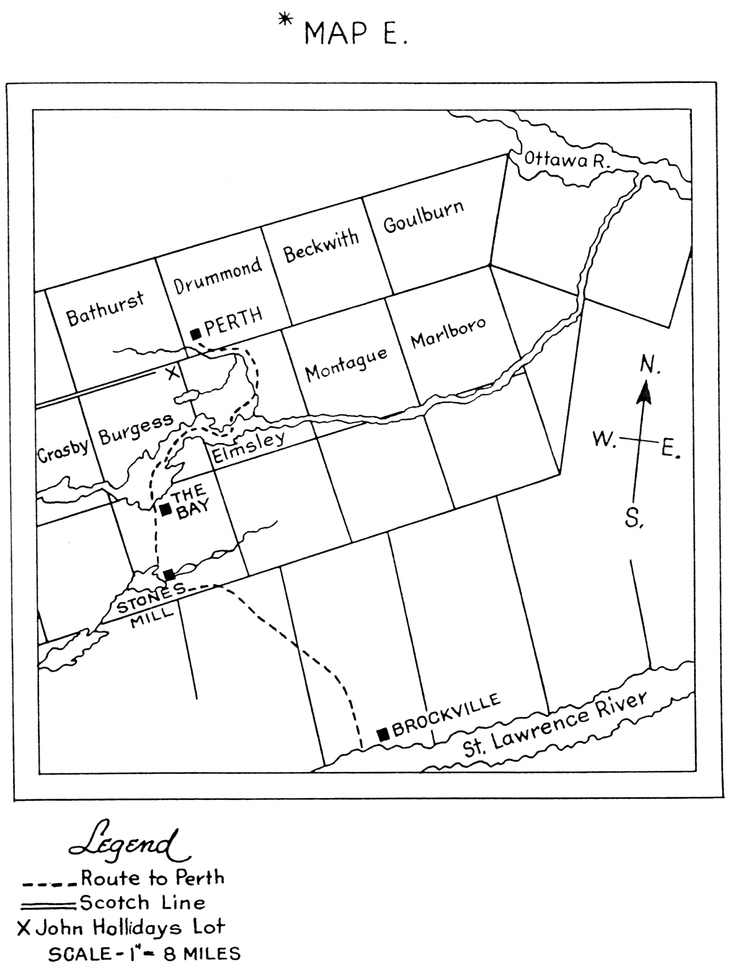

The trek from Brockville to Perth must have been taken by small contingents of the thirty families and over some time. By April 17th, however, the larger number of them had reached the settlement. At least fourteen location tickets for the tenth concession of Burgess alone bear that date. Among those officially settling on that day was John Holliday. His location ticket, No. 38, read as follows:
Superintendent's Office,
Perth, U. C., 17th April, 1816.
THE BEARER, John Holliday, Esquire is Located on Lot - A in the Tenth Concession of the Township of Burgess, County of Leeds and District of Johnstown.
THE CONDITION of this Location is such, That if the above named John Holliday - is not residing upon, and improving the above described Lot, clearing and putting in crops at least four acres yearly, then this Title to be void and of no effect, and subject to be immediately re-granted. N.B. After Location no exchange can take place, nor is this certificate of any value but to the original Grantee.
By Order,
(sgd.) D. Daverne,
Superintending Settlers.
Oddly enough, though John Holliday was officially located on his land on April 17th, he and his family were still in Brockville. His homestead site, Lot A, was selected for him by fellow settlers who had preceded him to Perth. According to his daughter Mary, John Holliday reached Perth in May, (12) according to Robert Gourlay it was July. (13) One would suppose that a man of John Holliday's temperament would delay such an important event as his choice of land in Canada only for some good reason. With the settlers already on the move, his schoolmaster's duties in Brockville would be over and could not be the reason. A domestic situation existed, however, which may explain the delay. It would also confirm Mr. Gourlay's statement of 1817, as opposed to Mary's statement of 1890. In June, 1816, John Holliday's wife, Margaret Johnstone, was delivered of a son. That would mean that in April, when the settlers were leaving Brockville to negotiate the difficult bush trail to Perth, his wife would be from seven to eight months advanced in pregnancy. Obviously there would be a considerable measure of risk both to mother and unborn child in such a journey. None could question a decision to delay the move; and it could well be received by fellow settlers as reason for their proxy on his behalf and by officials in Perth for issuance of the Location Ticket in absentia.
John Holliday's arrival at Perth on the later date may be accepted as reasonable. The venture that had begun for him in May, 1815, in the established civilization of Scotland had completed another stage in its history when in July, 1816, the Scots schoolmaster became a pioneer settler in the Canadian bush.

Chapter Six
Pioneering On The Scotch Line
"When (my father) and his family reached what was to be his future home, (my mother) sat down at the root of a big basswood tree until her husband and his neighbours put up a shanty. She had eight children beside her, and one of them (an infant) who was born in Brockville". (1)
So said Mary Holliday Fraser on the occasion of her eightieth birthday in 1890 as she recalled a momentous event of her sixth year. It was the day when her father, John Holliday, had arrived with his family on the Scotch Line homestead and she, as one of the eight children, had sat below the basswood tree.
Those words, "a big basswood tree", give a clue to the nature of the land, a land covered with forest. His neighbours helped him "put up a shanty"; and that tells of the first co-operative effort required of all such pioneers, - the provision of shelter. While the young family of "eight children" gave promise of a labour asset of great value in a pioneer household. The early years of the Holliday family on the Scotch Line revolved in large measure around those three elements.
The nature of the Upper Canadian bush at that time is well described by a visitor who wrote of his travels, "These lands were so thickly covered with forest trees standing near each other, and of so large a growth as almost wholly to exclude the sunshine from the soil in the leafy season... Hardwood trees of fifty and sixty feet high were plentiful; some white pines there were whose height was found to be a hundred feet." (2) An early settler described these dense forests in terms of their stillness. Apart from a few pigeons, he had heard no song birds, "different", said he, "from at home. No sound of music is ever heard there, but a melancholy death-like stillness reigns through the forests, except when they are agitated by the tempest or the storm." (3)
To the first settlers bush like that was not an asset, but a liability. Trees were a nuisance, standing in the room of arable land needed for food production. So the trees were felled. Most were piled indiscriminately for burning. They had no value as lumber, saw-mills being far distant. A relatively small amount was turned into cordwood which sold cheaply on the Perth market. The potash from the burning was more readily saleable and was almost the only product that summer which brought cash to the pioneer household.
One of the basic errors which had been made in the establishment of the depot at Perth had been the omission of over-night accommodation for the settlers as they arrived. They had, therefore, to erect shelters upon their homesteads immediately. These were primitive enough. Mr. Bell described them as "huts covered with boughs or bark". Such was the "shanty" built by John Holliday and his neighbours on that first day.
A temporary shelter being thus provided, the family proceeded to the task of clearing the land for crops. "In a new settlement", as Mr. Bell said later, "much labour and perseverance are necessary, to cut down woods, to build houses, and inclose fields; but here these are not wanting." Doubtless John Holliday would be able to use the labour of his two oldest children, - John of fourteen years and William of thirteen - in the lighter tasks incident to clearing. It will remain a conundrum how a man of thirty-eight who had spent at least the past thirteen years of his life in the sedentary work of a Scottish schoolmaster was equal to the physical labour involved in the clearing of the Upper Canadian bush.
To add to the pioneers' difficulties the tools provided by the government as part of the emigration contract (see above, chapter titled "Emigration") and paid for by the settlers proved to be inadequate for their purpose in Canada. Early in 1817, when the settlers had had a year's experience behind them, the Quarter-Master General reported on the axes which had been provided. "I am convinced", he said after his investigation, "that they will be of no service to (the settlers). They were made in England, and although the shape and weight comes near to that of the felling axe of Upper Canada, yet the manufacture is different, and axes of the same kind have been found to open out and give way at the eye when the handle is fixed.... The very existence of a settler depends upon a good and proper axe." It was not until 1819, however, that the slow-moving army administration made a final decision in the matter. Its Board of Enquiry, Montreal, made its finding in these words, "Re. 9, 881 common English axes which were sent out for settlers: These are not fit for settlers, being too narrow and too long and not of sufficient weight. In the opinion of the Board they will serve for no other use than for splitting wood. (It is recommended) that a portion be allotted for the Service, and that the remainder be returned to England, as if sold in this country they would only bring the price of old iron". In the meantime the Scotch Line pioneers were doing as best they could - and most of them did remarkably well - felling huge trees with axes fit only for splitting wood. Doubtless they expressed their opinion of the axes and of the delay in remedial action.
As though heavy bush and inadequate tools were not enough, nature itself contributed to the difficulties of that first year on the Scotch Line. One of the trials so added was the prevalence of insects. Mosquitoes thrived in the bush, where swamps covered the low-lying areas. One settler, recounting some of the problems of pioneering in Canada, wrote: "In addition to these difficulties, we had to encounter another - mosquitoes; wherever they sting it pierced through the skin. I have had my legs pierced all over with the fangs of these tormenting and mischievous insects, and from the effects of their bites they seemed as if they had been covered all over with the smallpox." (4) On occasion these hordes of insects could render further immediate work in the bush impossible. Even so determined a man as the Reverend William Bell discovered that they could prevent him from carrying on the work to which he had dedicated his life. He reported in his Journal that on June 25, 1817, the very morning after his arrival at Perth, he had set out to visit his new parishioners on the Scotch Line. "The day was hot", he wrote, "but the mosquitoes annoyed us so much that we had not proceeded more than two miles when we were forced to return."
Another natural phenomenon plagued the new settlers. Instead of the usual Canadian summer of warm days conducive to crop growth, the summer of 1816 was cold and wet, with virtually no June-July-August heat. It became known as "the summerless year". This resulted in very meagre growth on the necessarily small plantings, so that, as one writer put it, "the poor Scotsmen had a bad start". When Lieutenant-Governor Gore of Upper Canada visited the settlement in October that year he found that the crops of 1816 had been so unproductive that he recommended to Sir John Sherbrooke, the Governor for Canada, that the government continue the issue of rations for the settlers beyond December 24, the date originally contracted for. When Sir John asked for a detailed report from his Quarter-Master General he was told, "I am of the opinion that none of the settlers of Perth and in its immediate neighbourhood are in a state to provide for themselves during the winter.. . . I would, therefore, beg to recommend that rations of provisions be issued to them until next June." (5) The immediate results of the farming operations that first summer were not very encouraging.
In other respects, however, John Holliday and his family had made considerable progress. Having supplied a temporary shelter for his family with his neighbours' help, he had proceeded with the arduous task of clearing the land. Though hampered by nature and by government, this task had some success. Three reports exist as to the acreage cleared in that first season by the Scotch Line settlers. Lieutenant-Governor Gore's report stated, "Many (settlers) have cleared and sown from 6 to 10 acres of wheat. 11 Mr. Bell wrote a letter on July 11, 1817, to his Presbytery in Edinburgh in which he said, "Each settler has from 2 to 6 acres cleared, which in another year will support his family .... It is evident the settlers have not been idle." (6)
In that same month, July 1817, Robert Gourlay travelled up the Scotch Line and visited each settler in turn. He collected from each quite complete data about the settler's new life. From John Holliday he learned that in the first year (which would include the winter months of 1816-1817) he had chopped 7 1/2 acres of bush, had cleared 6 1/2 acres, and had sown 3 acres in wheat and 3 1/2 acres in other grains. (7) Gourlay's report emphasizes the size of the task when it distinguishes among the chopping of the trees, the clearing of the stamps and brush, and the sowing of grain. Probably John Holliday would not in that first summer be as far ahead as some of his neighbours who had arrived three months ahead of him. But the exact statistics of Robert Gourlay's survey are proof that whatever skill the Scots dominee may have had with pen and tawse, he did not lack skill also with axe and plough.
Another urgent project additional to land clearance faced the Scots settlers that summer. This was the provision of more adequate shelter for their families. As already shown, the first shelters constructed were rude indeed, being little more than palings interlaced with branches and covered with bark. Such were passable for summer weather, though in that "summerless year" of 1816 they must have proved far from comfortable. They would certainly be useless as shelter against a Canadian winter. And winter was fast approaching. On October 15 Governor Gore reported, "the settlers already begin to feel the severity of this climate, living under canvas and in small huts." Many settlers must have recalled at this time, - and not without a grim humour - the words of the emigration Proclamation in Scotland describing their prospective location "in Upper Canada, where there is a choice climate." So every settler had to take time in the early autumn to build him a house.
John Holliday's daughter Mary said years later that "during the fall of 1816 (my father) built a large log building and covered it with bark." (1) Robert Gourlay was more exact in his report, giving the dimensions of John Holliday's house as being 33 feet by 19 feet. For a family of ten persons this does not seem to warrant Mary's descriptive adjective "large", and must surely be rightly used by her only if it is by comparison with other log houses built in the neighbourhood. A general statement by Gourlay supports this inference, when he says that the larger number of settlers had log houses "mostly 23 feet by 16 feet". John Holliday's house, therefore, - 10 feet longer and 3 feet wider than the average one - could be described as "large". The reason for the size was given by Mary when she added, "Part of the building was used for a school-house." (1) Such houses, if properly caulked between the logs - and this one seems to have had an additional insulation from a covering of bark - were adequate protection even from a Canadian winter. So apparently John Holliday's family faced their first winter in Canada with good shelter and a good beginning made on the clearing of the land.
The clearing doubtless continued throughout the winter months. As the winter drew to a close the family engaged in another out-door activity, and here even the younger members might have a contribution to make. This was the production of maple sugar. Hard maples grew in abundance on the homestead. Tapping the trees, collecting the sap, boiling to syrup and then the sugaring-off were the regular procedures. While this was a change from the arduous work of chopping trees, it was not recreation. The next year's supply of sugar for the household depended upon diligent use of time and careful attention to each step in the process.
John Holliday's family gave the required attention. In September, 1817, Mr. Bell wrote to a friend in Scotland that "most of the settlers made as much (maple) sugar last spring upon their own land as will last them through the year. In the spring it was sold for 6d. a pound, now it is up to 15d." Robert Gourlay reported that the Hollidays had made 50 pounds of maple sugar that spring.
As already indicated, the bush crop of sugar was as important to the family's food supply as was the field crop of wheat and oats and barley. According to one of John Holliday's grand-daughters, each spring saw large blocks of maple sugar stacked in the pantry from floor to ceiling. This was meant for ordinary, family use. Refined sugar was a luxury. The household's small stock of it was carefully husbanded for special occasions such as the minister's pastoral visit. The years have reversed the roles of the sugars: the luxury of the early day has become the commonplace of today; the pioneer's commonplace has become a luxury for his descendant.
An interesting sidelight on the imposed self-sufficiency of the pioneer household is given in a novel of early life on the Scotch Line, "Perth-on-the Tay", sub-titled "A Tale of the Transplanted Highlanders". (8) While the plot of the tale is fictional, its descriptions of life are factual, even for those numerous settlers who were from the Lowlands. In one incident narrated the writer gives the menu of a dinner in a Scotch Line cabin. "This was the dinner: Barley brose and kail, pigs' feet, potatoes grown on new land and by and by bannocks and maple syrup from pure Canadian sap." Every item on it could come directly from the pioneer homestead. The fact inspired a popular ditty of the period:
"I grow my own lamb,
My own butter and ham;
I shear my own sheep,
And I wear it. "
The task of clearing and cropping the hundred-acre homestead proceeded steadily, each year seeing a few more acres reclaimed from the bush. Doubtless each year also saw the boys in the family more able to take a share in the work. Since their father was teaching in the Scotch Line school at the same time that he was clearing his land, the pressure upon all in the household must have been considerable.
Nor would all these be incident to the out-door work on the land. While little exact information exists about the family life in the home, enough can be deduced from external events to give some idea of it. Its furnishings in the first years would be sparse. According to Mr. Campbell in Glasgow most families in the emigrant body had taken with them such baggage as "webs of linen and woollen staffs, uncut". They also had "clocks, bellows, wheels and reels". John Holliday would doubtless be among the majority, so one can assume that "wheels and reels" would be in the home for the spinning and winding incident to home manufacture of clothing. It is to be hoped he had also brought some of the "woollen stuffs, uncut" for the more urgent needs of a Canadian winter. Such activities would devolve upon Margaret Johnstone Holliday and her older daughters, Jane of eleven years, Janet of nine, and possibly even Mary of six. John Holliday's wife would be one of the most industrious members of the household as she managed the distaff side of a large and growing family.
Only a few items of household furniture of those early years now are known to survive. One is the "grandfather clock" According to Scots custom, a family clock was bequeathed to the youngest son. John Holliday was himself the youngest son of the Berryscaur family and may well have been given the clock by his widowed mother when he left Scotland. Be that as it may, the clock which told the hours in the log house on the Scotch Line was left to John Holliday's youngest son, Calvin. Through him it has descended through two more generations of youngest sons, being now in the Canadian West in the possession of Calvin's grandson.
A further item of furnishings brought from Scotland was crockery. Since china of any quality would be difficult to replace in the Canadian bush, doubtless great care would be taken of the various pieces used on the family table. At the same time, the fragile nature of the article militated against its survival.
John Holliday's oldest son, John, passed on to his youngest son an interesting souvenir of the pioneer household. It is a snuff-box, hollowed out of horn and mounted with a silver, hinged cover. This cover bears upon it what is alleged to be "the Halliday family crest", a wild boar's head with the inscription on the ribbon "Virtute Parta". This is flanked by the initials "G. H." Although no coat-of-arms is known to have been issued to an Annandale Halliday, and therefore the use of a crest is suspect, it is tempting to believe that the snuffbox is an heirloom John Holliday inherited from his grandfather, George Halliday, the wauk-miller of Dumcrieff and Berryscaur. The box is in the possession of one of the schoolmaster's great-great-grandsons in Ontario.
There were books in the Holliday household, as might be expected in a ,schoolmaster's house. These would not be numerous enough to be considered a library by today's standards. Neither pioneer conditions nor a pioneer schoolmaster's needs demanded or allowed such. Not many of his books have survived, though those which have illuminate the ideas favoured in the household. The two most important volumes were bibles, one being the Family Bible in which were inscribed the record of family births and deaths. It probably was obtained in 1801 on the occasion of the marriage of John Holliday and Margaret Johnstone. This Family Bible passed on her father's death to Mary Holliday Fraser and by one of her descendants to a grandson of her brother James. The book appears to have been lost quite recently.
The Family Bible was not meant for frequent, household use. For the daily worship and for individual study another bible was provided, less pretentious in appearance. This volume was much used, as its worn, well thumbed pages testify. It is now owned by one of Mary Holliday Fraser's great-grand-daughters in Perth.
At least three other books have survived the years. One is a book of five tales by James Hogg, "The Ettrick Shepherd". It is entitled The Brownie of Bodesbeck, its stories being about the persecution of Covenanters in the very Annandale whence John Holliday came. It must have appealed greatly to him, both for its geographical and its religious elements. The book bears his signature, dated 1858. Quite appropriately, it stays now with the household bible.
Two books belong conspicuously to his pedagogical career. One is "Brande's Encyclopedia of Science, Literature and Art", published about 1840. An older book, "The Classical Geographical Dictionary", was published in 1715 and bears John Holliday's signature on its fly-leaf with the date 1812. It may well have been a text-book from his years as schoolmaster in Boreland. These two books are now in the possession of a great-grandson, the author of this biography.
Doubtless other items from the Scotch Line household do still exist in the care of various descendants. At no time, however, would the furnishings of the house be of such quality or uniqueness as to insure preservation of many of them. It was a pioneer household.
By 1819 settlement was far enough advanced for thoughts about title deeds to the land. On August 2 of that year twenty-nine of the settlers, of whom John Holliday was one, petitioned the Lieutenant-Governor to issue them their deeds. They gave two reasons for it: First, that Earl Bathurst had promised it when the primary conditions of settlement should be fulfilled, as was now the case; and Second, since it was reported that the area was to be allowed to send a representative to Parliament, they would not have "fall power to make that choice until we receive by the grant of our Deeds an indisputable title to our Freeholds".
Apparently the petition was favourably received. On June 28, 1820, Mr. Bell's Journal reported, "The deeds of those who have been three years and upwards upon their lands will be issued in a short time. Soon after this we shall all have the privilege of electing a member to represent us in the Provincial Parliament. Six candidates for that honour have already offered themselves". That election took place on July 10th.
The reference to the franchise in the petition indicates that the settlers were ready and even anxious to exercise all the rights of citizens. The degree of such interest would vary among them and there is little evidence extant to show that John Holliday took a very active part in political life. This appears at first sight to be contrary to the character of the man who had been so active as a leader in promoting the community interest at Cornwall and Brockville. It has been suggested that, once established on the settlement as its schoolmaster, the salary for which was paid from defence appropriations by the government, John Holliday would consider himself virtually a civil servant precluded from political activity.
Be that as it may, the only known record of a political interest by him is in a news item of The Independent Examiner, Perth, in 1830. It reads as follows: "Burgess and Elmsley inhabitants convened in the Wellington Tavern in Perth on Tuesday, 5 October 1830, with Jonas Jones in the chair and John Holliday as Secretary. Resolved - to assist in the election of Mr. Gowan and Sherwood. A Committee was formed composed of John Stewart, (teacher) Jolm Holliday.... (etc.)" It appears from this report that John Holliday gave political allegiance at that time to the government party, known as Tory. The party which Gowan and Sherwood, both of Brockville, were supporting is not immediately apparent. However, one of the members of the Committee listed in the newspaper was a Dr. Reade, who himself was a Tory party candidate in Perth in 1833.
One might expect John Holliday to support the anti-government "Reform" party, since he had been in personal conflict with local government representatives on several occasions. By 1830, however, the issues had been revolved in his favour, while by that date he had come into conflict with some of the leading "Reformers" of the area, notably Rev. Mr. Bell. Local animosities such as that one could have the effect of making John Holliday a supporter of the Tory party, though apparently it was not a very public or continuing support.
There is evidence, however, that the schoolmaster had a considerable place in the less-public affairs of the local community. He seems to have been something of an adviser to neighbours on matters of thought and conduct ranging from religious belief to the problems of "star-cross'd lovers". It has been pointed out (9) that Mr. Bell paid unwitting tribute to this place John Holliday held in his community when he admitted that many of the Scotch Line settlers withheld support from their minister's views because "a knowing man like Mr. Holliday had denounced them." On another occasion he gave further evidence of John Holliday's influence in religious matters. In August, 1830, he discovered what were to him "very odd notions" existing among some of his parishioners relative to religious doctrine. When he tried to argue against them one of his parishioners rejected his argument and "proved (his own interpretation) to be true, not by reference to scripture, but to the opinions of Mr. Holliday". (10)
Another instance of the same community influence, though in a different field, cast John Holliday in a role similar to that of the popular columnist of a later day. The story is vouched for by direct oral transmission from the bride herself, the names of 9-11 the parties immediately concerned being in the possession of this reporter. A young couple on the Scotch Line were preparing for their marriage when the prospective bride broke the engagement and left the area with the man of her new choice. The rejected suitor was heart-broken, but apparently believed that the centre of the affections could be repaired if another bride could be found. He went to John Holliday for advice. The latter suggested a Scotch Line lass who was eligible and might be available. She, however, declined the proposal and the would-be groom repaired again to his adviser. A second name was given to the young wooer, but she also refused the honour. Since both these young ladies married other local youths within the year, it is reasonable to suppose that their affections were already centred elsewhere. For the third time the rejected suitor went to John Holliday. This time the suggested lady accepted his offer of heart and hand. The couple were married. John Holliday was present at the ceremony.
As the years went on life in the pioneer community became less rigorous. This did not mean it was less active, simply that some of the hardships of the first years were disappearing. Thus, reasonably passable roads replaced the trails through the bush. Mr. Bell had described his first attempt to visit his Scotch Line parishioners in 1817 as a tiring trip, "going around swamps, climbing fences, and getting over fallen trees". Before long the Scotch Line could be traversed its full seven miles on horseback or on wheels. As the homestead was cleared time and labour were available for work that brought in a cash income. "The farmer, his boys and his horses found employment in the bush, in the shanties, and on the 'drive' in summer, bringing money to the family hearthstones to meet the pressure of current necessities. And so household wants found relief". So wrote an historian of the area in the Perth Courier Centenary Edition of 1934. It is doubtful if John Holliday himself engaged in this outside bush work, his school keeping him on the Line, but his older sons certainly did. The household benefited.
In due time, though the exact date is uncertain, John Holliday found the "large" log house of 1816 quite inadequate. It was inadequate in size for a family which increased from the eight children of 1816 to twelve by 1826. It was inadequate in style for a homestead becoming more prosperous each year. So the log house was replaced by a stone one. It stood two-story high. Its centre door was surmounted by an arched fan-light and flanked by vertical ones. The entrance was balanced on each side by a window for the respective "front" rooms. Above it, a gable in the roof-line gave space for a second-story window. It was typical of the period, unpretentious, yet with a solid appearance that spoke of hard-won achievement. It indicated successful pioneering effort.
With time one member of the Holliday family after another grew to adulthood. As the four boys who had been born in Scotland became twenty-one years of age, they applied to the Governor-in-Council for the one-hundred-acre grant of land to which they were entitled by the original emigration contract. This removed three of them from the Scotch Line. As the four boys who had been born in Canada grew to manhood they became apprenticed to the trades of their respective choice. This removed them also from the parental roof, the village of Perth being usually their first place of settlement. As the four girls grew into womanhood they married and set up homes elsewhere. Only one member of the twelve remained on the homestead, the fourth son, James. On August 24, 1846, John Holliday sold the farm to James for the sum of £330. On September 23. 1876. the homestead passed out of the Holliday family when James sold it to John Armour for $5,600.00 (11)

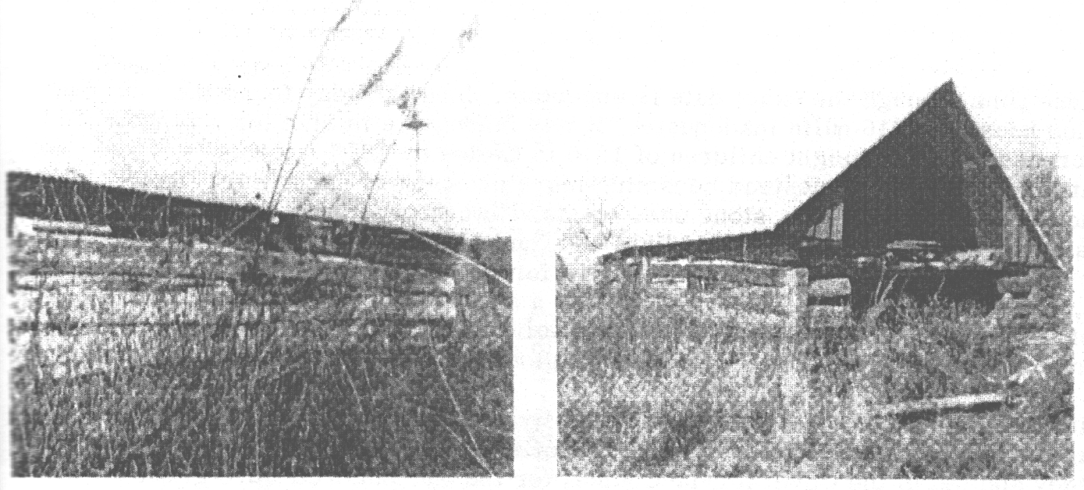
Remains 146 years later of log house built in 1816

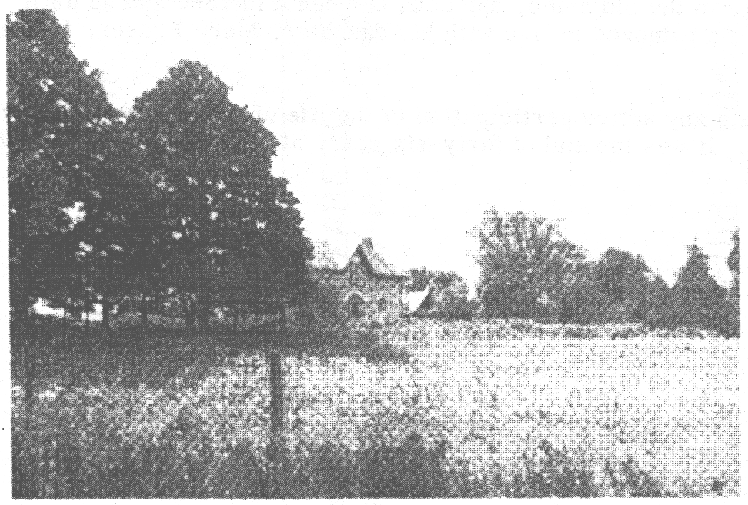
The Scotch Line Homestead
Note: In 1998 it was learned that the house was sold by the Armour family, restored, sold again and is now owned by Kevin Daly. The original log "shanty" has vanished with the exception of an outline in the brush behind the stone house.
John Holliday had owned the property for thirty years. At the age of sixty-eight he was, doubtless, ready to retire. He and his wife continued to live with their son, however, in the old home, she until her death in 1860 and he until 1862. In that year he removed to live with his daughter, Mary Fraser, farther up the Line.
From that date any active participation in the life of the community may be said to have ended. It was the end of forty-six years of pioneering on the Scotch Line.

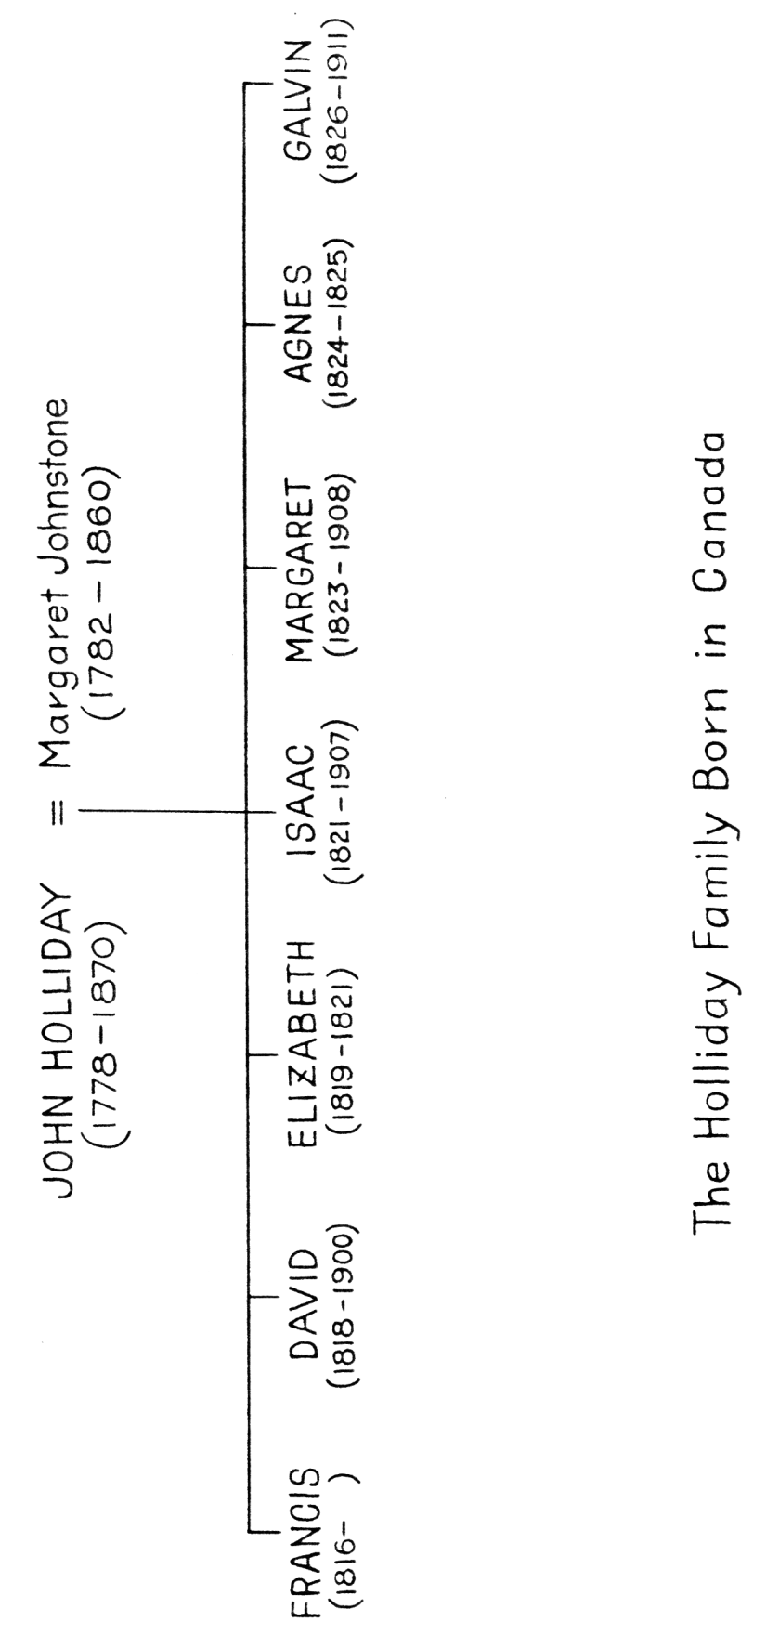

Chapter Seven
The Schoolmaster
When the Scots immigrants had sailed from Greenock one at least of the many problems of a pioneer community appeared to have been resolved. This was the important one of their children's education. While the equally important subject of a religious leader for the group had created disunity and they had sailed without a clergyman, a schoolmaster had been appointed. And apparently to the satisfaction of all. Some years later the Reverend Mr. Bell said that Francis Allan, one of the emigrants, had offered to be the teacher when an appointment was pending, but he "was rejected: his hand-writing being the principal, if not the only thing, to recommend him as a teacher". (1) This, however, is not mentioned in the official emigration records, whereas the appointment of John Holliday at the annual salary of £50 did receive full government approval. So the pioneers came to Canada in the assurance that their immediate needs for education were met. John Holliday would have no reservations about his future role in the community.
It was when the settlers were wintering at Brockville that the first hint was given of any possible flaw in this pedagogical arrangement. There was some disagreement between the local colonial administrators and the appointed schoolmaster. This did not, however, prevent a settlement being reached for that winter. John Holliday opened his first Canadian school in Brockville and taught the children of his fellow immigrants that winter and spring from November 11 to May 28. It was to be discovered later that the terms of the agreement at Brockville were not clear to both parties. Charges and counter-charges were exchanged before the matter was finally settled some four or five years later. (2)
A more serious problem relative to John Holliday's role as teacher in the Scotch Line community was soon to arise. It involved four parties and four positions: that of the government officials toward John Holliday; that of William Bell as a teacher in Perth; that of the settlers toward their children's education; and that of John Holliday toward his appointment as schoolmaster. Only after some years of disputation among the four principals was John Holliday's position in the matter approved as correct and his role as schoolmaster to the settlers finally established.
How long he taught is not clear. He was teaching as late at 1842, but in all likelihood did not continue long after that year. It is probable that his tenure was not continuous, being interrupted for one or two brief periods when non-payment of his salary forced him to give more attention to his farming operations.
It is unlikely that any teaching was done in the summer of 1816. That period would be given over, understandably, to clearing operations. When, however, John Holliday had built "the large log building" in the fall of that year, the building meant to serve as house and interim school-house, doubtless teaching began forthwith. On September 21 Col. Cockburn had reported to the Governor that "a schoolhouse is needed", but this does not rule out the probability that a school was already in operation in the schoolmaster's house. According to Mary Holliday the settlers who had preceded her father to the settlement had selected Lot A as "a lot for Mr. Holliday where they wished to have their school". So an early beginning upon his pedagogical duties would be a moral obligation upon him. He would also be anxious to begin earning a cash income. Only subsequent events would show that receipt of this desirable incentive would be long delayed.
The first hint that all would not be smooth sailing for education on the Scotch Line under the aegis of dominee John Holliday came in November, 1817. The Reverend Mr. Bell had reached the settlement in June of that year. Contrary to the expectation of the Scots on the Line, he had established his church and his manse in the village of Perth. He was a well educated man himself and knew the importance of elementary schooling. So it is not surprising that in November he wrote in his Journal, "Finding there was no school in the settlement, I determined to have one established". (3) With Mr. Bell to "determine" was to act. He at once proceeded to set up a school in Perth.
Doubtless he had no idea that this school would affect in any way the teaching being carried on by John Holliday on the Scotch Line. His school would be for the children resident in the village. It was receiving the financial support of the settlers there, most of whom were government officials. He certainly expected that his payment as schoolmaster would be from the pupils' fees. When he was notified that he would receive £50 per annum from the government additional to the fees, he said the notice was received "to my surprise". Mr. Bell did not realize, however, how the salary had come to be paid to him nor the hard feelings which would be generated in the Scots community as a result.
The local administrative officials had had what in their opinion were two good reasons for establishing Mr. Bell as the settlement's schoolmaster. First, they did not like John Holliday. He had been troublesome at Cornwall: moreover, his complaints there had been well founded and responsible officials had been forced to take cognizance of them. Again at Brockville he had proved less amenable to official decisions than was to their lilting. So when an alternative to him as holder of a semi-public position on public pay presented itself in the person of Mr. Bell, the opportunity to reduce John Holliday "to size" was not to be missed.
Doubtless, however, a second and eminently just reason for the appointment of Mr. Bell would be present to Perth officialdom. Their children in the village needed a school; the one on Lot A on the Scotch Line was too far removed for their use; a clergyman was resident among them and a clergyman was frequently the parish schoolmaster.
What the officials failed to recognize was the fact that John Holliday's appointment and salary had been established by the highest authority there was, Earl Bathurst, Secretary for the Colonies; that John Holliday held written proof of that fact; and that John Holliday did not submit to injustice with resignation. What Mr. Bell failed to realize was that the local officials had procured his salaried appointment in John Holliday's place and that even then he was only accepted as a second-best stop-gap, to be shouldered aside two years later when a clergyman of the Church of England would be available to supplant the Presbyterian. Mr. Bell appears to have been quite innocent of any intentional wrong to John Holliday or the Scotch Line settlers. Indeed, he did his best later on to see that justice was done to both.
The story of John Holliday's first years as schoolmaster on the Line is not clear on all points. The only fact about which there can be no doubt is that his promised salary was not being paid. Letters and replies to the letters, petitions and replies to the petitions, reasons and refutations of the reasons went back and forth between government officials on the one side and John Holliday, William Bell and the settlers on the other side. All dealt with the fact that the salary had not been paid.
The first extant letter on the subject was from Mr. Bell to the Hon. John McGill on April 5, 1818. The date suggests that almost two years of service had been given with no remuneration to the teacher. It read as follows: "When the settlers here left Scotland, they were promised £50 a year as a salary for a teacher, if they took one along with them. They accordingly made choice of Mr. John Holliday, who had been the teacher of a parochial school in the-south of Scotland .... Since his arrival in this country, Mr. Holliday has repeatedly applied to the Commander of the Forces, but has always been answered that no orders had been received on the subject by his Excellency. He was about to write to Earl Bathurst but I have requested him to wait till I receive an answer to this letter, as perhaps you can inform us whether any orders have been received by the Govt. of the Upper Province respecting this salary". (4)
Mr. Bells Journal records that a reply was received in a short time saying that "Mr. Holliday's salary would have been paid, but for the complaints that had been made against him". These complaints were two in number. One was that he had insisted upon taking fees from the pupils' parents and another that he was insolent to the government officials in the district.
In a letter sent to the Governor the next year John Holliday mentioned that he had had to discontinue teaching. Apparently this closing of the school took place soon after Mr. Bell's letter to Mr. McGill. For on August 1, 1818, in a letter to his friend, Rev. Dr. Peddie of Edinburgh, Mr. Bell stated that at that time there were no schools operating in the settlement outside Perth. In that place there were two, - his own and one operated by the Roman Catholic Church. He added, with an understandable criticism implied, that whereas his government salary as teacher was £50 per annum, that being paid the other was £100, "through influence of the priest". He remarked further that the settlers need not be without schools since "teachers can be found here (and) it appeared to be the government's intention (to supply funds) when this settlement was formed". The inference is that local authorities were preventing such schools being in operation.
Meantime, it was known on the Line that their schoolmaster had received no salary for his services at Brockville because he was alleged to have charged tuition fees from the parents. On August 10, 1818, the following letter was sent to the complainant authority. "We, the undersigned Scotch Emigrants, do hereby certify that Mr. John Holiday (sic), who accompanied us from Scotland as our Schoolmaster, taught our children in Brockville Barracks from Martinmas 1815 to Whitsunday 1816, for which he received no fee whatever, nor did we ever hear Mr. Holiday express an idea of malting a charge for same." This statement had nineteen signatures.
A year passed and still no payment was made. On August 10, 1819, John Holliday wrote a long letter to Sir Peregrine Maitland in which he set out at some length the position he took in the matter:
"May it please your Excellency
To give your indulgent attention to your humble petitioner, wishing to state to your Excellency that he is the person who was chosen by the Scotch Settlers near Perth, U. C., as their Schoolmaster prior to their leaving Scotland, which choice was sanctioned by the Rt. Honble. Earl Bathurst, as signified to your petitioner in a letter received from Mr. John Campbell, Govt. Agent Edin. which letter your petitioner still has by him.
That the Scotch Settlers in consequence of some false charges and misrepresentations having been laid against your petitioner, have been disappointed in receiving the Salary of £50 per annum promised to their teacher, and their children have been without the benefit of Tuition since their arrival in the Settlement, their circumstances being inadequate as yet to pay a teacher.
That your petitioner wrote to Earl Bathurst on the subject, which letter, containing an answer to the above charges, agst. your petitioner, was transmitted to your Excellency, which being sent (as your petitioner understands) to Captain Marshall at Perth accompanied with an order to make an investigation into said charges, That Captain Marshall informed your petitioner that he had written to your Excellency in his favor, being a total refutation of the charges alledged (sic) against him.
That should your Excellency not be satisfied with Captain Marshall's report, your petitioner is willing that any investigation may be made into his conduct your Excellency may be pleased to appoint; only he wishes to have the privilege of knowing and facing his accusers.
That your humble petitioner requests, that your Excellency will be graciously pleased to direct that an answer may be sent to inform him and the Scotch Settlers in general, whether the gracious promises and intentions of the British Govt. relative to the Schoolmaster's salary will be fulfilled: & whether he is to receive the amount due to him for the time he taught at Brockville, or if your petitioner ought to make a further application to the Rt. Honble. Earl Bathurst on the subject.
Your petitioner therefore humbly requests that an answer may be sent as soon as your Excellency may find it agreeable and convenient, and your Petitioner as in duty bound shall ever pray,
(sgd.) John Holliday"
Apparently the direct appeal to the Governor brought no response. This is understandable, the Governor's advisers in the Perth Settlement holding the opinion they did of John Holliday. But John Holliday was a determined man. He enlisted the further support of his fellow settlers and this time went with them to their minister, Mr. Bell, requesting his help. Mr. Bell was no strong admirer of John Holliday. He had admitted as early as March, 1818, that "it is natural to him to be insolent to every one in authority", so he was quite prepared to believe he had been so to the "officers of government in the settlement". "But this", he added, did not justify them in preventing his salary from being paid". (5) So, when appealed to by the Scotch Line settlers for his help in seeing justice done to their schoolmaster, Mr. Bell wrote to Governor Maitland on December 9, 1819.
"Sir,
The Scotch Line settlers, on the township line between Burgess and Bathurst have requested me to beg of your Excellency information respecting the salary of their teacher, Mr. John Holliday. Four years and a half have now elapsed, since they left their homes for this place, bringing Mr. Holliday along with them, to whom Earl Bathurst had promised a salary of £60 a year. He continued to teach as long as possible, but being unable to obtain any money, and having a large family, he was compelled to use other means for their support. He at last wrote to Earl Bathurst requesting to be informed why his salary had not been paid. The answer was that it had been reported to Government that he had charged fees from his scholars, which they were unable to pay. As this report had no foundation in truth, the settlers concerned, by certificate which they all signed, vindicated Mr. Holliday, in the hope that no further delay would take place. Still however they are disappointed, and their children left without education. They earnestly request that you will take their case into your favourable consideration and either order Mr. Holliday's salary to be paid, or inform them how to proceed respecting it." (6)
It appears from Mr. Bell's Journal that the first result of his letter was an explanation which showed that the authorities at York were confusing the school at Perth with John Holliday's school on the Line. "Mr. Holliday's school", Mr. Bell wrote, "was 4 or 5 miles from mine and in a different district, yet so ignorant were the Governor's advisers of these circumstances that they confounded his school with mine." They even reprimanded Mr. Bell for not realizing that the salary the Government had paid to him could not also be paid to John Holliday. They suggested that he had never applied before on John Holliday's behalf because he himself was getting the salary. Now that the Perth school had been taken away from him and given to the Church of England clergyman in Perth he was appealing on behalf of John Holliday. It is odd that no record exists of the righteous indignation Mr. Bell must have felt at this imputation of an unfair motive.
In his reply to this explanation Mr. Bell set forth the differences in the schools, referred to the promise Earl Bathurst had made, and called upon the Lieutenant-Governor to fulfill Bathurst's promise.
The last extant letter in the story was written by the Governor's Military Secretary to Lt. Col. Cockburn at Perth on December 23, 1819:
"Sir,
Referring to your letter... on the subject of Mr. John Holliday who emigrated from Scotland in 1817 (sic) under a promise from Lord Bathurst of being appointed schoolmaster at the Rideau Military Settlement with a salary of £50 per annum, I am directed by His Excellency Sir Peregrine Maitland to acquaint you that ... the representation of Mr. Holliday's ill conduct by which alone he could forfeit his claim to the enjoyment of those advantages which were originally held out to him were totally unfounded. His Excellency therefore directs that the salary of £50 ... be paid to Mr. Holliday from the time Mr. Bell was removed from his office".
The proviso that the salary be paid only from the date Mr. Bell ceased to receive it may have been made necessary in the eyes of the Upper Canadian authorities by the fact that Mr. Bell's salary had originally been considered by them to be the military appropriation authorized by Earl Bathurst in 1815. If John Holliday did not receive payment for his period as schoolmaster in Brockville and on the Line from 1816 to 1819 the contract between him and the British Government in 1815 had not been kept. The part Mr. Bell had played, albeit unwittingly, in this injustice may have had some part in the ill-will which developed between them.
Presumably, with the principal for which he had fought vindicated, and even though full justice had not been done to him, John Holliday resumed his teaching career. It was to continue without interruption for at least twenty-two years.
A century later it is difficult to assess the quality of John Holliday's pedagogy. Time has changed the attitude of educationists toward the subject matter of curricula, the teaching methods to be employed, the acquisition of knowledge by children, and the discipline necessary in a school-room. The tendency is to apply the criteria of the present to the performance of the past, obviously an unfair procedure. Yet even when every possible guard is taken against that error, the quality of John Holliday's school cannot be rated very high.
The subjects taught would be the minimum required by educational authorities of the day. In a report made from Cornwall on January 29, 1818, on The State of Education in the Common Schools (of Upper Canada) the "Branches of Education" being taught at the time were given as "Spelling, English Grammar, Reading, Writing, Arithmetic and Book-keeping". That is quite a comprehensive curriculum for primary education. Even though it omits "Branches" later considered important, such as History, Geography, Civics, Science, it did provide for a basic education. John Holliday was not a learned man, had not had higher education such as Mr. Bell had received. After all, the original statement of his ability, made in Scotland, had described him as "an ordinary school teacher". (7) He could not be expected to provide any advanced element in the content of his teaching material. So it may be confidently believed that his school on the Scotch Line would teach the bare rudiments of "the three R's".
No official report was ever made on John Holliday's teaching methods. Most schools in the Eastern District of Upper Canada were subject to annual inspection and report. In the extant reports of the education authorities his school, is listed, usually first among those of the district, but while the others are rated, his is not. The reason for this omission lies in the fact that his schoolmaster's salary was not paid from the civil list but from the military. The school and its teacher had been established direct by the United Kingdom's Secretary for the Colonies. This removed it from the immediate supervision of the local educational authority. To a later historian, this is to be regretted; probably John Holliday welcomed the freedom from any governmental inspection.
In those days no educational psychology existed to guide a teacher in his control of children in a school-room. One simple principle was accepted, make a child learn by enforcement of strict discipline. A successful school had a strict disciplinarian at its head. By this standard the first Scotch Line school was a success. Practically all references to John Holliday as a schoolmaster tell of this characteristic. One of his own grandsons (8), who attended the school about 1838 - 42, described his grandfather as "a very severe, even cruel, teacher". He used to add that he personally had never felt this severity. Years later residents of Perth told stories to the effect that John Holliday "used to sit in the chair and throw sticks of wood at the pupils for misbehaviour". This is something so inherently dangerous as a procedure that one doubts if it could have been commonly employed; it reminds one of the indubitable practice in those days where a schoolmaster singled out a pupil for punishment by throwing the leather tawse at him. Over the years memory could change the tawse - a harmless projectile - into a lethal "stick of wood."
One authentic story of the period is told by Mr. Bell in his Journal for March, 1831. He had conducted his periodic examination of the Bible Class in John Holliday's school-house. The young people behaved badly, "with levity", according to Mr. Bell. If the teacher was present during the examination, he had not exercised a very effective discipline. Later, in the road outside, Mr. Bell saw Mr. Adams (a resident on the Line) lecturing some of the boys on their conduct. He explained to Mr. Bell that "they are wicked", and went on to describe how they had even thrown snow-balls at his horse. Though to the modern mind this school-boy behaviour would not be considered very heinous, to Mr. Adams it was "wicked" and directly attributable to the lax discipline exercised by John Holliday in the school. "Twenty such schoolmasters as we have here", he concluded, "would ruin the country".
If choice must be made, however, between the reports of his severity and this one of his laxity in discipline, one would probably find in favour of the former his stern attitudes on matters other than pedagogical are in keeping with his grandson's description of him in the school-room as "a very severe teacher".
The first Scotch Line school did not continue to occupy John Holliday's house for long. Though the year is unknown, a log school-house was built at an early date. Its site was in the township of Bathurst on the west half of Lot 21, Concession 1. This was at the corner of the Glen Tay side-road about one-and-quarter miles west of John Holliday's homestead, and on the other side of the Scotch Line. Later a frame school was built nearer his house, but probably he never taught in other than the log building.
As already suggested, it is difficult for people three or four generations removed from John Holliday's time to be completely fair in an estimate of him as a teacher. The inadequacies of his performance are in part those of his generation and of the pioneer life. Only in part are they to be laid at his door as due to his personality. Perhaps even his alleged severity in the school-room had something in it of value.
A recent assessment of the contribution the old Scots' schoolmasters of his time made to their society points up this truth. "These (dominees) were men whose like will not be again, for values have changed. But they have left the impress of their ways, - their Caledonian forthrightness, their rugged dourness, and their stern but now disappearing moralities". (9) Just such an one was John Holliday, first dominee on the Scotch Line.

Chapter Eight
His Religion
John Holliday's religious beliefs were profoundly influenced by the Rev. Richard Cameron, a Scottish minister of the Seventeenth Century. This is not surprising, since all Annandale had been influenced by him. Oddly enough, Hutton Parish was probably less affected by the reformist preacher than some other parts of Annandale and there is no indication that its schoolmaster was a member of his dissenting church in Scotland. Yet when settled in Canada John Holliday was a vigorous supporter of all Cameronian doctrines.
Richard Cameron had been a devoted Covenanter. He had been an eloquent field preacher, winning thousands of Scots from Episcopalianism to Presbyterianism. His success was particularly noticeable in Annandale, where he was credited with changing the lawless reivers of the border into God-fearing Covenanters. His doctrine was that of a stern Calvinism. It was not until 1743, however, some sixty years after Cameron's death, that his followers formed a secessionist church, known by them as the Reformed Presbyterian, but known popularly as the Cameronian Church.
As indicated above, Cameronians were not numerous in Hutton Parish. About the time of John Holliday's birth a number of people in Hutton had "entered into secession", but they were "not ill-disposed toward the Established Church" and "often hear its Hutton minister". (1) The Rev. Jacob Wright, minister in John Holliday's later years there, held his congregation in the Church of Scotland surprisingly well, when secessionist branches were making marked gains in most parishes Early in the nineteenth century only one family in Hutton Parish gave allegiance to the Reformed Presbyterian Church. (1) John Holliday, as parish schoolmaster and "officer" of the parish would doubtless be in communion with the parish church. This would not, however, prevent him from holding religious views closer to those of the Cameronians than of the Establishment. Under circumstances which developed on the Scotch Line in Canada, these could become fixed. They did. John Holliday became an ardent - some would say a bigoted - follower of Cameronian Presbyterianism.
The Scots settlers had arrived without the minister promised to them, though this was not the fault of the British Government. The settlers belonged to at least three and possibly four branches of the Church, - the Established, the Associate, and the Reformed. Each wanted the minister to be of his own branch. Unable to agree, they had come without any. Once in Upper Canada, however, they found the absence of religious ordinances in the settlement a serious lack. Even those given by a dissenting minister would be preferable to none at all. For some months after the settlement was made, monthly visits to it were paid by the Rev. Mr. Smart of Brockville He belonged to the Associate Church. Perhaps his influence and his willingness to act for the settlers brought about some modification of views. In any event, in November, 1816, the Presbytery of Edinburgh of the Associate Synod "received a petition from the Scotch settlers at Perth, in Upper Canada, for a minister to be ordained and sent out without delay". (2) The Presbytery selected one of its candidates for ordination who had volunteered, - William Bell. He was ordained and on June 24, 1817, he reached Perth.
Mr. Bell was given a warm welcome by the settlers. A few days after his arrival he reported "(they) sent us a supply of milk, butter and maple sugar, of their own making. Indeed, the inhabitants generally have shown us every kindness in their power." (2) One of his early decisions, however, ran counter to the expectations and the wishes of the settlers. They knew that the salary being paid to him by the government was a part of the contract between it and them. They expected their minister to have his church on the Line and to live among them, whereas Mr. Bell decided to build the church and live in Perth. He said he did not consider himself minister to the settlers only, but to all in the area. This position was scarcely consonant with the fact that it was the settlers who had "called" him (a vital point in Presbyterian polity) and that the salary was for a minister to the settlers.
Mr. Bell's decision may have been a logical one in 1817, but it created the first sign of antagonism to him among the settlers. His domineering personality tended to increase rather than decrease this as various church matters called for decisions through the succeeding years. The more independent of the Scotch Line settlers increasingly took up positions contrary to his. From time to time he named them in his Journal, - Francis Allan, William Elliot, W. Rutherford, John Allan, and, of course, John Holliday. Apparently all these families were disposed to the Cameronian doctrines and this, along with the clash of personalities, made them what Mr. Bell called "of a very factious and troublesome disposition." John Holliday became the leader and spokesman for the dissidents. Ultimately it led to a charge against Mr. Bell of wrongful church practice and to a division in his church.
This unfortunate relationship between John Holliday and his minister did not exist from the beginning. On July 9, 1817, at a meeting to organize the congregation, John Holliday was chosen Clerk of the Committee of Managers. On January 5, 1818, steps were taken to elect a Session of five members for the congregation. On February 1st, three were ordained, two having been ordained to the eldership in Scotland before emigration. It is not known that John Holliday was one of these five, though in Mr. Bell's Journal of December 9, 1820, he speaks of "Messrs. Holliday and Rutherford, two of our elders". Since his reference had to do with action at a Session meeting, where elders only would be present, it is presumed that John Holliday was one of these original elders of the Perth church. Some doubt on this point has been expressed because of an entry in the Journal which reads, "On 3rd September, 1826, John Holliday having been elected to the office of elder was ordained and set apart as a member of the Session". This entry does not agree with an earlier one of May in the same year in which Mr. Bell says he "was accompanied by one of my elders, Mr. Holliday, on a preaching trip in the country". It is known that Mr. Bell revised his Journal later in life (1840) and on that occasion made unintentional errors in dates as well as post factum explanations of events. The date of John Holliday's ordination as an elder may be open to question. What is clear is that from 1817 to 1828 he was an active participant in the services and government of Mr. Bell's church, though almost from the beginning he was, apparently, a difficult colleague for the minister to have.
The most dramatic event in John Holliday's religious life began on Sunday, December 22, 1827. It arose from the Cameronian position which rejected all elements in public worship for which, as they said, "there is no Divine warrant". Since psalms were, as Cameronians held, the only songs so warranted, no church should use "man-made" hymns. On the Sunday in question Mr. Bell "when worship was over" gave notice to the congregation that he was about to open a bible class and that hymn books would be used. "At this", says Mr. Bell, "Mr. Holliday, one of our elders, started up and said, "I see no warrant in Scripture for using these hymns". It was the beginning of a conflict only to be resolved four years later when the Holliday family were among the fifty members of his church whom Mr. Bell reported had left his church to attend St. Andrew's Church of Scotland. The story is told in great detail by Mr. Bell in his Journal, copious extracts of it being found in his biography. (3)
On the next Sunday Mr. Bell announced the annual meeting of the congregation to be held on New Year's Day. After the service John Holliday gave notice that he would ask the congregational meeting to consider the use of the hymns, claimed by him to "contain Arminian doctrines". The annual meeting was largely attended. At the conclusion of the regular business, John Holliday presented his objections and asked for support, which Mr. Bell states was very slight. One supporter criticized an elder, which so annoyed Mr. Bell that he "took (his) hat and left the pulpit, which broke up the meeting"; scarcely a usual method for a minister to conclude an annual meeting of his congregation.
The hymns were used the following Sunday, January 6, but "Mr. Holliday and his friends ... neither stood up with the rest, nor joined with them in singing the hymns". On the next Sunday William Elliot joined his fellow elder in trying, as Mr. Bell said, "to raise a squabble in the Session about the hymns", but were unsuccessful in getting majority support. Thereupon they "resolved on an application to the Presbytery", preparing a petition to that body which "a few" members of Session and congregation signed.
Presbytery met on January 23 in Brockville. The complaint was thrown out on the ground that the complainants had not complied with church law in their approach to the Court and therefore the petition was irregular. The Presbytery, however, must have felt uneasy over this technical disposition of the complaint for it decided to have its members examine the hymns "unofficially" and express their opinions. This was done, the hymns being found quite proper and the objections "pronounced groundless and frivolous". Mr. Bell concluded his report of the Presbytery meeting by quoting John Holliday's rather apt comment on the decision, saying, that "he saw it was in vain to expect that corbies would pick out yin anither's een". (That crows would pick out one another's eyes.)
Mr. Bell consolidated his victory. On the following Sunday he reported to his congregation the action of the Presbytery. "It was received", he wrote, "with pleasure by all, except a few poor ignorant creatures"; and "for more than a week afterwards, almost every person I met congratulated me on the victory I had obtained over a despicable faction". Not content with this, he asked his Session on February 17 to censure "Mr. Holliday and his friend William Elliot". This was done, the censure being recorded on the minutes. "From this time," he says, "they absented themselves from the Session". Mr. Bell's victory was complete.
Naturally enough, as told in Mr. Bell's Journal the story shows John Holliday in an untenable position. This holds true not only as regards his theological views, but also with respect to his procedures in the matter and the manner in which he made his objections known. Mr. Bell uses such descriptive phrases as "this bigot", "an enemy to all improvement", "an outrage upon decorum", "a violent and outrageous manner", "truly disgusting", "turbulent bigots", "a despicable faction". It is quite likely John Holliday's manner was not a model of politeness. His forthright approach to any subject under debate, whether that of unfit living conditions at Cornwall or unlawful withholding of salary on the Scotch Line, did not conduce to mild expostulations. He may well have been in this religious issue quite "turbulent" in setting forth his position. But since Mr. Bell's Journal is the only known evidence, it may be unfair to John Holliday and William Elliot and other Scotch Line settlers to accept their minister's evaluation of the case and its proponents as a completely accurate one. Certainly, it was not an objective one.
To begin with, consideration must be given to the known intolerance of Mr. Bell toward any criticism of himself or his policies. He was, as his biographer said of him, "a man muffled up in positive sureness". (4) For one of his laymen to criticize his theological position was, in his own words, "not to be endured". (5) It seems odd also that nowhere in his story of the dispute did Mr. Bell examine the arguments of his critics with respect to the theology involved in the hymns. This would not have been difficult for him; he was educated in matters of theology, both Calvinist and Arminian. Yet he contented himself with making strictures upon the character and manners of his critics. Further, though the Presbytery decided the methods employed had been "irregular", nowhere as he unfolded the story did Mr. Bell draw attention to any of these alleged irregularities of procedure. Indeed, careful reading of his account shows that while Mr. Bell was incensed over John Holliday's "outrageous manners" and the "outrage upon decorum", he failed to draw attention to the care John Holliday took to raise the controversial issue only at appropriate times. On no occasion did he interrupt a service of worship. On Mr. Bell's own showing it was "when worship was over" (Dec. 22, 1827); or "as soon as the benediction was pronounced" (Dec. 29, 1827); or "when the business (of the annual meeting) was all settled" (Jan. 1, 1828) that John Holliday made his protests. Clearly, he was trying to register them on suitable and correct occasions. He was well within his rights in raising the matter at a meeting of Session (Jan. 13, 1828), and if he and his fellow elders were guilty of an error of procedure in preparing their petition to Presbytery, one might have expected the Moderator of Session, their minister, who would know correct procedure, to instruct his elders on how to approach a higher court. Could the Presbytery's "unofficial" trial, following upon its dismissal of the charge on a technicality, been prompted by a stirring of conscience, or, more probably, of consciences ?
When the only available evidence is examined closely, John Holliday may not come out of it as a victorious hero, but assuredly he is somewhat less than the villain it tries to make him.
Doubtless the hymn incident would change the close relationship which had existed between John Holliday and First Presbyterian Church, Perth. No complete break occurred, however, until a few years later. Though Mr. Bell reported that from February 17, 1828, John Holliday and William Elliot had absented themselves from the Session, this is not borne out by later entries in his Journal. Thus, in December of the same year Mr. Bell called a meeting of the Session and trustees "with a view to the formation of an Auxiliary Home Missionary Society for the benefit of the back townships. This Mr. Holliday decidedly opposed, saying that those who wished to have the gospel ought to provide it at their own expense". Mr. Bell considered this argument "absurd", but not so other elders of his Session, for, he wrote, "it so far influenced others, who probably wished to save their pockets (an imputation of motive surely not to Mr. Bell's credit that I saw it would be better to defer my plans for the present". So John Holliday was not only still attending the Session meetings, but was able to carry a point of non-action, against Mr. Bell's wishes. On January 7, 1829, Mr. Elliot was the representative elder who accompanied Mr. Bell to the Presbytery meeting in Brockville. He, also, must still have been active in Session affairs.
During 1829 steps were being taken by some of Mr. Bell's congregation to secure a minister from the "Auld Kirk" in Scotland to form another church in Perth. During the winter of 1829 - 30 a Cameronian minister from the United States had preached in Perth "where he had large congregations". (6) Doubtless the Holliday family would be in attendance. Yet in October, 1830, John Holliday was still annoying Mr. Bell by actions in the Session. On October 10th he objected to Mr. Bell having organized a congregation on his own initiative at the home of Mr. Balderson and was reproved by Mr. Bell. The latter made no mention of the fact, which would be well known to him, that in Presbyterian polity only a Presbytery could erect a new congregation and apparently John Holliday was only being a strict Presbyterian at this point. The next week he called for a list of the members of the church, probably ready to pursue the illegal nature of their membership. But apparently the point was not followed up. The reason would be the final break from Mr. Bell's church by the "turbulent" elder.
For in December, 1830, the Church of Scotland began services in Perth at the new St. Andrew's Church. Mr. Bell said he "felt rather anxious.... fearing that many might be drawn away (from First Church) by a new preacher". Not too many left, about fifty members in all. Among them, however, were John Holliday and his family. Mr. Bell's relief was almost audible, credit being given by him to "Divine providence" as John Holliday was "at last exposed in his true colours". (7)
At first glance it would seem difficult for John Holliday, a convinced Cameronian, to move from First Church to St. Andrew's. Normally, a Cameronian had more in common theologically with a dissenting Associate Presbyterian Church than with the Established Church of Scotland, to which St. Andrew's belonged. But it has been shown that back in Scotland he maintained membership in the Established Parish Church of Hutton. (8) Apparently he could still hold to the Cameronian. interpretation of Calvinism while using the "Auld Kirk" as his vehicle of worship. It would be just as possible in Canada as in Scotland. In addition, the move would constitute a final break with Mr. Bell and doubtless John Holliday was just as pleased to be away from Mr. Bell's ministry as Mr. Bell was to have him away from his congregation and Session.
Over a distance of one-hundred-and-thirty years it is not easy to accept the dispute between the minister and his elder with equanimity. Time has changed the way in which such incidents are evaluated. Neither the domineering role which Mr. Bell assumed for himself nor the theological intolerance which John Holliday exhibited is today acceptable in Protestant ecclesiasticism. In the judgment of a Twentieth Century jury both would be condemned. But the mistake should never be made of judging citizens of one century by the standards of another one. In their time each of these two men was displaying aspects of religious belief, not only tolerated, but even considered vital to the faith. For Mr. Bell any open criticism of himself, representing the Church, was "not to be endured" (a favourite expression of his); while for John Holliday any deviation from the Calvinism he knew was to fly in the face of "Divine warrant". Given two such beliefs, held by two strong and similar personalities, and a clash was inevitable. The twentieth-century observer will record the facts and try to withhold judgment on the protagonists.
Apparently John Holliday did not hold office of any kind in St. Andrew's Church, although he and his family did attend its services. This absence of official responsibility in the congregation did not prevent him from expressing his opposition to any practice which he considered to be against the interests of true religion. The first recorded instance took place at a congregational meeting on January 28, 1835. The minister of St. Andrew's was the Rev. Mr. Wilson. Mr. Wilson read his manuscript sermons. This was disliked intensely by many of his congregation. It must have reminded John Holliday of the days of his youth in Hutton Parish when the Rev. Mr. Nisbet had the same habit and when, in part as a result of it, the church there had suffered sorely. (9) The incident is related by Mr. Bell, though since it could not concern his own congregation his reason for incorporating it in his Journal must be suspect. It tells that at the meeting, amid much dissatisfaction and criticism by the congregation, "while the uproar was at its worst, Mr. Holliday said, very gravely, he wished to put a question to the minister. This produced silence for a moment, when he said, "I wish to ask him if he considered reading a paper from the pulpit to be preaching". (10)
Whatever the outcome of the congregational meeting in January, the dissatisfaction in St. Andrew's continued. It is very likely that John Holliday's fanatical opposition to read sermons did much to keep the dissension acute. By October the Presbytery felt called upon to intervene and convened a meeting of the congregation to discover the facts. Among the accusations made were a list of grievances presented by "two boys, sons of Mr. Holliday, and their brother-in-law (who may have been William Elliot's son, Adam S. Elliot, who had married Janet Holliday in 1829), supposed to be composed by their father, abusing Mr. Wilson on many points, but especially for reading in the pulpit, which they denounced as 'The Popish practice of reading sermons'." (11)
With such dissatisfaction existing in St. Andrew's, especially on the part of members with Cameronian beliefs, it is not surprising that these members took an early opportunity to obtain church services in Perth from a minister of their own branch of Presbyterianism. This they did in the fall of 1835. They petitioned the congregation of the Reformed Presbyterian Church at Ramsay (later, Almonte) for a part of their minister's time. This was agreed to and the Rev. Mr. McLachlane preached every fifth Sabbath at Perth. Doubtless John Holliday was one of the petitioners and his family would be in attendance on the fifth Sabbaths.
In April, 1836, the congregation in Perth was officially organized. Its ruling elders were John Brown and John Holliday, its deacons Francis Holliday and John Walker. The original families included John Holliday and his sons George, James, Francis, and David; Thomas Dobie (possibly Jane Holliday's husband), and Adam Elliot (possibly Janet Holliday's husband); in all, about 30 members. The Hollidays would contribute almost a majority of the membership. In the summer of 1837 the Perth congregation became a self-supporting charge, associated with the Ramsay and Carleton Place congregations, but with a separate Session.
For fifteen years this Cameronian church existed in Perth. It must have been a period of relative peace and ecclesiastical satisfaction for John Holliday. Then, in 1851, trouble developed between the Rev. Mr. McLachlane and some of his people. A synodical commission repaired to Perth, heard the case, and recommended that the pastoral relation be dissolved. This divided the congregation, part of it strenuously adhering to Mr. McLachlane.
In June, 1852, a second congregation was formed. Those members who adhered to Mr. McLachlane were known as the First Cameronian, those who opposed his ministry as the Second. One suspects that the Hollidays were among the instigators of the disruption, for John Holliday and his son Francis were ordained elders in the new Second Church.
In 1854 Second Church called the Rev. John Middleton to be its minister. It was, apparently, the stronger numerically of the two Cameronian bodies. For it erected a large church. But its debt was too heavy to be carried and a few years later the property was sold. In 1856 Mr. Middleton resigned the pastorate. What appears to have been the last meeting of its Session was held on August 16, 1856, both John and Francis Holliday being present. "These (Perth) congregations never again enjoyed a settled pastor". (12)
With this last meeting of the Session of Perth's Second Cameronian Church, John Holliday's official connection with the church ended. That connection had covered a period of sixty years. It began in 1796, when he had become schoolmaster for his native parish of Hutton in Scotland; it continued from 1817 to 1835 when for eighteen years he served the pioneer church at Perth in the way he thought was right; it seems to have concluded more happily for him in the twenty-one years between 1835 and 1856 in the Cameronian faith he approved. Whatever the shortcomings of that faith as practised by him, it was without question a sincere faith. More than any other element in John Holliday's life, his religion made very clear that it could be said of him,
"He was a forthright man, who knew what he (believed) and never hesitated to say it."

Chapter Nine
The Family He Founded
Fifteen children were born to John Holliday and Margaret Johnstone. Three died in infancy. Twelve lived to maturity, married, and had children. As generation succeeded generation descendants became quite numerous, so that a century after their deaths the number is approximately a thousand persons. Three factors make an exact account of this family difficult, indeed impossible.
First of these is the self-evident one of the number involved. Second is the fact that the multiplicity of different surnames makes the tracing of lines of descent ever more involved with each generation. Upon marriage of a female member the surname changed. Thus, within two generations the descendants of the eight Holliday sons bore exactly fifty surnames different from theirs, while the four Holliday daughters had in one generation descendants bearing twenty-seven surnames other than Holliday. By the time the sixth generation from John Holliday has been reached (in 1962) the number of different surnames is beyond calculation. Any precise knowledge of the individual descendants has become impossible.
Even when one confines the record to those descendants born to the Holliday (or Halliday) surname, there is a factor which makes a completely accurate account difficult. This is the fact that as settlement in North America moved westward in Upper Canada, then to the Great Central Plain, and ultimately to the Pacific Coast members of the family dispersed widely over the continent. Contacts one with another became increasingly difficult and tended to disappear entirely with successive generations. To re-establish contacts and to acquire from long-separated 'cousins' the data required for a reliable family history became a task of some magnitude, requiring time and persistent effort. Complete success has not yet (1962) been obtained.
It follows that this particular record of the family John Holliday and Margaret Johnstone founded can be but a partial one. It will in crude only descendants who were born to the surname. It will be limited to information obtained about approximately four hundred such descendants. Since, however, these form a significant proportion (about 40%) of the estimated total number of descendants and include those who have lived from Atlantic to Pacific and from the Panama Canal Zone to the northern Canadian prairies, it may be taken as a reasonably accurate picture of the whole. Since very few of the living descendants are known to the author to spell their name with an 'loll, this record may justifiably return to the original spelling and refer to them as the "Halliday" family.
As already indicated, the Hallidays became a part of the general westward spread of North American settlement. This did not occur, however, for the oldest members of the family. When the six oldest sons, - John, William, George, James, Francis and David - reached maturity the area around Perth was still in a developing economy. They took up land or practised trades of a frontier community in the immediate vicinity. Only the two youngest sons, Isaac and Calvin - went westward. They settled in the newer Upper Canadian frontier near Lake Huron. For the next generation the attraction was to the farther West of the prairies. By the end of the century descendants of every one of the eight sons, with the possible exception of Francis (whose line is still undiscovered) and of David (whose line remained in the East), were to be found in Western Canada and the United States. Even one of the first generation, Isaac, spent the last years of his life on the North Dakotan plains. It is not surprising, therefore, that succeeding generations were found and still are found in every Canadian Province from Quebec westward and in at least twelve States of the American Union.
Equally diverse as their places of residence were the vocations followed by the family's members. Three sons (and possibly a fourth) of the Scotch Line family became farmers, - John, William, possibly George, and James, - the two former on homesteads on the Madawaska River, and James on the old homestead. The others learned trades, - carpentry, harness-making, and similar ones in demand in a frontier community. The second generation showed wider diversity, with many of its members engaged in such commercial pursuits as retail merchandising, banking, milling, or other light manufacturing. Not until the third generation did professional careers become frequent among the Hallidays. Then and afterwards practically every learned profession has had members of the family among its ranks. These include those of the Church, law, medicine, pharmacy, dentistry, engineering, social work, pedagogy, musicology, astronomy, journalism, and others. Since the earlier pursuits of agriculture and merchandising continued - and continue - to be represented, the family vocations comprise a cross-section of the general economy.
The distaff side of the family confined their careers in the earlier generations to household arts. These have continued to be prime vocations as demanded, but as the social mores have altered female members have moved into the same professional or business spheres as male members of the family.
Individuals among the Hallidays have achieved a modest degree of prominence in their respective communities. One of the more interesting of such was William Halliday, second son of John Holliday. He had become a pasterer by trade but returned to farming and settled at Springtown, U. C., in Bagot Township. There he became known as "The Madawaska Poet". William was described by Senator Haydon in his "Pioneer Sketches" as "a bit of a wag and a poet withal". He liked to seize upon a local event and celebrate it in verse, with a kind of pawky Scots humour. The one existing complete poem from his pen followed upon the unintentional shooting by a neighbour of two dogs belonging to him. He chose, in verse, to consider it reason for a family feud. It is worthy of reproduction.

THE DEATH OF THE TWA' DOGS
1. Ye Scots wha roost on Bagot's rocks and Blythfield's mountains high,
Where prowls the wolf and wily fox - you hear them nightly cry -
And he that tills the fertile yird by Springtown's stately ha',
And ye wha border on McNab - we should be brithers a'.
2. Come listen to a brither Scot, wha bears Sir William's name,
That far-famed Knight of Ellerslie, Wallace, dear to fame;
And in my veins pure rins the bluid that warmed that man of might,
If there was one degenerate drop it soon should see the light.
3. I warn ye a', both great and sma', to wale your steps with care,
A treacherous band through a' the land has laid the deadly snare;
For waur than fox or prowling wolf are waiting to betray,
The Brills of late beset my path, to take my life away.
4. With rancorous hate and murderous hearts they laid my collies low,
But I have sworn to be revenged, they soon shall feel the blow;
I never did a body wrang, I scorn a wicked deed,
I am a canny, harmless man, that plaisters for my breid.
5. The serf may thole the tyrant's lash, and cringing, lowly fa',
But my proud spirit canna brook an insult, great or sma'.
The bluid o'Wallace, boiling hot, shall sco'rn their low degree,
I never shall disgrace my name, though not as stout as he.
6. Yes, rouse the Wallace bluid, for bluid shall all my wrongs repay,
A hero's name shall nerve my arm to sweep my foes away;
The Brill may boast with haughty tongue, a Chief of all his clan,
There's not a Wallace e'er was born but stood a better man.
7. Come on! proud Brill! your haughty head shall soon be lying low;
'Tis no great honour to my name to meet so mean a foe.
If I should fal poor Scotia's sons, from Bagot's rocks and bogs,
May gather up my worthless clay and lay me wi' my dogs.
8. Scorned and despised, let no man weep; I ask no filial tear;
Let the worst Scot amang the lot shout 'Coward' o'er my bier;
Engrave these words upon my tomb, to my eternal shame -
'Here lies a Wallace, and the first that e'er disgraced the name'.
The kind of local fame more commonly achieved by the Hallidays was, in the realm of politics. The frequency with which its members were elected as school-trustees, councillors reeves, or mayors of their respective municipalities showed a strong sense of responsibility for the conduct of local government. This began with the first generation, with John in Bagot Township and James in Burgess where the family homestead lay. It has been continued in each generation since, with specific known instances down to the fourth generation today. Perhaps the most prominent of such political achievement was that of two brothers of the second generation (sons of James) when Francis Halliday became a State Senator in North Dakota, U.S.A., and his brother James a Member of Parliament in the House of Commons, Ottawa.
While this New World branch of the Hallidays is not known to have produced any professional member of the armed forces, like other families of the western world it did provide its quota of soldiers, sailors, and airmen for "duration" service in the XX century wars. In both First and Second World Wars and in the later Korean War many of its members served in various capacities and ranks. Several of them made the supreme sacrifice. At least two received special recognition: one member of the fourth generation serving in Italy in the Second World War was given a Citation and the Bronze Star, U.S.A.; while in the First World War one of the third generation was awarded the Military Cross during service with the British Army in France.
As the story of his life shows, John Holliday considered adherence to the Cameronian branch of Presbyterianism a matter of vital importance. Not so most of his descendants. Some of them remained staunch members of that branch and several of their direct descendants still do. The majority, however, gave allegiance to the larger and more widespread Canadian Presbyterian Church. Through the years and as the influence of inter-faith marriages, frontier mission conditions, and individual convictions made themselves felt in religious matters, members of the family were found in many different branches of the Christian faith. They have been or are adherents of the following: Anglican, Associate Presbyterian, Baptist, Methodist, Pentecostal, Plymouth Brethren, Presbyterian Church in Canada, Reformed Presbyterian, United Church of Canada, and possibly others.
Were John Holliday expressing his opinion upon the succeeding generations of the family he founded - and doubtless he would be ready to express one! his judgment would probably be one of mingled blame and approval. Without a doubt he would disapprove of the general transference of religious loyalty from the Cameronian discipline. On the other hand he would be proud of the degree of professional education achieved by so many of his descendants, some of the intellectual competence therefor perhaps being credited to a direct inheritance from the schoolmaster himself. His enforced Scots thrift would approve the financial affluence which several of the family gained through business acumen. While his own struggle to assert his and his fellow settlers' rights in the pioneer community would appear to have won a permanent victory as many of his children's children became the elected heads of their respective communities, and one of them a member of the nation's Parliament. On balance, his family might be considered a credit to their pioneer ancestor, the schoolmaster of Hutton and of the Scotch Line.

John Holliday died at the home of his daughter Mary on the Line, on March 21, 1870, at the age of ninety-two. His body was laid to rest beside that of his wife in the family burial plot on the old homestead. There is a nostalgic fitness in the fact. Years later it was expressed by a great-granddaughter thus, "Many a staunch old pioneer sleeps his last sleep where he pillowed his head the first night after his soul felt the joyous anguish of the words 'the ground that is mine own'." John Holliday sleeps his last sleep on ground forever his own.

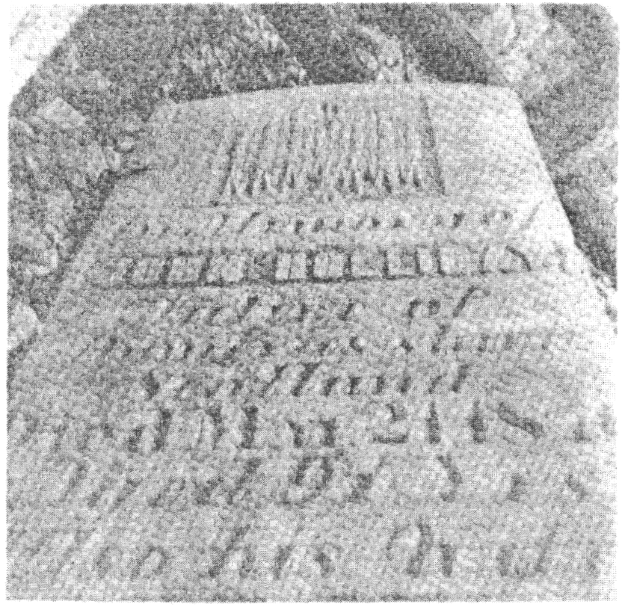

Notes
Notes - Chapter One
(1) William Bell, Journal, July, 1817.
(2) Andrew Haydon, Pioneer Sketches in The District of Bathurst, p. 29.
(3) William Bell, Journal, March 18, 1818.
(4) Ibid, December 22, 1827.
(5) Ibid, October 10, 1830.
(6) Ibid, December 22, 1827.
(7) Ibid, June 29, 1817.
(8) Isabel Skelton, A Man Austere, p. 118.
(9) William Bell, Journal, 1819.
(10) Andrew Haydon, Pioneer Sketches, p. 30.
(11) Public Archives of Canada, Q 135, p. 192.
(12) Ibid, Q 133, p. 268.
(13) Ibid, Upper Canada Sundries, December 28, 1815.
(14) William Bell, Journal, December 9, 1819.
(15) Ibid, January, 1828.
(16) Isabel Skelton, A Man Austere, P. 119.
(17) Public Archives of Canada, U. C. Sundries, August 10, 1819.

Notes - Chapter Two
(1) Map A.
(2) History of Annandale Family Names, Archives of Annan.
(3) Prevost, Annals of Three Dumfriesshire Dalesil, p. 33.
(4) For the complete poem, "The Twa Dogs" by William Halliday of Springtown,
Ont., see the chapter titled The Family He Founded.
(5) Agnes Marchbank, Upper Annandale. (Paisley, 1901).
(6) Map A.
(7) Anonymous article, The Clan Halliday, Moffat News and Times, June 21, 1956.
(8) Woodrow, History of the Covenanters, p. 242.
(9) Map A.
(10) Prevost, History of Dumcrieff (unpublished); and Record Office, Edinburgh, Clerk of Penicuik, 5697; 5720.
(11) Session Records, Moffat Parish Church, January, 1739: and Record Office, Edinburgh, Registers of Moffat Parish

Notes - Chapter Three
(1) Statistical Account of Scotland, 1793: Hutton and Corrie.
(2) Map B.
(3) Agnes Marchbank, Upper Annandale (Paisley, 1901)
(4) see "Berrier", Oxford Dictionary of English Place-names.
(5) see "Berscaur", Johnson-Ferguson: Place-Names of Dumfriesshire
(6) Map C.
(7) William Rogerson, Hutton-Under-The-Muir (Dumfries, 1908)
(8) see below, Chapter Eight.
(9) Henry Graham, Social Life in Scotland in XVIII Century
(10) Map D.
(11) see below, chapter titled Emigration
(12) see below, chapter titled A New Life Begins
(13) Public Archives of Canada, U. C. Sundries, 1815 (vol. 25).
(14) Ibid, 1819.

Notes - Chapter Four
(1) Public Archives of Canada, Q 328, p. 143.
(2) Ibid, L. C., series G, p. 6.
(3) Andrew Haydon, Pioneer Sketches etc, p. 11.
(4) Public Archives of Canada, Q 127, p. 169.
(5) Ibid, Q 135, Pt. I, p. 3.
(6) lbid, Q 135, Pt. 1, p. 106.
(7) Ibid, Q 135, Pt. I, p. 109.
(8) Ibid, Q 135, p. 125.
(9) Ibid, Q 135, p. 129.
(10) William Bell, Hints To Emigrants, Letter X.
(11) Public Archives of Canada, Q 135, p. 149.
(12) Isabel Skelton, A Man Austere, p. 85.
(13) Public Archives of Canada, Q 135, p. 186.
(14) Ibid, Q 135, p. 192.
(15) Ibid, Q 135, p. 197.
(16) John Holliday, Letter to Sir Peregrine Maitland, August 10, 1819. (See below, Chapter Seven)
(17) Isabel Skelton, A Man Austere, p. 85.
(18) Ibid, p. 86.

Notes - Chapter Five
(1) Public Archives of Canada, Q 135, p. 268.
(2) Isabel Skelton, A Man Austere, p. 87.
(3) Andrew Haydon, Pioneer Sketches, etc., p. 25.
(4) Public Archives of Canada, C. 621, p. 103.
(5) lbid, Q 133, p. 266.
(6) lbid, Q 133, p. 268.
(7) lbid, Q 133, p. 268.
(8) Josephine Smith, Perth-on-the-Tay, appendix.
(9) Mary Holliday Fraser, Almonte Gazette, May 3, 1890.
(10) Public Archives of Canada, (R.G.5, Al, Vol. 25) 1815.
(11) Ibid, U. C. Sundries, March 25, 1816.
(12) Mary Holliday Fraser, Almonte Gazette, May 3, 1890.
(13) Robert Gourlay, Report on Settlements in Upper Canada, 1817.

Notes - Chapter Six
(1) Mary Holliday Fraser, Almonte Gazette, May 3, 1890.
(2) Robert Gourlay, of the Ottawa Valle ) p. 7.
(3) John McDonald, Pamphlet, 1826, quoted by Andrew Haydon, Pioneer Sketches, etc. p 104.
(4) Ibid.
(5) Public Archives of Canada, Q 137, p. 259.
(6) William Bell, Journal. July, 1817.
(7) Robert Gourlay, Settlements1817.
(8) Josephine Smith, Perth-on-the-Tay (Ottawa, 1901).
(9) see chapter titled A Forthright Man
(10) William Bell, Journal August, 1830.
(11) Lands Titles Office, County of Lanark, Perth.

Notes - Chapter Seven
(1) William Bell, Journal, June, 1818.
(2) On this incident see above, Chapter V.
(3) William Bell, Journal, November, 1817.
(4) Ibid, April, 1818.
(5) Ibid, March, 1818.
(6) Ibid, December, 1819.
(7) Public Archives of Canada, Q 135, p. 186.
(8) John Dobie, son of Jane Holliday Dobie.
(9) H.E. Wedick, Scotland's Magazine, January, 1961, p. 39.

Notes - Chapter Eight
(1) Statistical Account of Scotland, 1793: Hutton
(2) William Bell, Journal June, 1817.
(3) Isabel Skelton, A Man Austere, P. 167 - 170.
(4) Ibid, P. 118.
(5) William Bell, Journal February, 1828.
(6) Ibid, March 30, 1830.
(7) lbid, December, 1830.
(8) See above, chapter titled Early Life in Scotland
(9) Ibid.
(10) William Bell, Journal, January, 1835.
(11) Ibid, October, 1835.
(12) History of Ramsay Reformed Presbyterian Congregation - Almonte, 1888

