John Halliday's Homestead

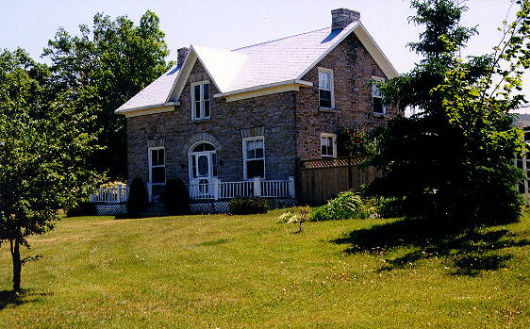 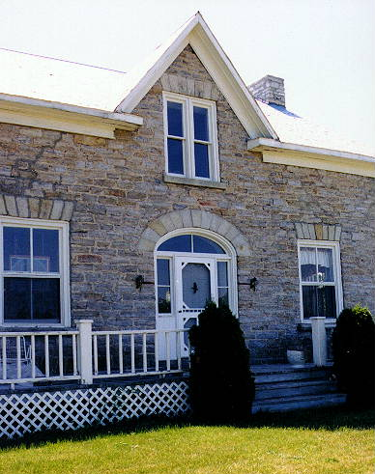

*John Halliday's homestead on the Scotch Line, Lanark County*

*Photo by Tom Carmody - 1999*

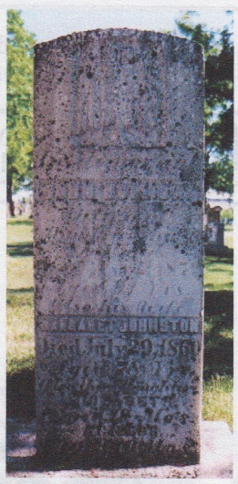

John Halliday and his wife Margaret Johnston Gravestone in Perth, Ontario

*(He is actually buried on the homestead on the Scotch Line)*

From “The Carmody Genealogist”  
http://www.magma.ca/~leprecha/john_halliday_photo_page.html