*Clan Halliday*

|  |  |
| --- | --- |
| https://web.archive.org/web/20070922155626/http:/www.hallidayclan.com/DSC_0075.JPG | **"Frae Annan fit to Errickstane**  **Man and horse lang syne hae gane**  **Neth greenwood gay: and a'the way**  **Upon the lands of Halliday"** |

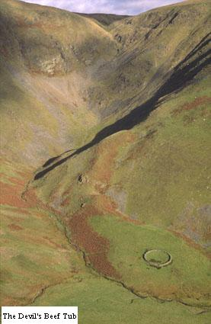

The River Annan has its source in an area of rugged hills some 6 miles north of the town of Moffat and its mouth 32 miles further down Annandale, where it empties into the Solway Firth. At the rivers source there is a remarkable, awesome hollow in the hills known as the ''Devil's Beef Tub.''

A few hundred yards below the Tub the glen begins to widen and take on the characteristic features of the Annandale watershed-gently flowing stream bordered by water meadows with rounded hills flanked along the valley. At this point where Annandale begins stands the first farmstead of the dale: Corehead. Here at Corehead the Halliday family had its historical beginnings.

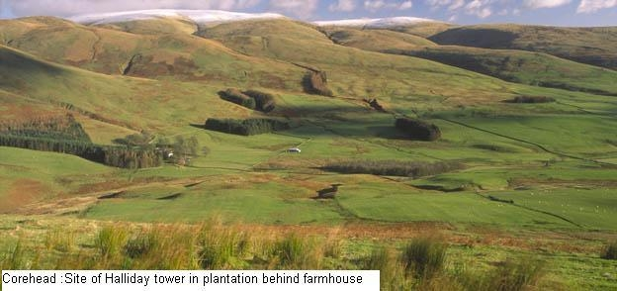

Origin of Name

The surname appears to derive from old English or Anglo-Saxon ''HALIG DAEG'' and the old German 'halegtag'. This means ''HOLY DAY'' and would appear to be given to one born on a religious festival. Some sources state that this was the war cry of the family-'A HALLIDAY! A HALLIDAY! as they charged into battle. The long ''O'' of holy is shortened as the first syllable of a trisyllable and northern forms should keep the ''A'' of old English and not change it to ''O'' as in the northern Halliday, but ''O'' forms occur even in Dumfriesshire and Cumberland

History

The Hallidays are not again heard of in history until the time of Wallace, the great patriot. His sister was married to the Chief Halliday at Corehead. Wallace speaks proudly and affectionately of "the brave Tom Halliday, my sister's son" Sir John Grahame and Johnstone of Eskdale, the faithful friends of Wallace were also married to the ladies of the Corehead family. It was from Corehead that Wallace, near the beginning of his career, set out one Sunday morning, on the pretence of attending church, with sixteen followers to reconnoitre the possibility of taking Lochmaben Castle. The company did not take the direct road there, but went around about road through Kirkmichael. They were followed by a band of soldiers from Lochmaben Castle and were attacked. Had not Sir John Grahame with a band of men turned up, it would have been an entire defeat instead of a complete victory.

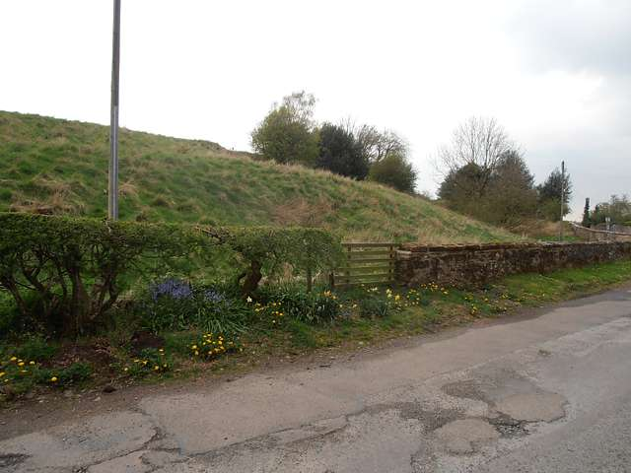

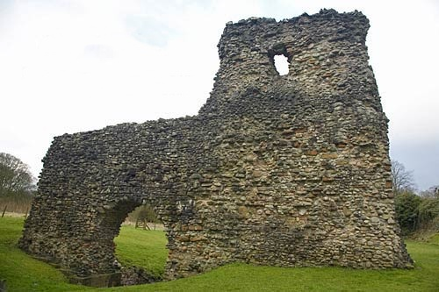

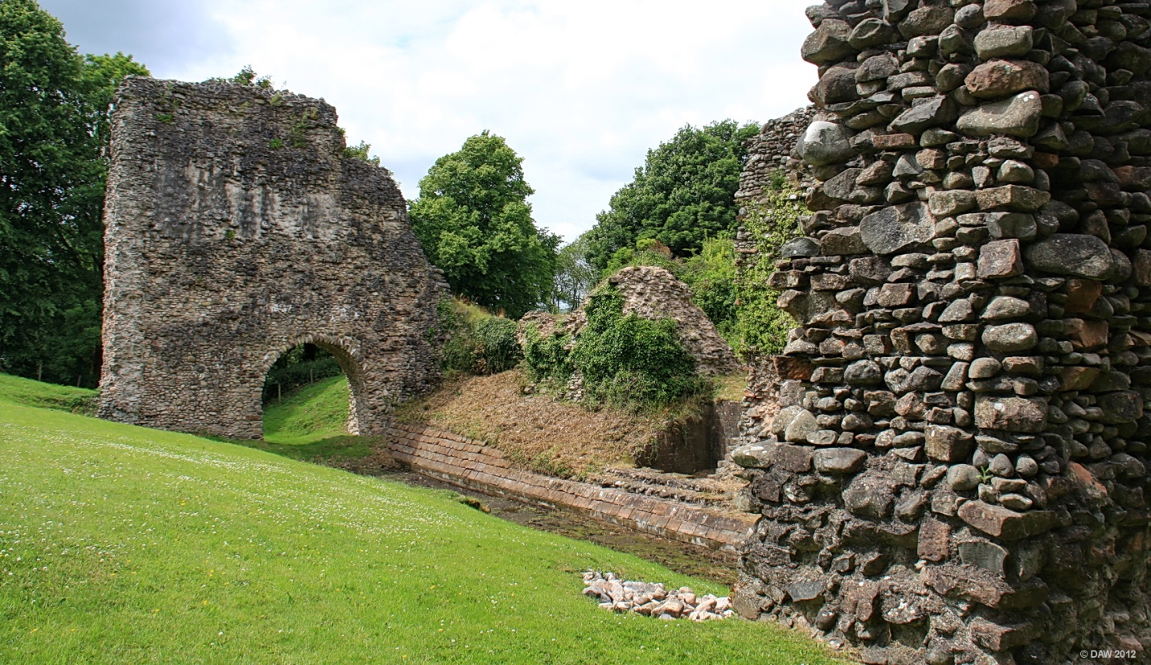

Siege of Sanquhar Castle; Dumfriesshire   
  
Sir William de Douglas, ex-Governor of Berwick, was in 1297 making things rough for the English in his barony. He attacked and secured the small Castle of Durisdeer in Nithsdale. The neighbouring Castle of Sanquhar was defended by a powerful garrison, but by a trick using a waggonload of wood fuel used to jam the portcullis, Douglas' force overcame and put to death all the defenders. Sir Robert de Clifford of Lochmaben Castle and Henry de Percy decided to put a check on Douglas activities as it was undermining the English occupation of the district, and besieged him at Sanquhar, but Wallace had been informed and marched from the Lothians via Peebles and Crawford to raise the seige but the English heard of his approach and hurried away. They lost many men in the retreat and a body of Dumfriesians made up of Kirkpatricks, Corries, Johnstones, Hallidays and Maxwells joined in the hot chase as far as Cockpool near Comlongan, the ancient seat of the Murrays. Wallace rewarded Douglas for his bravery by making him Governor of the territory which stretches from Drumlanrig to Ayr.

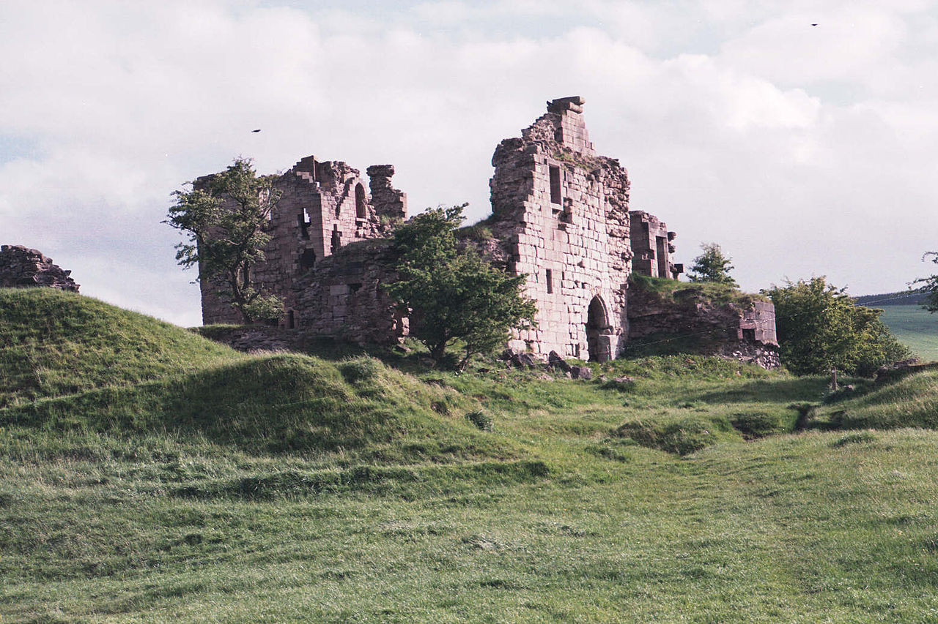

Geographical Distribution in Scotland

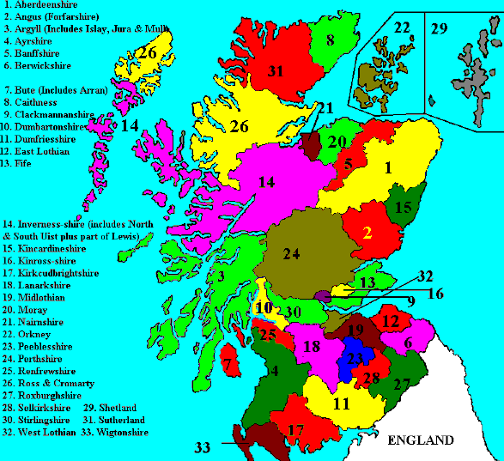

The Halliday surname is most commonly found in the Border Counties of Dumfriesshire and Kirkcudbrightshire with isolated pockets in Roxburghshire and Berwickshire. When the Industrial and Agricultural Revolutions of the 18th and 19th centuries happened, there is evidence of Halliday families moving to Glasgow(Lanarkshire),Edinburgh and Dundee. Many became coal miners in the Central Belt of Scotland. There also appears a few Halliday families in the Highlands and from census records they were natives of Dumfriesshire who worked as shepherds during the great influx of sheep to replace people in the Highland Clearances.

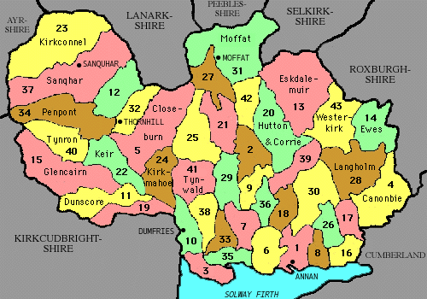

|  |  |  |
| --- | --- | --- |
| Annan (1)  Applegarth (2)  Caerlaverock (3)  Canonbie (4)  Closeburn (5)  Cummertrees (6)  Dalton (7)  Dornock (8)  Dryfesdale (9)  Dumfries (10)  Dunscore (11)  Durisdeer (12)  Eskdalemuir (13)  Ewes (14)  Glencairn (15) | Gretna (16)  Halfmorton (17)  Hoddam (18)  Holywood (19)  Hutton (20)  Johnstone (21)  Keir (22)  Kirkconnel (23)  Kirkmahoe (24)  Kirkmichael (25)  Kirkpatrick Fleming (26)  Kirkpatrick Juxta (27)  Langholm (28)  Lochmaben (29) | Middlebie (30)  Moffat (31)  Morton (32)  Mouswald (33)  Penpont (34)  Ruthwell (35)  St Mungo (36)  Sanquhar (37)  Torthorwald (38)  Tundergarth (39)  Tynron (40)  Tinwald (41)  Wamphray (42)  Westerkirk (43) |

Future topics on the web site

History

Halliday DNA Project

Sources for Halliday research : births, marriages, deaths, census

Send me your [comments and questions](mailto:c.john.halliday@lineone.net).  
 c.john.halliday@lineone.net

Useful web links

* [Scottish Births,Marriages,Deaths & Census,Index](https://web.archive.org/web/20070922155626/http:/www.scotlandspeople.gov.uk/)
* [National Archives of Scotland](https://web.archive.org/web/20070922155626/http:/www.nas.gov.uk/)
* [Scottish Wills & Testaments Index](https://web.archive.org/web/20070922155626/http:/www.scottishdocuments.com/)
* [Scottish Genealogy Society](https://web.archive.org/web/20070922155626/http:/www.scotsgenealogy.com/)
* [The Dumfries and Galloway Family History Society](https://web.archive.org/web/20070922155626/http:/www.dgfhs.org.uk/)
* [The Statistical Accounts of Scotland 1791-1799 and 1845](https://web.archive.org/web/20070922155626/http:/www.stat-acc-scot.edina.ac.uk/stat-acc-scot/stat-acc-scot.asp)
* [Family Tree DNA host for Halliday DNA Project](https://web.archive.org/web/20070922155626/http:/www.familytreedna.com/)
* [DNA results for Halliday DNA Project Members](https://web.archive.org/web/20070922155626/http:/www.familytreedna.com/public/halliday)
* [Halliday genforum](https://web.archive.org/web/20070922155626/http:/www.genforum.genealogy.com/halliday/)
* [Halladay genforum](https://web.archive.org/web/20070922155626/http:/www.genforum.genealogy.com/halladay/)
* [Holiday genforum](https://web.archive.org/web/20070922155626/http:/www.genforum.genealogy.com/holiday/)
* [Holliday genforum](https://web.archive.org/web/20070922155626/http:/www.genforum.genealogy.com/holliday/)
* [Holladay genforum](https://web.archive.org/web/20070922155626/http:/www.genforum.genealogy.com/holladay/)

Bibliography:

* Hallidays: Colonel C.A.T. Halliday 1980 Portia Press Ltd Hampshire
* John Holliday: A Forthright Man: Clarence Halliday 1962
* A Halliday Family Tree: Clarence Halliday, Coburg. Ont 1963
* Anonymous article:"The Clan Halliday" :Moffat News & Times June 21 1956
* The Moffats: Major F. Moffat of that Ilk
* History of the Commoners of Great Britain and Ireland Vol 2 :John Burke 1834-1838 ed
* The Surnames of Scotland: George Black 1946 New York Public Library
* Minstrelsy of the Scottish Border: Sir Walter Scott
* Annals of Three Dumfriesshire Dales: W.A.J. Prevost. Lockerbie 1954
* History of Dumfries: Robert Edgar. 1915
* The Scottish Nation: William Anderson
* Scots Kith and Kin: Albyn Press Ltd
* Historic Families of Dumfriesshire: Johnstone
* Tales of Sir William Wallace "The Wallas": Blind Harry
* The Fortified House in Scotland Vol 2: Nigel Tranter

From www.hallidayclan.com

This document is derived from printed web pages received from Bibit Trout (nee Halliday, daughter of John Meech Halliday). The original web pages no longer exit. Some material, however, was reconstructed from the Internet web archive (www.archive.org). Not all photos and maps from the original web pages were available from the archive. Similar photos and maps were substituted.

Bob Baggerman (son of Jean Halliday)

Published 7/7/2016