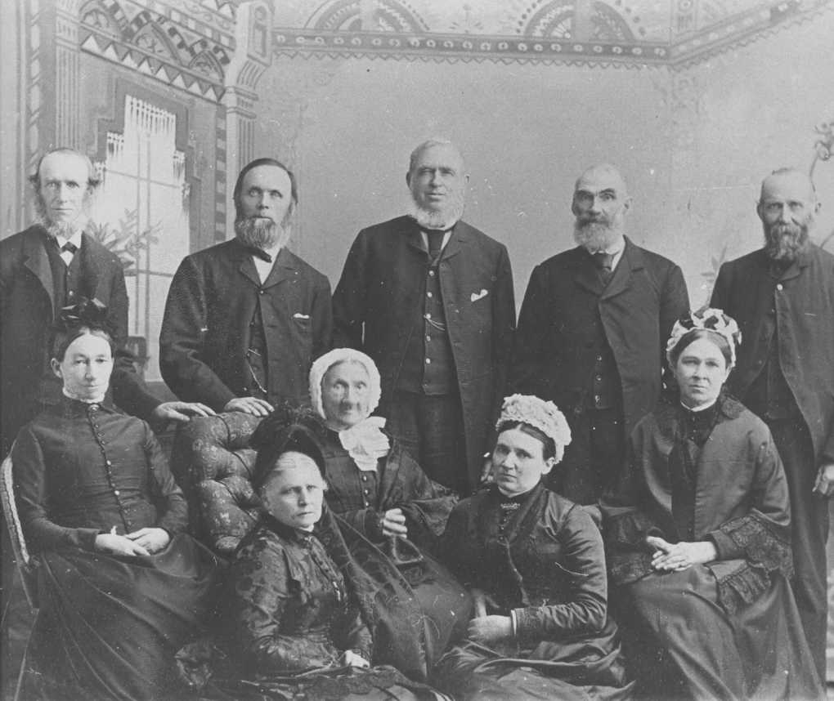

Photo taken on the occasion of 50th anniversary of James Halliday and Jessie (Janet ?)(nee Allan) - about January 29, 1889. Back Row, left to right: Robert Allan, William Allan or Matthew Dodd, Francis Allan, John Allan, Alexander Allan. Front row, left to right: Janet (nee Allan) Halliday, Janet (nee Brown) Allan - wife of James, Janet (nee Cowie, formerly Allan) Fraser, Elizabeth (nee Allan) Dodds, Agnes (nee Allan) Halliday. Janet Cowie Allan Fraser (1798-1892) was mother to the Allan clan in the photo.