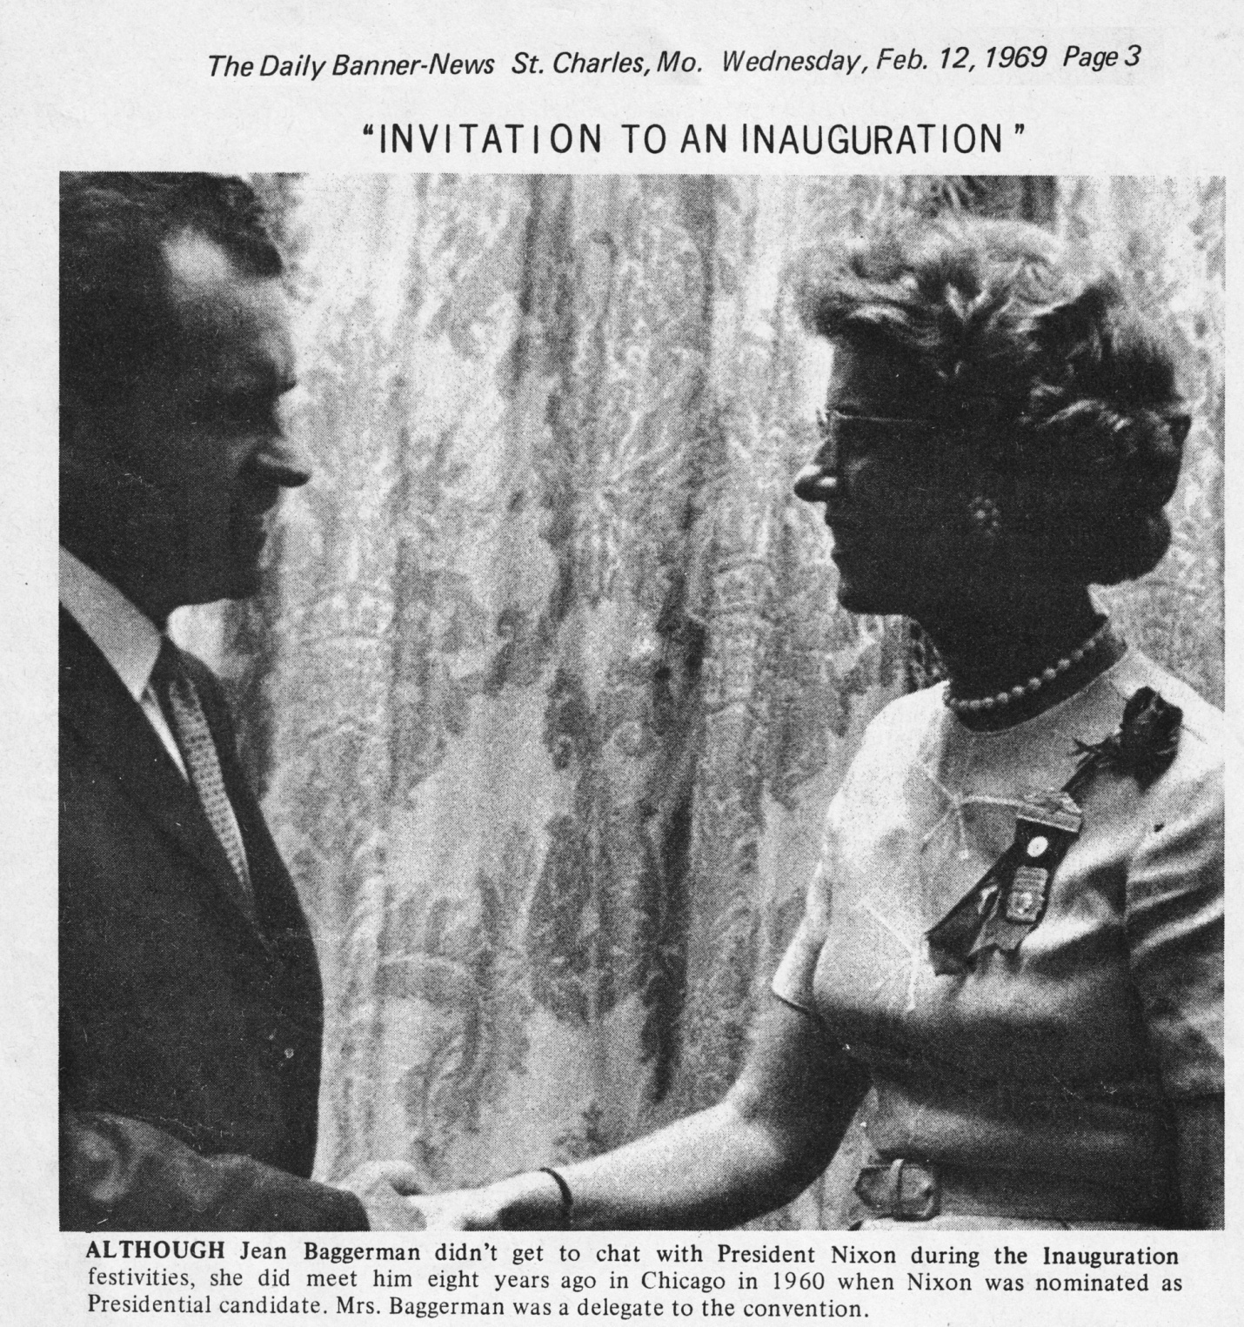

(Ed. Note) Mrs. William Baggerman, 20 Briarwood Lane, recounts the human interest side of her trip to Washington D. C. to attend the inauguration of Richard Nixon as president of the United States last month.

by Mrs. William Baggerman

I didn't want to go, but Rosemary Ginn, Republican National Committeewoman from Missouri, sent an invitation to the Distinguished Ladies Reception and the children insisted I go. So, after washing everything in sight, making enough food for three weeks, and writing out nine pages of instructions, I left for the airport early Friday afternoon. My plane was three hours late. I was off to a good start.

Saturday was rainy and cold but my sister - in - law and I took off for the Distinguished Ladies Reception in our very best. The National Gallery of Art was gloriously decorated with flowering plants everywhere. The Marine Corp Band was playing beautiful music. And 11,000 women were trying to guess which reception line led to Mamie Eisenhower or Pat Nixon. We took our chances and stood in our line for thirty minutes. As we neared the end Pat, my sister-in-law, turned to me and said, "I bet we get Mrs. Agnew". We have nothing against Mrs. Agnew but we know Mamie, Pat and the Nixon girls much better. My only comment was, "She'll probably be standing next to Mrs. Hickel”.

About this time two men escorted a little old lady into the room. She was dressed in a silver lame dress with gloves to match her name tag indicated she was a member of the Nixon family. She stood behind me and asked in a loud voice, "What in the - - - do I do with these - - - - gloves when I get up there?" We all assured her it didn't make a bit of difference because by this time we could see that our line led to Mrs. Agnew and Mrs. Hickel. Oh well . . . .

Sunday morning, Mr. and Mrs. Wolberger of St. Louis Country had a brunch for Missourians at the Marriot Motel. This was the first and last time the Missourians got to see each other as a group.

Ray Bliss, Republican National Chairman, spoke to us and we had a great time visiting. After the Distinguished Ladies Reception the day before I decided to forego the Vice-President's Reception and visit with my brother and his family.

Monday morning I woke up to the usual, rain. Wanting to get an early start the next morning I packed as much as possible and watched the inauguration ceremony on television. Then I headed for the parade. After standing for two hours and being thoroughly chilled I walked back to my hotel. I'm sure those watching the parade on television saw much more than I did.

Some friends and I decided we'd have an early dinner so that we would have time to beautify ourselves before the Ball. It had stopped raining so I decided I'd walk the two short blocks to their hotel. It was very pleasant to stroll along a quiet side street and not have to push my way through a crowd for a change. I was in the middle of a block when a great horde of bearded, long – haired youths with their dungareed girl friends turned the corner and descended on me chanting "Ho-Ho-Ho Chin Minh". I headed for the nearest store but the man had just locked the door and wouldn't let me in. So I ducked into a small liquor store and cowered between the bourbon and the scotch. When I had enough nerve to come out the police were rounding up the rowdies and several paddy wagons were full of the screaming youths. The store I had originally tried to get into had been shattered by stones and bricks. Undaunted, I ran for the hotel and my friends and I had a good stiff drink before dinner.

Since there were only a few Missourians staying at my hotel, we decided we would all go to the Ball together. As we came out the lobby door we discovered it was raining again. It looked as if at least five hundred people were waiting for a taxi. We decided to use a small side entrance to the hotel and catch a taxi before someone else did. There was not a taxi in sight, but there was a big black limousine with a large No. 2 on the front of it. Courageously, I went up to the loitering chauffeur and said, "I believe you're waiting for us". And sure enough, he thought he was. As we drove up in front of the Statler - Hilton, the police stopped traffic and escorted our car to the front door. I'm still wondering if that poor man ever picked up the people he was supposed to. We told him that Stanley Ginn, Rosemary’s husband, was the Ambassador to Bolivia and he was impressed.

The ballroom of the Statler was so crowded it took us a half hour to find Superintendent Roos' and Governor Hearnes' boxes. Dancing was impossible and even Cokes were selling for $1.85. Some friends from St. Charles were there and I never even saw them. But the gowns were gorgeous and everyone was happy. If I ever get an invitation to another Inauguration, I'm going to send them a note saying, "No thanks, I've been"!

Truthfully, I had a BALL.